**RPI User Manual**

**Hardware and Software**

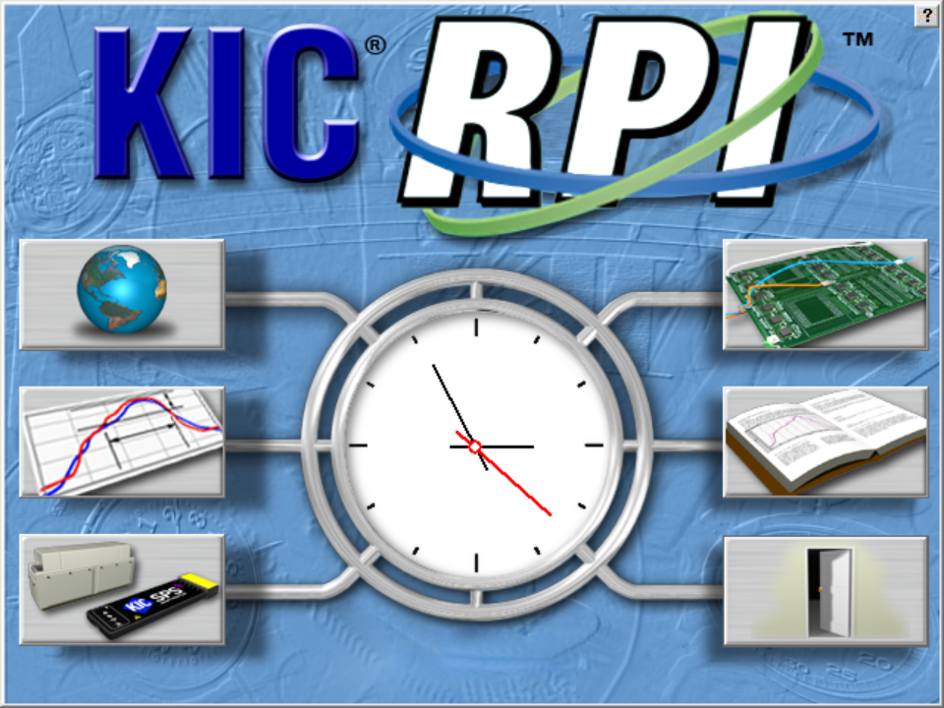

Version 3.11

Publication Number SFT-324000-000



**KIC RPI Hardware and Software User Manual**

Copyright © 2022 KIC. All rights reserved. Patents pending.

16120 West Bernardo Drive

San Diego, CA 92127

Phone: +1 858 673 6050 Fax: +1 858 673 0085

A Division of Embedded Designs Inc.

This document contains information that is proprietary to KIC. Said information, is copyrighted as is all associated software and hardware. All rights are reserved. Patents are pending.

This document and the information contained in it may not be sold, duplicated, used, or disclosed, in whole or in part, except as specifically authorized in writing by KIC. The information contained in this document and associated software is subject to change without notice.

There are no warranties with respect to the information contained in this document, express or implied, except as provided by written contract between KIC and the customer.

All KIC product names and logos are trademarks of Embedded Designs, Inc. All other trademarks used herein are the property of their respective owners.

**Software Licensing Agreement and Product Warranty**

The KIC software is subject to the following license terms and conditions.

**KIC SOFTWARE LICENSE**

* 1. This is a software license granted by *KIC*, mailing address 16120 West Bernardo Drive San Diego, CA 92127.
  2. The KIC software is licensed to you as the end user and is not sold.
  3. The KIC software is copyrighted material.
  4. The KIC software is licensed for use with one or more pieces of associated hardware that together constitute a thermal process management system. This license allows you to use the software with the purchased system. You must purchase additional copies of the software if used with additional system hardware.
  5. You may not change, modify, decompile, disassemble, or otherwise reverse engineer the licensed software or any associated hardware.

**LIMITED WARRANTY**

* 1. KIC warrants that the system hardware and software are free from defects in material and workmanship under normal use. KIC warrants that the system as a whole will perform substantially in accordance with the specifications set forth in the documentation provided with it.
  2. Warranty regarding rated temperature: Components of the system hardware are rated by KIC for proper performance up to a specified maximum temperature. Any component that KIC determines to have been exposed to temperatures higher than the rated temperature is not covered under this warranty.
  3. Start of the Warranty period. The warranty period begins the day the KIC product is delivered to you as the first customer.
  4. Obligations of KIC during the warranty period:
     1. Return for complete refund: If, within the first thirty (30) days after the start of the warranty, the customer returns, for any reason whatsoever, any of the purchased hardware or software in its original condition, KIC will refund the associated money paid and accept the return as payment for any money owed.
     2. Replacement: Within the first year of the start of the warranty, KIC will replace, on an exchange basis and without additional charge, any product proven defective in materials or workmanship.
     3. Correction of software: KIC will either replace or repair, without additional charge, any software that does not perform in substantial compliance with its documented specifications. In the foregoing circumstances, KIC will deliver either corrective code or a corrected copy of the software.
     4. Final Remedy: If KIC is unable to replace defective media or provide a corrected copy of the software within a reasonable amount of time, KIC will either replace the software with a functionally similar program or refund the license fees paid for use of the software.
  5. **Exclusion of Other Warranties**
     1. KIC does not warrant that the functions contained in the software will meet your requirements or that the operation of the software will be uninterrupted or error free. The Warranty does not cover any copy of the software that has been altered or changed in any way by you or others. KIC is not responsible for problems caused by changes in the operating characteristics of the computer hardware or operating system which are made after delivery of the software.
     2. **EXCEPT WHERE LIMITED BY LOCAL JURISDICTIONS, KIC SHALL NOT IN ANY CASE BE LIABLE FOR SPECIAL, INCIDENTAL, CONSEQUENTIAL, INDIRECT OR OTHER SIMILAR DAMAGES ARISING FROM ANY BREACH OF THESE WARRANTIES EVEN If KIC OR ITS AGENT HAS BEEN ADVISED OF THE POSSIBILITY OF SUCH DAMAGES.**
  6. **Other Conditions**
     1. **The warranties set forth above are in lieu of all other warranties, whether oral, written or implied, INCLUDING BUT NOT LIMITED TO ANY IMPLIED WARRANTIES OF MERCHANTABILITY OR FITNESS FOR ANY PARTICULAR USE. the remedies set forth above are the customer’s sole and exclusive remedies**. Only an authorized officer of KIC may make modifications to this warranty, or additional warranties binding on KIC. Accordingly, additional statements such as advertising, collateral or presentations, whether oral or written, do not constitute warranties by KIC and should not be relied upon as such. This warranty gives you specific legal rights, and you may have other rights, which vary by state and/or country.

**LIMITATION OF LIABILITY**

* 1. In no case shall KIC's liability exceed the license fees paid for the right to use the licensed software or One Hundred Dollars ($100.00), whichever is greater.

Table of Contents

[Introducing the RPI System 1](#_Toc115681666)

[The Hardware 2](#_Toc115681667)

[The Software 5](#_Toc115681668)

[Install The Software 6](#_Toc115681669)

[Start the Software 7](#_Toc115681670)

[The Main Screen 9](#_Toc115681671)

[Global Preferences 10](#_Toc115681672)

[Global Tab 10](#_Toc115681673)

[Define Your Oven 11](#_Toc115681674)

[Auto-Focus Tab 12](#_Toc115681675)

[Control Limits Tab 13](#_Toc115681676)

[Disable Alarm Tab 16](#_Toc115681677)

[Barcode Tab 17](#_Toc115681678)

[Outputs Tab 18](#_Toc115681679)

[Process Window Setup 21](#_Toc115681680)

[Solder Paste Menu 22](#_Toc115681681)

[Edit Specs 23](#_Toc115681682)

[Specify Different Specs For Individual TCs 24](#_Toc115681683)

[Use Sweet Spot Target (Optional) 25](#_Toc115681684)

[Change Specs Name 25](#_Toc115681685)

[Save - Process Window 26](#_Toc115681686)

[Import Legacy Process Windows 27](#_Toc115681687)

[Hardware Status 28](#_Toc115681688)

[Run A Profile 29](#_Toc115681689)

[Run a Profile Screens 30](#_Toc115681690)

[Auto-Focus, Product Dimensions 31](#_Toc115681691)

[Auto-Focus, Confirm 32](#_Toc115681692)

[Specify Oven Characteristics 34](#_Toc115681693)

[Attach Thermocouples 36](#_Toc115681694)

[Attach Thermocouples To Semiconductor Wafers 37](#_Toc115681695)

[Select Thermocouples 38](#_Toc115681696)

[Start the Profile 39](#_Toc115681697)

[Live Profile Graph 41](#_Toc115681698)

[Profile Retransmission 43](#_Toc115681699)

[View The Profile And Statistics 44](#_Toc115681700)

[Profile Optimization With Navigator 54](#_Toc115681701)

[Manual Profile Prediction 55](#_Toc115681702)

[Set Different Top And Bottom Setpoint Temperatures 56](#_Toc115681703)

[Profile Explorer 61](#_Toc115681704)

[Find VP Production Run Data By Lot ID Code 62](#_Toc115681705)

[Browse For Historical Data 63](#_Toc115681706)

[View Historical Data Over A Network (History Mode) 63](#_Toc115681707)

[Profile Explorer Buttons 64](#_Toc115681708)

[Profile Explorer – Virtual Profiling 65](#_Toc115681709)

[History Data Files 67](#_Toc115681710)

[Insert Data Files From An Outside Source 67](#_Toc115681711)

[Rename Profiles 67](#_Toc115681712)

[Virtual Profiling 68](#_Toc115681713)

[Get A Valid Baseline Profile 68](#_Toc115681714)

[Create/Load A Virtual Profile 69](#_Toc115681715)

[Use the Profile Grouping Utility 72](#_Toc115681716)

[Monitor Production In Live Mode 77](#_Toc115681717)

[How to Avoid The Grey Crystal Ball 77](#_Toc115681718)

[Use the Index Screen 78](#_Toc115681719)

[Live Mode - General Tab 80](#_Toc115681720)

[Live Mode - Description Tab 83](#_Toc115681721)

[Live Mode - Charts Tab 84](#_Toc115681722)

[Live Mode- Troubleshooting Tab 86](#_Toc115681723)

[VP Live Mode Buttons 87](#_Toc115681724)

[Virtual Profiling With Barcode Process Control 88](#_Toc115681725)

[Read Barcodes With A Product Traceability Scanner 89](#_Toc115681726)

[Verify The Virtual Profile 90](#_Toc115681727)

[Historical Mode 92](#_Toc115681728)

[View Historical Data While Running a Live Virtual Profile 92](#_Toc115681729)

[Historical Mode - General Tab 92](#_Toc115681730)

[Historical Mode - Description Tab 95](#_Toc115681731)

[Historical Mode - Chart Tab 96](#_Toc115681732)

[Historical Mode - Troubleshooting Tab 98](#_Toc115681733)

[Barcode Functions 99](#_Toc115681734)

[Barcode Types 100](#_Toc115681735)

[Scanner Installation 103](#_Toc115681736)

[Virtual Profiling And Barcodes 104](#_Toc115681737)

[Enable Barcoding Per Product 107](#_Toc115681738)

[Display the Current Barcode Queue 107](#_Toc115681739)

[View Barcode Traceability Information For Barcodes Previously Run 111](#_Toc115681740)

[Search For Barcode Entries 111](#_Toc115681741)

[Live Data Output And Barcodes 112](#_Toc115681742)

[Live Data Output 113](#_Toc115681743)

[LDO Formats 114](#_Toc115681744)

[Details of Output Files 114](#_Toc115681745)

[Configure LDO 115](#_Toc115681746)

[Delete Accumulated LDO Files 117](#_Toc115681747)

[Dual Lane Systems And Functionality 118](#_Toc115681748)

[Dual Lane Dual Systems 118](#_Toc115681749)

[Dual Lane Single Systems 119](#_Toc115681750)

[Configure Dual Lane Systems 120](#_Toc115681751)

[Vacuum Reflow Oven Systems And Functionality 122](#_Toc115681752)

[RPI Vacuum System Hardware 122](#_Toc115681753)

[RPI Vacuum System Functionality 122](#_Toc115681754)

[Run RPI without the Board Sensor 126](#_Toc115681755)

[Preload the Oven 126](#_Toc115681756)

[Remote Process Monitoring 127](#_Toc115681757)

[Configure RPM Output 129](#_Toc115681758)

[KIC Server 130](#_Toc115681759)

[KIC Viewer 132](#_Toc115681760)

[O2 Live (Optional) 140](#_Toc115681761)

[Configuration 140](#_Toc115681762)

[Operation 142](#_Toc115681763)

[VP Idle Mode (Optional) 144](#_Toc115681764)

[Configuration 144](#_Toc115681765)

[Centralized Process Window Control (Optional) 145](#_Toc115681766)

[KIC File Administrator 145](#_Toc115681767)

[Configuration of RPI software 148](#_Toc115681768)

[Operation of RPI software 149](#_Toc115681769)

[Footprint (Optional) 150](#_Toc115681770)

[Live Viewing 150](#_Toc115681771)

[Historical Viewing 151](#_Toc115681772)

[Units Per Hour 152](#_Toc115681773)

[Configuration 152](#_Toc115681774)

[Auto-VP 153](#_Toc115681775)

[Password Protection 154](#_Toc115681776)

[Profile Printing 155](#_Toc115681777)

[Portrait Mode 155](#_Toc115681778)

[Landscape Mode 156](#_Toc115681779)

[Write Data To and View RPI Data Over A Network 157](#_Toc115681780)

[Write Data To A Network Drive 157](#_Toc115681781)

[View Historical Data 160](#_Toc115681782)

[Communicate with Oven Controllers 161](#_Toc115681783)

[Confirm Oven Communications 162](#_Toc115681784)

[Configure Software For Oven Communication 163](#_Toc115681785)

[Use a Base Oven Recipe With Oven Communication 163](#_Toc115681786)

[Run A Profile Using Oven Communication 164](#_Toc115681787)

[Start a Virtual Profile With Oven Communication 166](#_Toc115681788)

[Base Oven Recipe Automatic Verification 167](#_Toc115681789)

[Troubleshoot COM Ports 168](#_Toc115681790)

[Comport.Exe 168](#_Toc115681791)

[Status Messages And Alarms 170](#_Toc115681792)

[Acknowledge Alarms 170](#_Toc115681793)

[Messages During Profiling and Baseline Profiling 171](#_Toc115681794)

[System Message and Alarms 171](#_Toc115681795)

[Alarms and Messages during Virtual Profiling 172](#_Toc115681796)

[Light Tower 194](#_Toc115681797)

[Standard Light Tower 194](#_Toc115681798)

[3 Color USB Light Tower 194](#_Toc115681799)

Appendices

[Appendix A: The Process Window Index 195](#_Toc115682085)

[The Problem 195](#_Toc115682086)

[Define the Process Window Index 195](#_Toc115682087)

[Calculate the PWI 196](#_Toc115682088)

[Benefits of Ranking Thermal Profile Performance 197](#_Toc115682089)

[Conclusion 197](#_Toc115682090)

[Appendix B: Recalculating Zone Delta Limits From Navigator/Auto-Focus Predictions 198](#_Toc115682091)

[For Stand-alone Software Installations (Not Communicating with Oven) 198](#_Toc115682092)

[For Oven Controller Software Installations 200](#_Toc115682093)

[Appendix C: Configuration Program 202](#_Toc115682094)

[User Settings Tab 202](#_Toc115682095)

[Use Baseline Profile Expiration 203](#_Toc115682096)

[Shifting Tab 204](#_Toc115682097)

[Decimal Tab 204](#_Toc115682098)

[Hardware Tab 204](#_Toc115682099)

[Auto-VP Tab 205](#_Toc115682100)

[RPM Tab 205](#_Toc115682101)

[Message Config Tab 205](#_Toc115682102)

[Password Control – Multi User 206](#_Toc115682103)

[Access to the Password Control Tab 206](#_Toc115682104)

[Multi User Control 207](#_Toc115682105)

[Password Control Tab 208](#_Toc115682106)

[User Type Area 210](#_Toc115682107)

[Password Area 211](#_Toc115682108)

[Password Timer Area 211](#_Toc115682109)

[Main Screen With Password Control 212](#_Toc115682110)

[Main Screen Log In 213](#_Toc115682111)

[Responding to an Alarm 215](#_Toc115682112)

[Alarm Tab 216](#_Toc115682113)

[Alarm Relay Matrix configuration 216](#_Toc115682114)

[USB Light Tower configuration 217](#_Toc115682115)

[Barcode Tab 218](#_Toc115682116)

[Barcode Interface Method Area 219](#_Toc115682117)

[Missing Barcode Trigger Area 219](#_Toc115682118)

[Process Control String Area 220](#_Toc115682119)

[Disable Missing Barcode Option Area 220](#_Toc115682120)

[Options 221](#_Toc115682121)

[Contact KIC 222](#_Toc115682122)

# Introducing the RPI System

The RPI (Reflow Process Index) system is a comprehensive suite of thermal process management tools designed to give you the ultimate in PCB soldering quality control. KIC RPI can monitor the entire thermal process, giving advanced warning before a product drifts out of specification. Its barcode control features can prevent costly product/recipe mismatches, and its power management features enable efficient operation at the lowest energy cost.

RPI combines software and hardware components into an integrated system. The software supplements its thermal profile analysis core with special tools for performance optimization, changed variable prediction, and data file management. The RPI hardware includes the probes that measure oven temperature, sensors to track product movement and conveyor speed, a profiler to move through the process accumulating thermal data, an Ethernet communication hub, and alarm system.

## The Hardware

The six major hardware components to an RPI system are:

* Ethernet Thermocouple Processing Unit (eTPU)
* Probes
* Board sensor
* Conveyor speed encoder
* Alarm relay/light tower
* Profiler

### eTPU

The eTPU interfaces with the computer using an Ethernet cross-over cable that connects from the UpLink port on the eTPU directly to a USB to Ethernet adapter (or to an installed Network Interface Card (NIC)). Please follow manufacturers’ instructions to install the USB adapter or NIC.

The computer used with the RPI system can be a machine that is dedicated to only supporting RPI or it can also serve as the oven controller PC. RPI can interface directly with the oven controller on selected models from oven manufacturers. If you have an oven that is capable of communication with the RPI software, you will want to connect RPI to the oven controller computer.

The eTPU must be plugged into an AC power source. The eTPU utilizes a universal A/C transformer power supply. The eTPU ships from the factory with multiple AC connectors to accommodate any connector/voltage requirement.

### Probes

The probes are mounted in the oven process chamber. They are usually suspended from the conveyor rails by oven manufacturer approved brackets. The probes are connected to the eTPU - Odd/Even ports. Each probe connector is stamped with an **E** or **O** in order to designate **Odd** or **Even**. See the [Hardware Diagram](#_Hardware_Diagram_1).

### Board Sensor

The board sensor is mounted near the entrance of the oven. It can be mounted further into the oven if necessary. The board sensor is usually mounted to the fixed conveyor rail. The Board sensor is connected to any of the eTPU Sensor ports. Dual lane systems use a board sensor for each lane.

### Conveyor Speed Encoder

The conveyor speed encoder is mounted to read pulses from a gear that turns while the oven is operating. The conveyor speed encoder connects to any of the eTPU Sensor ports.

### Alarm Relay/Light Tower

The Alarm Relay connects to the Alarm/Barcode port of the eTPU and provides an external notification to the user when an alarm condition occurs. It allows for a KIC supplied audible light tower to be powered and triggered; can include SMEMA interface connections; and it allows a user to hardwire in an external device of their choosing. The Alarm Relay is required to have an external AC power source.

There are two audible light towers available – one model connects directly to the Alarm Relay device; the other model connects directly to the USB port of the PC. See the [Light Tower section](#_Light_Tower).

### Profiler

The profiler is the data acquisition component of the RPI system. It provides the on-board, through-the-process temperature data. RPI analyzes this data together with oven zone temperature and conveyor speed factors to graphically display the thermal profile.

### Profiler Models

You can use RPIsoftware with several profiler models:

1. SPS Smart Profiler
2. X5
3. K2
4. EK7

The software works the same with any of the profilers. Once you have the software running, you indicate your specific profiler model. The program then displays the text and graphics that reflect the model you chose. (The artwork that appears throughout this manual reflects a variety of profiler models.)

Profilers can operate in either of two modes—datalog and wireless*.* In standard datalog mode, the profiler records temperature data as it moves through the thermal process. A cable then transfers the data to your KIC software computer. In wireless mode, the profiler transmits data directly to the computer by radio signals or Wi-Fi instead of an attached cable. KIC software can then display the accumulating data in real-time.

For specific information regarding your profiler, consult one of the following KIC publications:

* SPS Smart Profiler Hardware Guide, (Publication Number PTG-330310-000)
* X5 Profiler Hardware Guide, (Publication Number EXP-337310-000)
* K2 Profiler Hardware Guide, (Publication Number EXP-331310-000)

### Barcode Reader

The user-supplied, serial port barcode reader connects to the eTPU Alarm/Barcode port. When used in conjunction with the alarm relay, the barcode reader hardware is connected to the alarm relay Y- cable. The barcode reader should be mounted in front of the oven on an infeed conveyor when using *Process Traceability* or *Process Control*. A USB scanner can also be utilized, by connecting to the PC where the software is installed. For additional information about using USB scanners, see [*Appendix C – Barcode Tab.*](#_Barcode_Tab_1)

### Dual Lane Functionality

RPI software can now monitor production through dual lane reflow ovens. A *Dual System* configuration uses two instances of the software application to track different recipes through the oven. The *Single System* tracks two lanes of the same recipe with one instance of the software. A radio button display during the installation routine lets you choose between the standard configuration or one of the dual lane setups. For more information, see the section titled [Dual Lane Systems](#_Dual_Lane_Systems).

**Note**: For more information about the hardware components of the system, see the *Automatic System Hardware Installation Manual* (TFS-330210-000).

### Hardware Diagram

The interconnection of the hardware components is illustrated in the hardware diagram below:

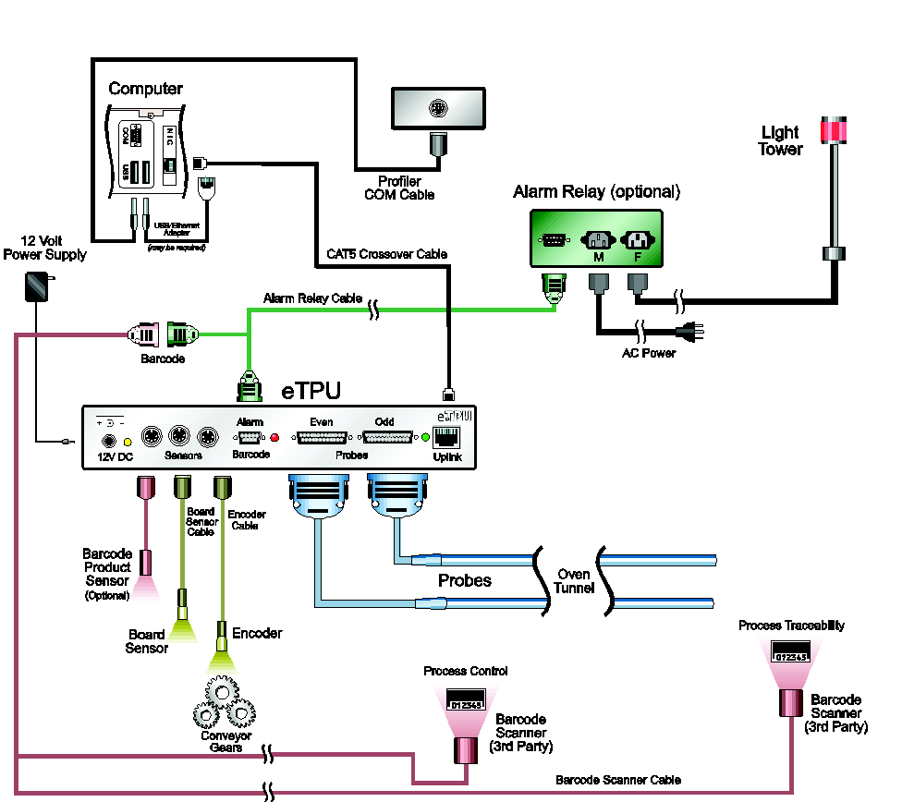

Figure 1: Hardware Configuration Diagram

It is critical that all RPI hardware is properly installed and configured. If one of the system components is setup incorrectly or is malfunctioning, the RPI system will not allow you to run Virtual Profiling or provide accurate data. If you have any questions or are unsure about any of the following, contact KIC Technical Support for assistance: [tech@kicmail.com](mailto:tech@kicmail.com)

## The Software

The RPI optimization tools include *Navigator*, *Auto-Focus*, and *Power*. Data management tools include *Live Data Output* and *Remote Process Monitoring*.

### Navigator

The KIC Navigator is a prediction tool that automatically finds the optimal oven setup for each product you profile. Navigator lets you understand how changes to belt speed and oven setpoints will affect a product profile. The KIC Navigatorcan create and evaluate billions of potential product profiles, automatically selecting the profile and oven setup that best fits the Process Window. This automated prediction tool is exponentially more powerful and accurate than any tool currently on the market and allows you to find the optimal profile in about a minute. The automated prediction tool is designed to center the profile in your process window, and you may set the limits to fit your process. An example of this is running sensitive components with lead-free solders: if your assembly cannot see temperatures above 235°C, but must see a fairly high peak temperature to reflow the lead-free solder, the KIC Navigator will find a profile that will be centered between the high and low limits.

Perhaps the most significant feature of RPI and KIC Navigator is that they rank your profiles using the *Process Window Index*. This allows you to compare performance between processes and, more importantly, to be assured that you have found the most robust and reliable profile for a given product that your oven can achieve.

### Auto-Focus

*Auto‑Focus* is simulation software that eliminates the need to guess at an initial oven recipe. Auto-Focus automatically calculates the ideal oven recipe, allowing you to avoid conventional oven setup pitfalls. Auto‑Focus gets smarter with every profile you run, providing you with increasingly accurate oven recipes.

### Navigator/Auto‑Focus Power

Used with Navigator and Auto-Focussoftware, the Power feature optimizes your profiles and/or initial oven settings based on reduced energy use. Studies have shown that many reflow ovens and wave machines consume more energy than required in order to process the products in spec. The KIC Navigator Power and Auto-Focus Power functions identify the oven or wave solder recipes that consume the least amount of energy while processing the products in spec. The result is improved quality at reduced energy costs.

### Live Data Output

Live Data Output (LDO) processes data for every board as real-time output for use with third-party applications. Third-party software can provide line balancing, production host monitoring or statistical process control.

### Remote Process Monitoring

The Remote Process Monitoring (RPM) system distributes real-time thermal process information for display on a server anywhere on your network. When a software system installed at an oven includes RPM, it monitors the process and transmits real-time data for each production board as an *output*. Each output includes the oven name, product name, *Process Window Index* (PWI), real-time *Process Capability Index* (Cpk), and the current alarm status, including the text and light bar state. As each board exists the oven, its data output is sent to a computer provisioned with *RPM server software.* This RPM server can display the data and act as the distribution hub for a network of *viewing* terminals. With the appropriate software installed, these additional networked computers can access the data from the main RPM server and display it on their own monitors. RPM software can display data as an iconic status overview of the whole production floor, individual oven process histories, or graphs charting the last 100 production units.

## Install The Software

### Minimum PC System Requirements

* Dual Core / 1GHz processor PC with 2GB RAM
* 2GB available storage
* Video 1024 x 768 / 16-bit color
* 1 available USB port for data download
* 1 available USB port (for software key)
* 1 available Ethernet port or 1 available USB port with Ethernet-to-USB adapter
* For product compatibility with Windows® operating systems, visit our website at <http://kicthermal.com/support-download/os-compatibility-chart>

**Note**: Additional powered USB ports may be needed for additional accessories.

### Notes Before Installation

* Shut down all other applications as a precaution against software conflicts.
* If you are installing the RPI software on an oven that is capable of communication with the software**,** DO NOT place the RPI icon in the Windows Startup folder. If the RPI software loads before the oven controller software, it can cause the oven controller software to malfunction.

### Languages

The software supports the following languages:

|  |  |
| --- | --- |
| * English | * Japanese |
| * German | * Korean |
| * Spanish | * Simplified Chinese |
|  | * Traditional Chinese |

The use of specific languages depends on the operating system:

* English, German, and Spanish can be run on any of the supported Windows operating systems.
* Japanese, Korean, Simplified Chinese, and Traditional Chinese cannot be used with English versions of Windows operating systems.
* To run the software in Japanese, the operating system must be Windows-Japanese version.
* To run the software in Simplified or Traditional Chinese, the operating system must be Windows-Chinese version.

### Install

1. Insert the USB flash drive into a USB port on your computer.
2. Depending upon your computer setup, a dialog box may appear. If it does, select ***Open*** folder to view files. If a dialog box does not appear, use Windows Explorer to browse to the USB flash drive directory.
3. Double-click the installation file in the root directory to begin the installation.
4. Follow the instructions for the installation program as the screens appear.

\*When installing the software over an existing RPI directory, the installation will automatically create a backup folder of the existing directory. A warning message will be displayed when selecting an existing directory, and a checkbox can be de-selected if you do not wish to create a backup.

The name of the backup directory created will be C:\RPI\_Old\_MM-DD-YYYY

**Note**: If you have questions regarding your hardware or software configuration contact KIC Tech Support.

During the installation process, you will encounter the following screen:

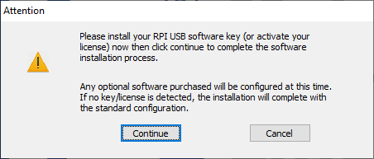

When the supplied USB software dongle is connected, or your license has been activated, and then click ***Continue****,* the software will identify what additional purchased options are available. When applicable, an additional prompt may appear regarding the configuration of those options.

If there is no USB software dongle or license present when clicking the ***Continue*** button, the software will continue the installation with the standard, default configuration.

## Start the Software

**Note**: The installation automatically adds a **KIC** folder to the main Windows Start Menu.

|  |  |
| --- | --- |
| 1. Click the **Windows Start** button to locate the **RPI icon**.   **Note**: The icon may appear in the Start button’s list of frequently used applications or you can click the ***All Programs*** command to find it in the **KIC folder** that appears among the displayed folder/icon list. | Start button |

1. Click the icon. 

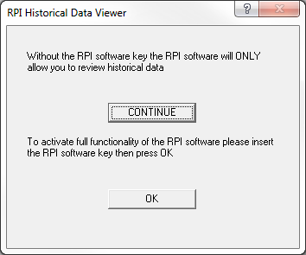

1. A specifically programmed USB dongle key is required to run the RPI software. When starting, if you see the above message, insert the key and click ***OK***.

The Product Tracking Initialization screen appears, prompting you to either enter the current belt speed for the oven, or choose to work in History mode.

**Note**: This screen will not appear if the RPI software is installed on an oven that has compatible oven controller software unless the communication between the two applications is not enabled.

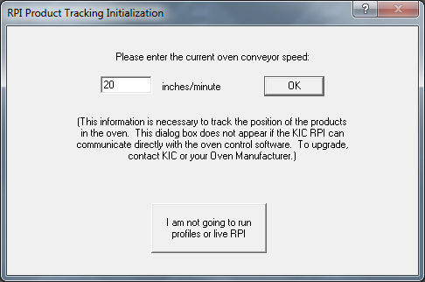

**Production Mode -**Choose this button to run profiles and Virtual Profiles.

**View History Mode-**

Choose this button to view Virtual Profile history, browse to a different hard drive or computer on the network.

Figure 2: Product Tracking Initialization

**Production mode -** If you wish to run profiles or Virtual Profile, enter the current belt speed for your oven and choose the ***OK*** button, this will activate Production mode. You can view historical data while in Production mode, but not while a Virtual Profile is running.

To view historical Virtual Profile data from the same PC while Virtual Profiling live, launch a separate KIC Host.exe file located in: C:\RPI\AppforViewer\KICHost.exe. This will open a separate Profile Explorer that lets you browse through the history of any product including the one currently running VP. Historical data will be available for any boards that have already exited the oven.

**View History mode** - If you wish to work offline and do not plan to profile or Virtual Profile, choose ***I am not going to run profiles or live RPI***button, this will activate History mode. While History mode is active, you cannot run profiles or Virtual Profile, as the software will not communicate with the RPI hardware. The RPI software will not even check for KIC hardware unless Production mode is active. If working in History mode you can browse to any working directory in Profile Explorer, even over a network.

# The Main Screen

The main RPI screen has six buttons. The buttons on the left are for setup and status; the buttons on the right are for running and viewing profiles and exiting the software. Placing the mouse pointer over each button will display a description for each button. See Figure 3.

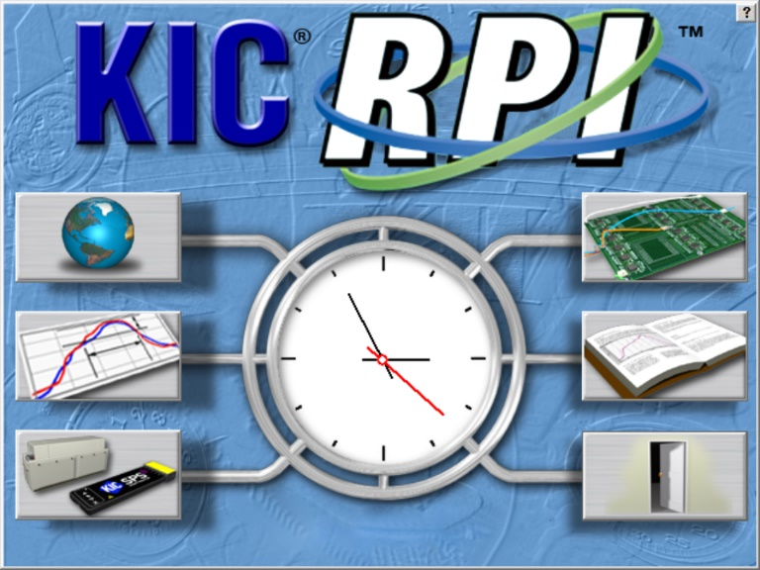

**Status**

**Exit**

**Run**

**Setup**

**View**

Figure 3: RPI Main Screen

|  |  |  |
| --- | --- | --- |
| **bt-NAV_Prefs Global Preferences**  Set units of measure, Maximum product start temperature, Oven name, Password. Board sensor, Cpk and Optional equipment setup.  **bt-NAV_Process-menu Define/Edit Process Window**  Create or edit Process Window files for solder paste and profile specifications.  **bt-NAV_HW-status-X5-9ch Hardware Status**  Shows the status of the oven controller (if applicable), *e*TPU Inputs, the profiler status, and operating software components. |  | **bt-NAV_Run-profile Run a Profile**  Begins the step-by-step procedure for running a product profile.  **bt-NAV_Log-book Profile Explorer**  Filing system used to manage and view all profiles and Virtual Profiles run using the RPI software.  **bt-NAV_Exit Exit**  Exits the RPI software. |

# Global Preferences



## Global Tab

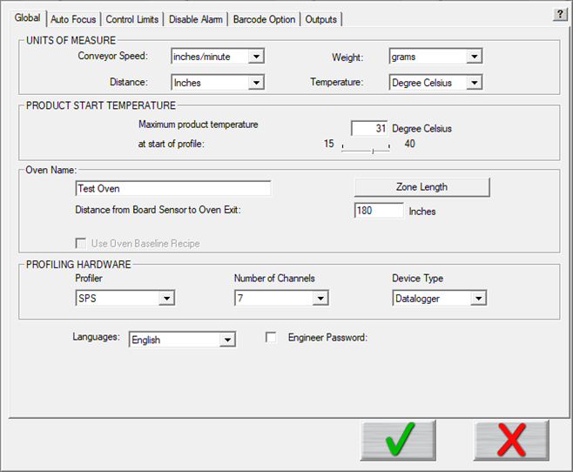

Figure 4: Preferences – Global Tab

* **Units of Measure** – There are four drop down menus to choose units for *Conveyor Speed, Distance, and Temperature.*  Auto Focus users enter the units for weight.
* **Product Start Temperature** – The software cannot accurately analyze a profile while a board is too hot. Before it can begin, the temperature of all thermocouples connected between the product and the profiler must be below the value you specify here with the slider bar. Profiling automatically starts when the Air TC temperature drops to less than 2° C above the product start temperature.
* **Oven Name –** Enter a name for your oven, and click the oven Zone Length button to enter the minimum and maximum zone temperatures, and as needed, the length of the zones.
* **Profiling Hardware** – Specify the model of your profiler, the number of channels (7, 9, or 12), and, if using the SPS Smart Profiler, X5, or the K2, specify the data transmission mode (Datalogger or Transmitter).
* **Languages –** Select the language (English, Spanish, German, Traditional Chinese, Simplified Chinese, or Japanese) you prefer to see displayed in the software. A restart of software is required after change of language.
* **Engineer Password** – By checking this and entering a password you can control access to certain menus in the software. See the [Password Protection](#_Password_Protection) section of this manual for details.

## Define Your Oven

|  |  |
| --- | --- |
| 1. On the **Global Preferences** screen ***Global*** tab, type a new, unique name in the *Oven Name* field. |  |
| 1. Click the ***Zone Length*** button. |
| The Verify the Length of Each Zone and the Minimum and Maximum Setpoint Temperatures screen (Figure 5) appears. | Figure 5: Run a Profile screen | |
| 1. In the *Number of Zones* field, type in the quantity for the oven.   **Note**: For best results only define and enter heated zones. |
| The screen populates with numbered zones and default length and temperature values.  Description: C:\Users\dklueck\Desktop\Autopopulate zonesTemps.png | | |
| 1. Change the default values as needed. 2. Click the ***green check*** button Description: \\RND\RND_Service\For DaveK\RPI\RPI Graphics\RPI Art File\bt-NAVint_Check.bmp to save the settings and return to the Global Preferences screen. | | |

## Auto-Focus Tab

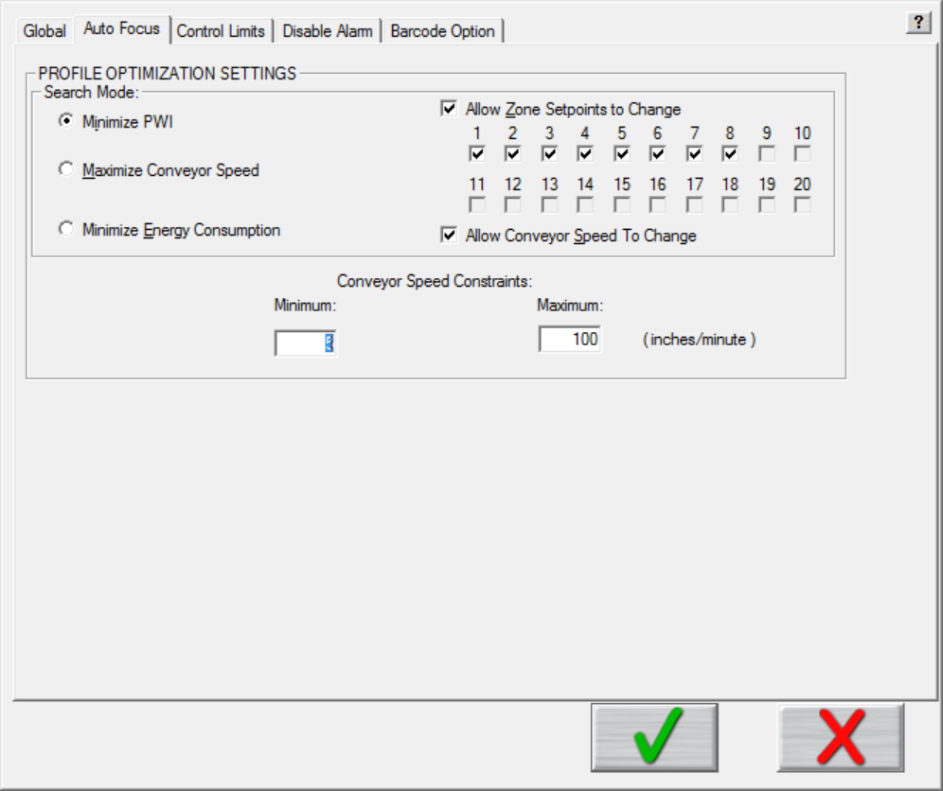

Figure 6: Preferences – Auto Focus Tab

### Profile Optimization Settings—Search Mode

* **Minimize PWI** – Search for the combination of setpoint temperatures and conveyor speed that will minimize the Process Window Index (PWI).
* **Maximize Conveyor Speed** – Search for the setpoint temperatures that will maximize conveyor speed.
* **Minimize Energy Consumption** –Using the Power feature; the software will search for the oven settings that will minimize the power consumption of the oven by finding setpoint solutions with slower conveyor speeds and lower temperature settings.
* **Allow Zone Setpoints to Change –** This option determines if Auto*-*Focus will include zone setpoint changes when predicting new solutions. It also allows you to exclude individual zones from suggested changes.
* **Allow Conveyor Speed to Change -** Choose whether to allow Auto-Focus to vary the conveyor speed. If you choose Allow to Vary you can set the minimum and maximum.

### Conveyor Speed Constraints

* **Minimum** – Select the minimum conveyor speed you would like Auto-Focus to recommend for profiling new products.
* **Maximum** – Select the maximum conveyor speed you would like Auto-Focus to recommend for profiling new products.

## Control Limits Tab

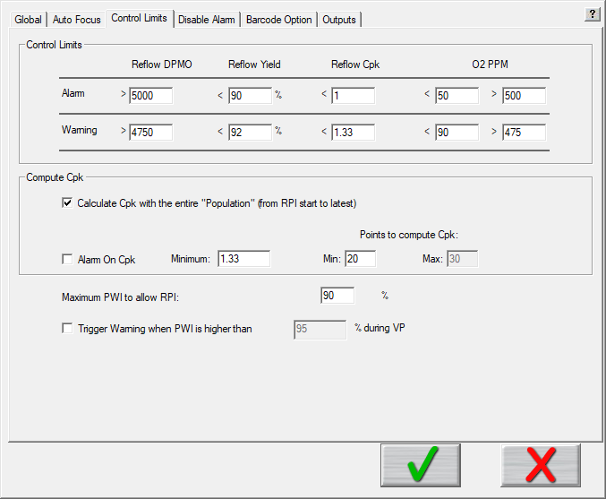

Figure 7: Preferences – KIC Control Limits Tab

Settings on the ***Control Limits*** tab let you set threshold values related to important process quality measurements that, when exceeded, trigger warnings and alarms. These values can monitor defect and yield capacities as well as statistical process control and capability index measurements.

**Statistical Process Control** (SPC) for the thermal process is critical for any manufacturing program that involves continuous quality monitoring and improvement. SPC provides the ability to understand the predictability of the process and to know in real-time when a process may be changing and affect product quality.

**Process Capability Index** (Cpk) gives a continuous indication of how current production is keeping within specifications and will indicate if the process is drifting towards a condition where defective product may be produced. It is a measure of where the process spread falls within the Process Window. By monitoring this and alarming when it becomes too low, you can proactively address issues in the process before a single defect occurs.

**Note**: Cpk is only calculated and displayed when Virtual Profiling is running:

### Set Control Limits

* **Reflow Defects Per Million Opportunities (DPMO) –** Specify the number of defects that indicate a quality control problem. Exceeding these limits generates a warning or an alarm.
* **Reflow Yield –** Specify a value (as a percentage of a given production run) representing the yield of boards that have fewer than five defects. Failing to achieve these percentage limits generates a warning or an alarm.
* **Reflow Cpk –** Specify aminimum tolerance value for the Process Capability Index measurement of output outside of specification.

**O2 PPM** – When the *O2 Live* option is purchased, allows you to specify a maximum tolerance value, which is measured by an external oxygen analyzer (user supplied). See [O2 Live (Optional)](#_O2_Live) for details.

### Specify Cpk Computation Values

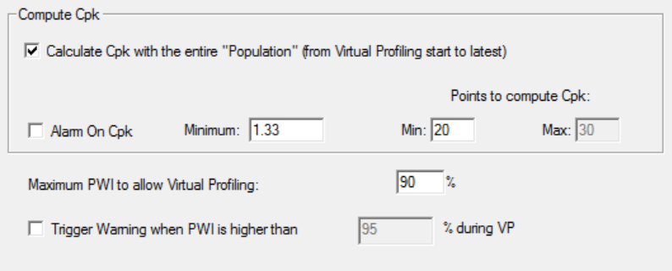

* **Calculate Cpk with the entire “Population” (from Virtual Profiling start to latest) –** When selected, the software will calculate Cpk across an entire production batch once the specified minimum points to compute Cpk has been exceeded.
* **Alarm on Cpk –** Enable or disable the Cpk alarm that can accompany the SPC charts that the software automatically displays when running Virtual Profiling. If the Cpk drops below the defined value, the software can activate an onscreen, or hardware alarm. (Default = 1.33.)
* **Minimum –** When Alarm on Cpk is enabled, this value determines the lower threshold for the Cpk alarm. If the Cpk value drops below this minimum, the software activates a software and/or hardware alarm. (Default = 1.33.)
* **Points to compute Cpk**
  + **Minimum –** Specify the minimum number of data points needed for the software to begin calculating Cpk.
  + **Maximum –** Enter the maximum number of data points to calculate Cpk. The Cpk value is calculated over a rolling window of data, only using up to the maximum data points at any given time.
* **Maximum PWI to enable Virtual Profiling –** This percentage value determines the maximum PWI allowable in order for any given profile to qualify as a Virtual Profile baseline. If the PWI for a profile is lower than this value, it can be used as a Virtual Profile baseline. By default this value is 90%. Profiles that exceed this value cannot be used as a Virtual Profile baseline.
* **Trigger Warning when PWI is higher than** – Enabling this feature allows you to display a Warning dialog box on the screen when the PWI exceeds the user defined PWI percentage.

### How the Software Calculates Cpk

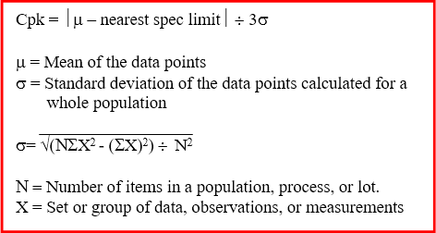

Figure 8: How RPI calculates Cpk

Values used for the spec limits and the data are translated in terms of the Process Window Index.

Here is a simple example. Let us set the Points to Compute Cpk to 5, and the five PWI values are as follows: 68%, 88%, 70%, 64%, and 65%.

Mean = (68 + 88 + 70 + 64 + 65) ¸ 5

= 71

StdDev = √ ((5 • (682 + 882 + 702 + 642 + 652)) – (68 + 88 + 70 + 64 + 65)2) ¸ 52

= √ (127945 – 126025) ¸ 25

= √ 76.8

= 8.76

By definition, the overall PWI is always positive and the limit is always 100%.

Cpk = ½71 – 100½ ¸ (3 • 8.76)

= 29 ¸ 26.29

= 1.10

So, while the worst PWI is 88%, the Cpk is 1.10 which is below the typical target minimum of 1.33. This tells us that the chance that the process drift out of spec is too high and this process should be improved.

Here is five more sample PWIs: 91%, 91%, 92%, 89%, and 90%.

Mean = 90.6.

StdDev = √ (205235 – 205209) ¸ 52

= 1.02

Cpk = ½90.6 – 100½¸ (3 • 1.02)

= 3.07

Even though every PWI in the second list is considerable higher/worse than the worst PWI in the first list, the Cpk is a very good 3.07. Such a high Cpk indicates that there is very little chance this process will drift out of spec. The reason the second process is better than the first is because the second process has very little variation in it.

## Disable Alarm Tab



Figure 9: Preferences – Disable Alarm Tab

By default, RPI software provides many on-screen notifications and alarm relay signals to help keep your process within spec and your production flowing. Selecting the ***Disable Alarm*** tab displays a matrix of options to let you *selectively disable* any alarm, warning, or relay signal *that does not suit your workflow*.



**Screen Alarm –** This column of features lets you specify if the alarms and warnings appear on your monitor.

**Alarm Relay -** This column lets you specify the conditions under which an eTPU signal energizes the alarm relay to let it power an audible or light indicator or to stop an infeed conveyor.

**NOTE:** For some alarms, if you disable a *Screen Alarm* selection, but leave the corresponding *Alarm Relay* selection active, you will have no way of acknowledging the alarm condition. This type of configuration is NOT recommended.

**Select All -**This toggle selects or deselects all of the options in the column once selected. Toggling ***Select All*** again resets the options to let you more easily choose individual items.

|  |  |
| --- | --- |
| A check box at the bottom of the screen lets you turn off the crystal ball graphic that provides a color-coded status during Virtual Profiling. |  |

## Barcode Tab

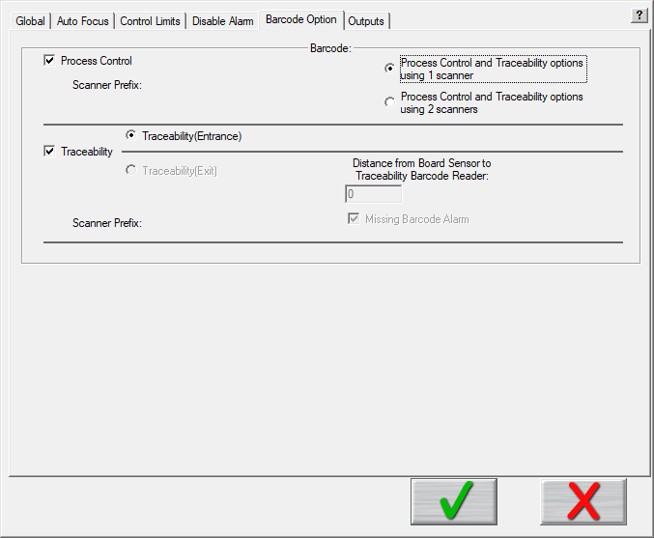

Figure 10: Preferences – Barcode Option Tab

**Process Control –** Enable or disable the *Process Contro*l barcode feature. The feature allows control of the process by comparing the barcode string of a product to the corresponding process currently running. It ensures that the product matches the process.

**Traceability -** Enable or disable the *Traceability* barcode feature. This feature links each product’s profile data with its barcode.

**Note:** When both *Process Control* and *Traceability* are selected, radio buttons appear that let you specify using one or two scanners, together with fields for entering identifying prefixes for the scanners. The feature enables the choice of applying traceability at the oven entrance or exit.

**Scanner Prefix** – Enter the predefined prefix number to identify each barcode scanner when using two scanners. The software uses this prefix to determine which scan goes to which feature—process control or traceability. The prefix is programmed using the barcode manufactures software program. Contact the barcode scanner manufacture for more information.

**Note:** The *Traceability (Exit)* feature, its associated settings, and functionality are no longer supported.

## Outputs Tab

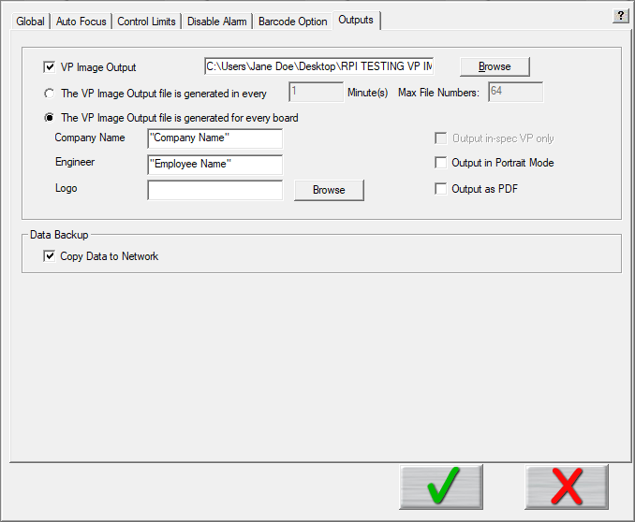

### Virtual Profile Image Output

The *Virtual Profile Image Output* generates a Virtual Profile image file while Virtual Profiling is running live. The image file is output in the form of a .jpg file type, with the naming structure of ProductName\_OvenName\_YYMMDD\_HH:MM:SS.JPG. If barcode feature is used, the product barcode string is included after the time stamp. The output file can be generated at user selected time intervals, or for each board processed.

* **VP Image Output –** To enable this feature select the check box and browse to a network location to store the Virtual Profile image files. There are two (2) different ways the images can be generated:
  + **The VP Image file generated every X minute(s) –** Selecting this option will generate the images based on time interval. Enter the time in minutes (1 – 2880) at which the software generates each image.
    - **Max File Numbers -** Enter the maximum number of files (64 – 512) to be stored in the destination folder. RPI automatically limits the number of files in this folder during live Virtual Profiling situations. When the maximum number of files is exceeded, new files automatically replace the oldest files.
  + **The VP Image file generated for every board –** Selecting this option will generate an image for each board. **Note:** When this selection is in use, the *Run a Verification Profile* and *View/Edit Process Window* buttons are unavailable. Additionally, when using this selection you can specify additional information that will appear on the image:
    - **Company Name**
    - **Engineer**
    - **Logo** (.bmp files only)

* + **Output in-spec VP Only** – This feature is only available when using the time output. It will NOT create output files if the Virtual Profile is in an out-of-spec condition at the specified interval.
  + **Output in Portrait Mode** – Default output is in Landscape mode.
  + **Output as PDF** – Generates a PDF file instead of a .jpg

#### Examples of Image Outputs

Example of VP Image file from time interval:

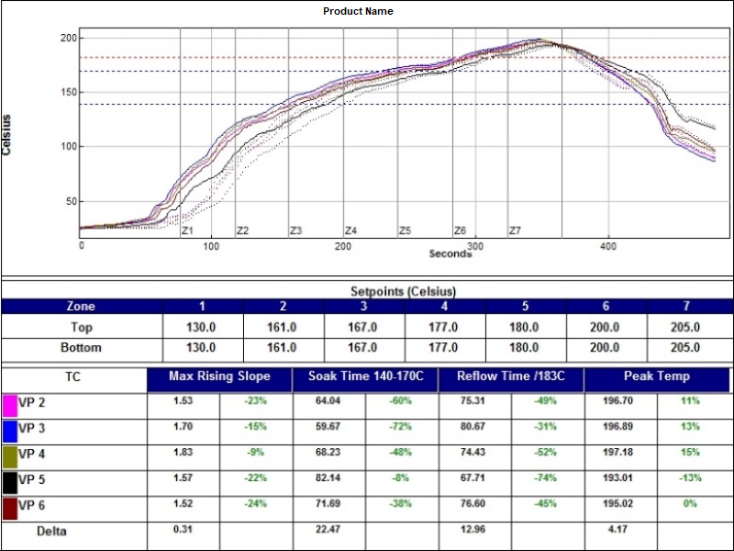

Example of VP Image file for every board:

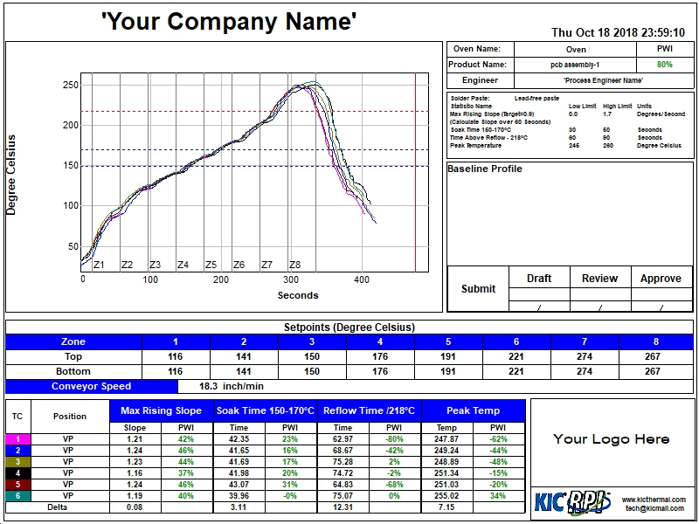

### Copy Data To The Network

The Copy to Network tool lets you store all your system files and data to a network location for backup or archival purposes. When you select the check box, the tool software launches, and an icon appears in the system tray area. Right click, and then choose *Settings* to configure the *CopyToNetwork* settings.



Figure 11: CopyToNetwork Software Tool Screen

Select the folders and/or data to be copied and then enter or browse to the network location. You must enter a valid network path. Click the *Save and Start* button to begin copying the selected files and folders to selected network location.

**Note:** The Baseline Profiles selection creates a separate folder of ONLY the current baseline profiles for your products. It does NOT save any other profiles that may be in your directory.

The software will prompt you to either, copy all the data now or save the settings without copying the data.



Figure 12: CopyToNetwork Message

**Yes** – The selected data is copied to the selected network location and the settings are saved.

**No** – The settings are saved, but no data is copied.

**Notes:**

* If the network location is not available, is an invalid path, or the network is disconnected, RPI temporarily writes the selected data to the C:\RPI\\_Data\_Backup\_ folder until the network path or connection has been reestablished.
* The CopyToNetwork tool launches automatically as long as the Copy to Network option is checked in the Global Preferences-Barcode tab.

Whenever any selected folder is updated with new/modified information, the new information is automatically backed up to the network location without any further user interaction.

# Process Window Setup

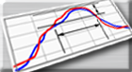

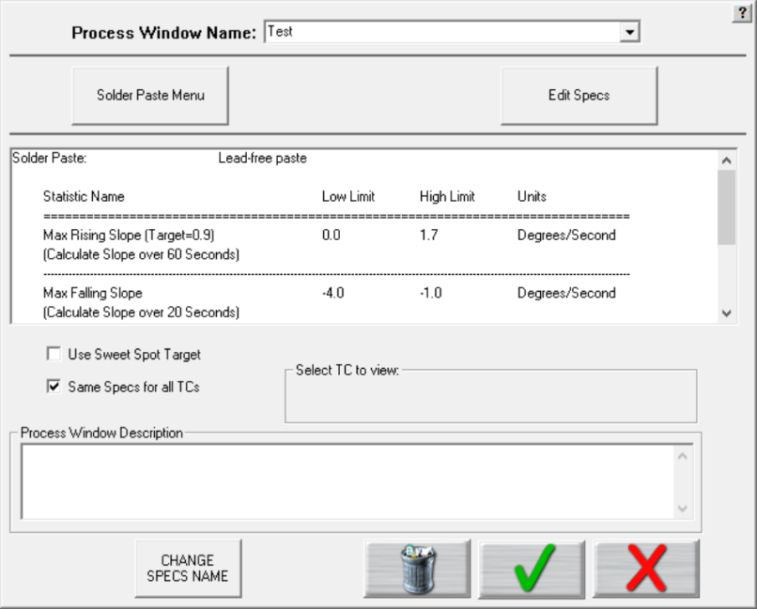

Deselect this check box to assign separate specs for each thermocouple used. See details below.

Figure 13: Process Window Setup

**Process Window Name** – Name of the Process Window file that includes the statistics chosen and limits for those statistics, along with whatever text appears in the Description field.

**Solder Paste Menu** – A read only library list of numerous solder pastes along with the statistics and limits suggested by the paste mfg.; also included is a user-defined option in the list which allows you to create a spec. of your own. See below for additional details.

**Edit Specs** – Screen allowing you to edit or choose statistics and limits for a chosen solder paste or define your own specs.

**Read only text box** – Shows the paste name, statistics name, and limits for a Process Window chosen, edited, or saved by you. To edit select the *Edit Specs* button.

**Same specs for all TCs** – By deselecting this checkbox, you can assign separate specifications for each individual thermocouple you are using. This option would be used if you had component specific specifications that differ from the general solder paste specs. Another use for this would be if you wanted to monitor the actual board temperature as well as component temps. You would then only select the statistics for that TC that are relevant. If you wish to use the same specifications for all thermocouples, put a check mark in the box.

**Select TC to view** – This dialog box will appear only if the *Same Specs for all TCs* checkbox is deselected. By clicking on the dropdown menu, you can view the specifications that have been defined for that number thermocouple. If a description was included, it appears next to Label.

**Process Window Description** – Field allowing for freehand notes for a particular Process Window.

**Change Specs Name** – Opens an external application allowing you to customize the name of any individual statistic. (See below for additional details)

**Use Sweet Spot Target** - When the *Sweet Spot Target* option is purchased, enabling it allows you to manually define the target (0 % PWI) for each statistic. (See below for additional details)

## Solder Paste Menu



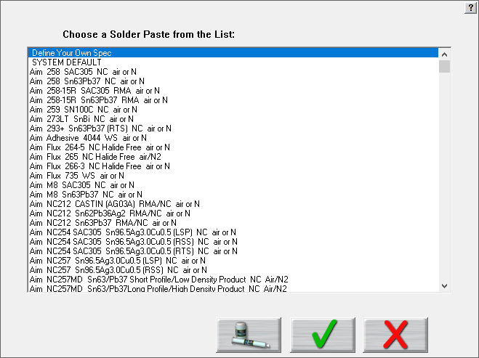

Figure 14: Solder Paste Menu

**Solder Paste Menu** - Once you have clicked on the***Solder Paste Menu*** button you will have a list of pastes to choose from. Use the scroll bar on the right to find your paste, and then click on the paste in the list.

* Clicking the **green check** will accept that paste and load its specs. The software first presents disclaimer information. When you click the green check, a new screen presents an opportunity to fine-tune the solder paste specifications. When you click the green check on this screen, you return to the Process Window Setup screen. Clicking the green check on this screen saves the named process and associated solder paste specs.
* Clicking the picture of the **paste jar and tube** will give you technical support information for the solder paste manufacturer that you chose.
* Clicking the **red X** will cancel your selection and return you to the Process Window screen without making any changes.

**Note**: Updates to the solder paste list occur on a regular basis. Check for updates at [www.kicthermal.com](http://www.kicthermal.com)

## Edit Specs



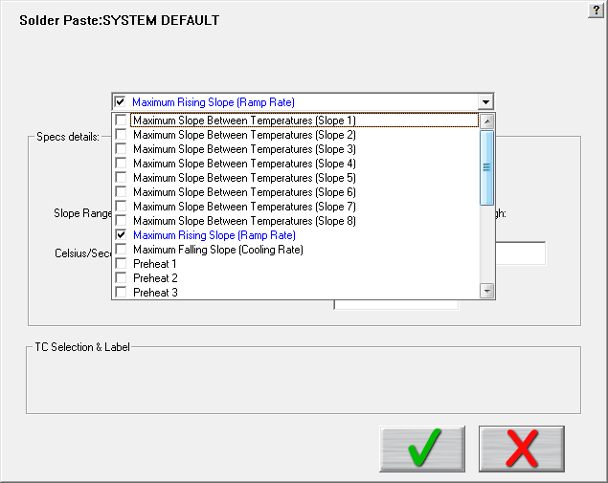

Figure 15: Process Window Edit Specs

Process Window name appears at the top of the screen.

There is a single drop-down list at the top that contains all of the available specifications that can be applied to your Process Window. These specifications are specific limits or a group of limits that define the overall Process Window for your product. These specifications include Slope, Preheat, Soak, Peak temperatures, and Time above temperatures.

**Spec Details** – The Spec Details coincide with the selected Specification. For each Specification selected, enter the Temperature, and Time limits (See Figure 16.). These limits are usually dictated by the solder paste used. The limits are used to measure the profile PWI.

**Caution**: Changes made within this screen will have a direct effect on the profile PWI value.

Once you have completed all spec modifications you can click on the **green check** (Save and Exit) button and your changes are applied. Clicking on the **red X** button will cancel your changes and exit.

## Specify Different Specs For Individual TCs

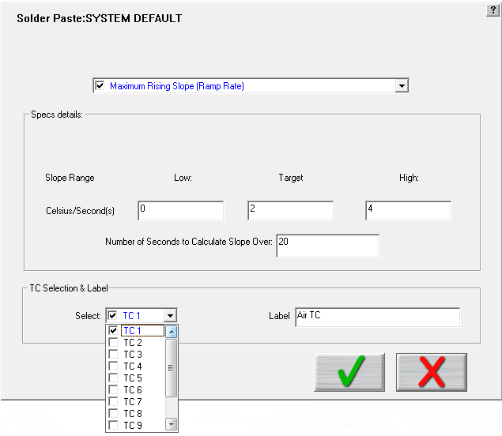

This Section is specific for *Separate Specs* for each TC

Figure 16: Edit Specs screen with TC Selection & Label panel displayed

### TC Selection & Label

If you have deselected the Same Specs for all TCs option on the Process Window Setup screen, when the Edit Specs screen appears, it will display an additional TC Selection & Label.

* **Select** – Use the select drop-down menu to select the TC whose specifications you wish to view/edit. The Spec Details for the selected TC appear.
* **Label –** This area lets you type in a description or label to identify that particular TC. If left blank, the TCs will simply be identified as TC2, TC3, etc.

**Note**: When using separate specs, the Edit Specs screen is the only place where you can select or deselect which TCs are used for a profile.

Once you have completed all edits of the specs you can click on the **green check** button and your changes are applied. Clicking on the **red X** (Cancel) button will cancel your changes and exit.

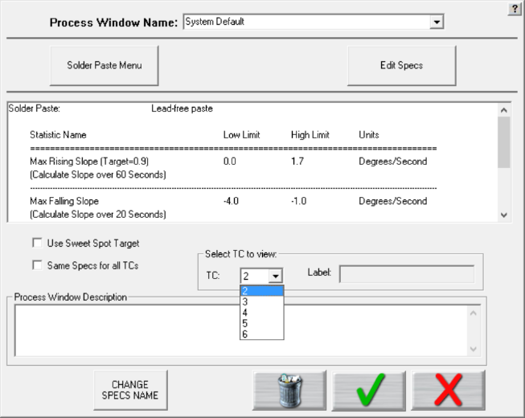

Figure 17: Process Window Select TC to View

**Select TC to View** – Drop-down menu containing the TCs that have already been defined. (Previous step).

## Use Sweet Spot Target (Optional)



Normally, when selecting a specification, only an upper and lower limit is defined, and the “target” value is automatically the center of the upper/lower limits. If you have purchased the *Sweet Spot Target* option, enabling this feature allows you to manually define your own Target value for each statistic. This function may be desired when there is a defined specification window, but the desired optimal value may not be the exact center of the limits.

## Change Specs Name





If you wish to rename the label for a particular statistic, start by clicking on the *Change Specs Name* button, which opens a separate window. Put a check mark in the checkbox at the top of the screen to enable the change function. Next, locate the desired specification in the greyed out columns, and type in the new name in the corresponding editable column. Click the ***Save***, then ***Exit*** to close the window and return to the Process Window screen.

## Save - Process Window

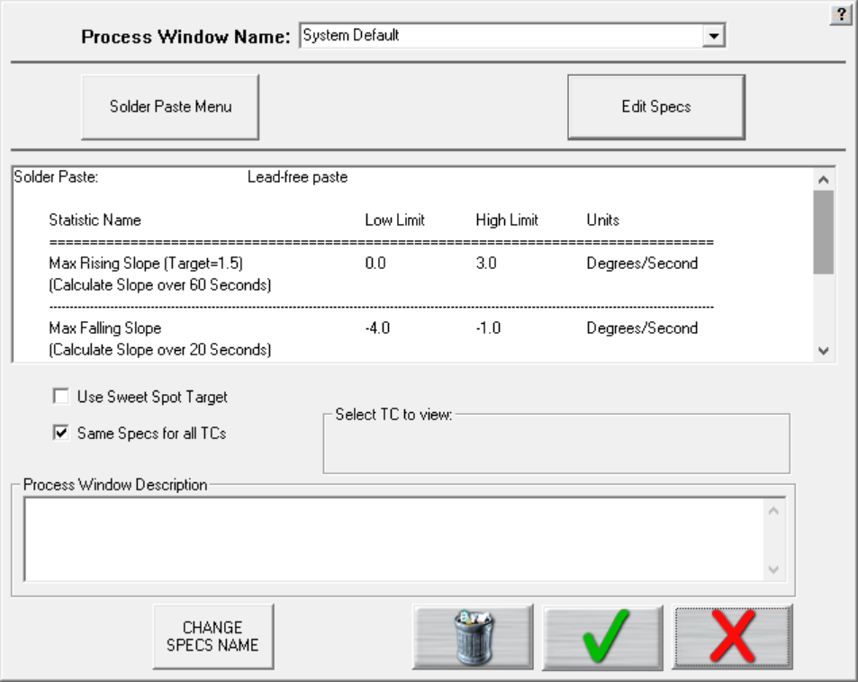

Figure 18: Save Process Window

**To create a Process Window, follow these steps:**

1. Choose a solder paste from the *Solder Paste Menu*.
2. Edit the specs if necessary.
3. Name the Process Window
4. Save the Process Window by clicking the **green** check (save and exit) button

A dialog box appears asking if you want to add this Process Window to your current list of Process Windows:

Clicking ***Yes*** will save it and exit to the main screen.

You can click ***No*** and then click the ***red X*** (cancel) button to exit without accepting or saving any changes.

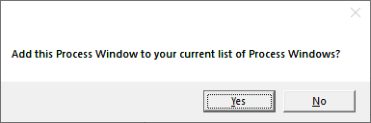

Figure 19: Add Process Window Prompt

## Import Legacy Process Windows

You can import process windows that you’ve created in KIC 2000 software into RPI and use them in your current production.

|  |  |
| --- | --- |
| 1. Open the KIC 2000 main product folder. | C:\Users\dklueck\Desktop\KIC 2000 folder.jpg |
| 1. Open the KIC 2000 **Process Specs** folder: | C:\Users\dklueck\Desktop\process specs folder.jpg |
| 1. Copy the files that you want to run in RPI. | C:\Users\dklueck\Desktop\KIC 2000 files selected.jpg |
| 1. Open the RPI main product folder and then open the RPI **Process Specs** folder. 2. Paste the copied KIC 2000 files into the folder. | C:\Users\dklueck\Desktop\RPI folder.jpg  C:\Users\dklueck\Desktop\RPI process specs copied files.jpg |
| 1. Run the RPI software. | C:\Users\dklueck\Desktop\RPI select Define-Edit Process Window.jpg |
| 1. On the RPI Main screen, click the **Define Edit/Process Window** button. |
| The Process Window Name screen appears, showing the copied files available for selection in RPI. | C:\Users\dklueck\Desktop\Process Window pull downShortened.jpg |

# Hardware Status

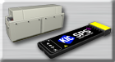

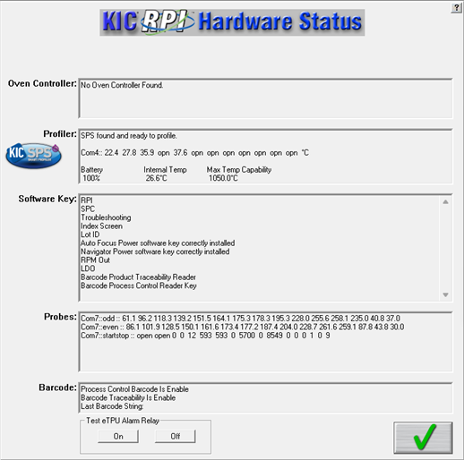

Figure 20: Hardware Status Screen

**Oven Controller –** When connected to an oven that is capable of communicating with the RPI software, the software will display oven status and display the oven control software name.

**Profiler –** Shows the status of the profiler. This box displays the following information:

* Profiler communication status.
* Temperature display – for all connected thermocouples.
* Battery information
* Internal Temperature – Temperature inside the profiler.
* Maximum Temperature Capability – This value determines the maximum temperature the profiler can read.

**Software key –** Displays all of the features currently programmed on the USB Dongle key.

**Probes –** The current live temperatures for the probes are displayed. A third line displays hardware information for the Board Sensor, and Conveyor Speed Encoder. If you do not see any data displayed in this field, the RPI software is not communicating properly with the eTPU hardware.

**Note:** If you are using the barcode capabilities, the last barcode read by the scanner also appears in the *Barcode* section, as well as your enabled barcode features.

**Test eTPU Alarm Relay** – Use this button to test the alarm relay function of the software. The alarm relay hardware must be properly connected. Use this button to manually disable the alarm, should it stay active after Virtual Profiling is not running. The button appears as long as the software is detecting the eTPU device.

**Note**: The alarm relay is not energized until VP is first running and then goes out of spec. To learn more about this see the alarm relay section.

# Run A Profile

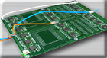

The *Run a Profile* button will guide you through a series of screens. Use the **Back** and **Next** arrow buttons at the bottom to move through the screens in the process, which will end with a completed and graphed profile. The **Cancel** button returns you to the main menu

**Note**: If you have already profiled your product using the RPI software, you can save time and go directly to the Profile Explorer, start a Virtual Profile, or load the most recent profile for your product, then use the RPI prediction capabilities to improve the profile PWI and generate new oven settings.

## Run a Profile Screens

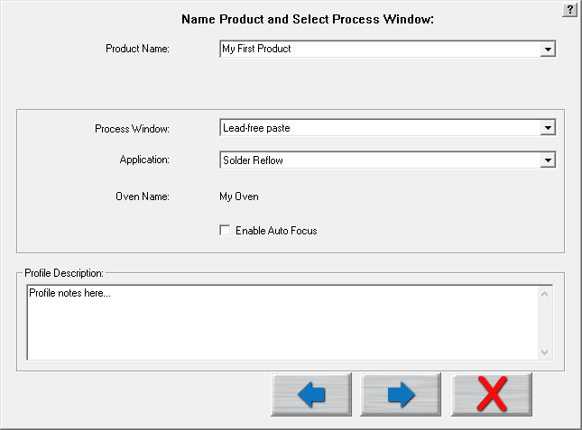

**Back**

**Next**

**Cancel**

Figure 21: Run a Profile Screen #1

**Product Name** – Enter a unique product name (long file names are acceptable) or choose an existing product name from the drop-down list.

**Process Window** – Choose a *Process Window* from the drop-down list. These Process Windows are created in the Define/Edit Process Window screen that is accessed from the main screen.

**Application** – Select your application type from the list. The software will function depending on the selected application type. Some variables that might change depending on the selected Application type are: *data-sample rate, profile temperature trigger values, and specific artwork*.

**Oven Name –** The oven file has information about the number of zones saved with it as well as other zone information. These details, as well as the oven name, are entered into the Global Preferences screen.

**Enable Auto Focus**: When the check box is selected it enables an autofocus tool to help with generating new recipes. (See below)

**Profile Description** – Allows for freehand typing of any notes you may want to include with this profile. These notes can be changed later from the Profile Explorer.

1. **Click the Next button.**

## Auto-Focus, Product Dimensions

If you enable the Auto-Focus software, the following screen appears:

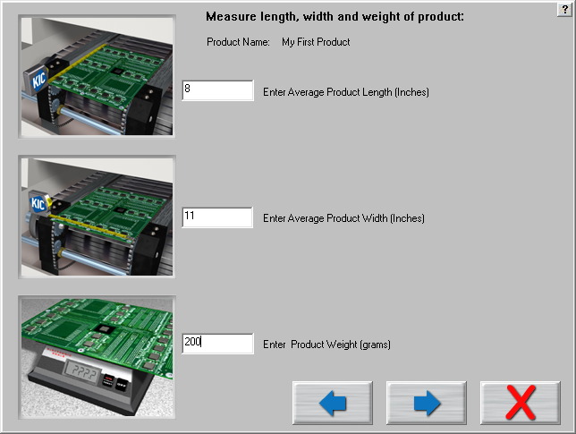

Figure 22: Run a Profile – Auto Focus screen #1

Use the fields to enter the length, width, and weight of your product. (Make sure to measure using the correct units of measurement)

1. **Click the Next button.**

This product is included in the Auto-Focus library from this point forward.

## Auto-Focus, Confirm

|  |  |
| --- | --- |
| The *Confirm* screen appears so that you may confirm the product measurements you entered. See Figure 23.  You have two choices:   1. *Use the current Oven Recipe* – use the most recent oven recipe setting for this product.   The next screen will display the most recent setpoints and conveyor speed for this product.   1. *Use Auto-Focus to find an in-spec Oven Recipe* – This will initiate the Auto-Focus software for this product. | Graphical user interface, application  Description automatically generated  Figure 23: Run a Profile – Auto Focus screen #2 |

|  |  |
| --- | --- |
| If the *Use Auto-Focus…* button is selected and no matching product is found, this dialog will appear. Click the **OK** button. See Figure 24.  You are returned to the Confirm screen. Select the *Use Current Oven Recipe* button and enter the oven setpoints and conveyor speed you want to start with. | Graphical user interface, text, application, email  Description automatically generated  Figure 24 |
| If the *Use Auto-Focus…* button is selected, but there are not enough products in the database to confidently give an expected PWI, this *Auto-Focus* dialog appears. See Figure 25.  **Yes:** the next dialog box shows the Auto-Focus first guess recipe in order for you to confirm.  **No:** you are returned to the Confirm screen. Select the *Use Current Oven Recipe* button and enter the oven setpoints and conveyor speed you want to start with. | Figure 25 |

|  |  |
| --- | --- |
| If the *Use Auto-Focus*… button is selected and there are a sufficient number of boards in the database, this *Auto-Focus* dialog appears. See Figure 26.  **Yes:** the next dialog box shows the Auto-Focus –First Guess recipe in order for you to confirm.  **No:** you are returned to the Confirm screen. Select the *Use Current Oven Recipe* button and enter the oven setpoints and conveyor speed you want to start with. | Figure 26 |

If you select **YES**, the following screen appears, prompting you to confirm the first guess recipe. See Figure 27.

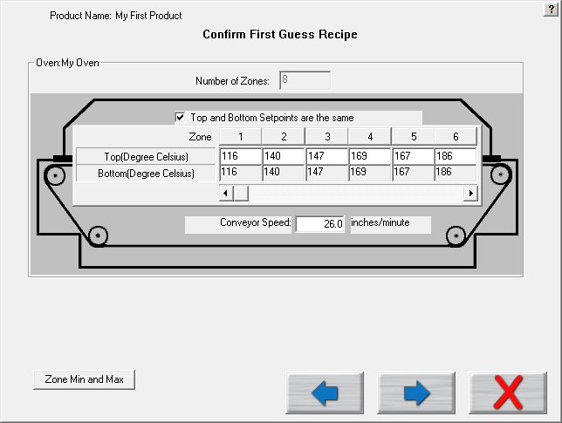

Figure 27: Run a Profile – Auto Focus screen #3

1. **Click the Next button.**

If there is no communication with the oven controller, the following dialog box appears. You must manually enter the recipe information on the oven. See Figure 28.

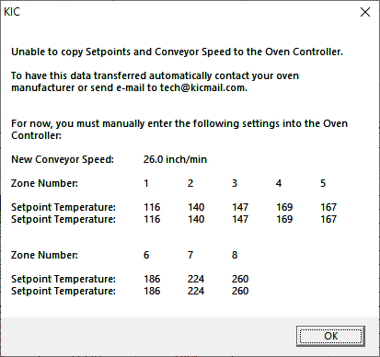

Figure 28: Run a Profile – Oven controller communication error

If there is communication with the oven, then the recipe is copied directly to the oven.

## Specify Oven Characteristics

To ensure accurate profile data, you may need to enter specific information into the software about the oven(s) you intend to use--information that changes the default values used by the software’spredictive algorithms. These default values are stored in an oven *initialization* file that the software creates when you first enter the name of a new oven. The software adds the extension .kiccfg to the name you entered and stores the file in this location:

C:\RPI\Ovens

Unless you specify otherwise, the software works with the following initialization file default assumptions:

* The zones are uniform and consecutive with no large gaps between them.
* The minimum temperature for all zones is 70° C.
* The maximum temperature for all zones is 350° C
* Default setpoint values start at 100° C and increases at 5° intervals at each zone.

These values are entered in the Global Preferences/Zone Length tab. You will likely need to set some values, such as the length of oven heating zones, and min/max temperature limits only once - when you first set up the oven. Others, such as temperature setpoints and conveyor speed values that make up an oven *recipe*, you may change frequently to match to new products.

### Specify An Oven Recipe

|  |  |  |
| --- | --- | --- |
| 1. In the *Enter Oven Setpoints and Conveyor Speed* screen (Figure 29), type in new temperature values for the top of the oven zones appears.   **Note**: This screen does not appear when theRPI softwareis communicating with an oven controller. | Description: C:\Users\dklueck\Desktop\Enter Oven Setpoints and Conveyor Speed1.png  Figure 29: Run a Profile screen | |
| 1. If the bottom of the zones are to have different setpoint values than the top, deselect the **Top and Bottom Setpoint are the same** checkbox.   The bottom row of fields becomes editable (white). | Description: Description: C:\Users\dklueck\Desktop\New oven setup art\Top and bottom zones.png | |
| 1. Enter new temperature values in the bottom row fields. 2. Type in a value in the **Conveyor Speed** field.   Description: Description: C:\Users\dklueck\Desktop\New oven setup art\conveyor speed field.png | | |
| 1. Click the next button to advance to the thermocouple attachment phase of running a profile. | | |
|  | |  |

## Attach Thermocouples

Thermocouples (TCs), attached to solder joints or other important sites on the board, directly measure the temperature at the point that the TC bead is in contact with the PCB. The TC measurements are collected by the profiler and the KIC software to create thermal profiles.

Two methods are typically used to attach TCs—*aluminum tape* and *high temperature solder*. Both methods are discussed below.

The system works with two kinds of TCs—*standard* TCs and the *Air TC*. Standard TCs record the temperature data for various sites on the board. The air TC gets specific positioning because its temperature *triggers the start of the profile* data processing, aids with TC shifting, and improves the prediction capabilities of the software.

### Attach The Air TC

There are two important considerations regarding the Air TC:

|  |  |
| --- | --- |
| * It must be attached at the leading edge of the board, extending one inch (25 mm) in front of the leading edge of the board. * It MUST be plugged into **channel 1** on the profiler.  1. **Click the Next button.** |  |

### Attach Standard TCs

|  |  |
| --- | --- |
| Attach the standard TCs at selected sites on the board, and plug them into the remaining connectors on the profiler. Order is not important, unless you plan on labeling where each TC is attached.  When selecting a position for the standard TCs, you want to measure points on the product that represent the mass-range of the product. Select at least one position that is a high mass (large component) area of the board and at least one position that is a low mass (small component) area of the board. If you can develop an acceptable profile for the low and high mass areas of the board, you can process the other areas of the board within the same parameters.   1. **Click the Next button.** |  |

## Attach Thermocouples To Semiconductor Wafers

|  |  |
| --- | --- |
| Attach The Air TC  1. It must be attached at the leading edge of the wafer, extending one inch (25mm) in front of the leading edge of the wafer. 2. It MUST be plugged into **channel 1** on the profiler. |  |
| Attach Standard TCs Attach the standard TCs at selected sites on the wafer, and plug them into the remaining connectors on the profiler. Order is not important, unless you plan on labeling where each TC is attached. |  |

## Select Thermocouples



Figure 30: Run a Profile Screen #6 – Select TCs

**Include Thermocouple (TC) Labels (20 char. Max)** – Checking this will display a field below each TC that is selected. Up to 20 characters can be used to describe the placement or description of the TC.

**TC Check Boxes** – Place a check next to each TC channel that is going to be used for this profile. TC number 1 is always used for the AIR TC. You must use at least one other TC as well.

1. Turn on theprofiler*.*
2. Click on the green traffic light button to start the profile

**Live Reading** – When the KIC profiler is on and plugged directly to either the download cable for datalogging or the receiver/Base Station, you will see live temperature updates for the TCs plugged into the KIC profiler. The TC checkbox must be selected for each TC you are using in order to view the temperature readings.

**Battery Voltage** –Displays the live readings of the KIC profiler battery voltage. The software will recognize if your battery voltage is too low and will not allow you to start a profile until you have batteries with enough voltage to complete the profile.

**Profiler Internal Temperature** – Displays the internal temperature of the KIC profiler. If the temperature is too high to complete the profile and stay under the maximum rating for the unit, it will not allow you to start the profile. You must wait until the KIC profiler is cool enough. The software will let you know what temperature you will have to cool below.

**Board Length** – Enter the length of the board to be profiled. When using Auto-Focus, this value will automatically be filled in based on previous Board Length entry.

## Start the Profile

**Note**: Make sure your profiler is powered on and ready to operate.

Depending on the settings in the profiler and in the software, you may have to initialize the profiler. (The RPI software lets you know when this is necessary.) To initialize your profiler, connect the communication cable directly to the SPS, X5, or K2. Click **OK** when the software displays the message that the initialization was successful.

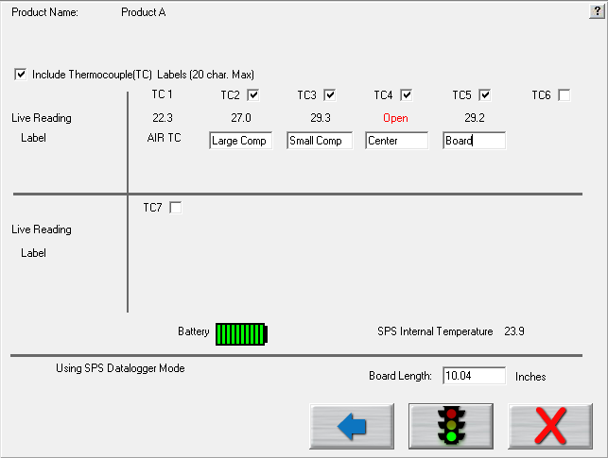

Select this button to start a profile.

1. Once the oven has stabilized and you are ready to load the profiler and profile board, click the start profile button (green traffic light).

|  |  |  |
| --- | --- | --- |
| The software will ask if all the oven control thermocouples are within 2 degrees of the setpoint temperature values. See Figure 31.  **Note**: This dialog box will not appear if the RPI software is communicating with the oven controller. The oven controller will send the oven control thermocouple data directly to the RPI software. | Graphical user interface, text, application, email  Description automatically generated  Figure 31 | |
| **If you answer yes**, the RPI software will display a prompt telling you that the next board to pass under the Board Sensor must be the board being profiled. If no Board Sensor is used, this screen is skipped. You acknowledge the prompt, by selecting **OK**. See Figure 32.  If the control thermocouples are NOT within 2 degrees of the setpoints, click **No**, then reference Appendix B. | Graphical user interface, text, application, email  Description automatically generated  Figure 32 |

|  |  |
| --- | --- |
| Next, the software will prompt you to put the profiler and profile board into the oven. Then choose the forward button. See Figure 33.  In order for the board sensor to properly calculate the length of the profile board, make sure the KIC profiler is at least 8” behind the profile board. For profiling and Virtual Profile Verification profiling, the software will ignore any boards including the KIC profiler that fall within 24” of the trailing edge of the profile board. | Figure 33: Run a Profile screen #7 – Insert Profiler/Product |

**IMPORTANT NOTE**: All profilers have a maximum operating temperature that, to avoid damage, should never be exceeded. See the product datasheet for temperature tolerance information:

|  |  |
| --- | --- |
| Profiler model | Maximum operating temperature |
| X5 | 85°C/185°F |
| K2 | 85°C/185°F |
| SPS Smart Profiler | 85°C/185°F |

### Trailing Wire Profiling

You can also use the KIC profilers with elongated thermocouples or a thermocouple extension long enough to pass through the process. This is especially useful for low clearance processes or higher temperature processes that would normally cause the profiler to overheat during use.

If you have a data logger model and plan to keep the KIC profiler connected during the profile, ignore the message to unplug the download cable from the KIC profiler. At the end of the profile, be sure to leave the product TCs connected long enough to achieve the profile-stop trigger value, 110°C, otherwise the profile will not complete. Leave the product TCs connected until the download has completed and the software asks you to turn off the KIC profiler.

Using long thermocouples or thermocouple extensions will have an effect on the KIC profiler temperature accuracy. In order to compensate for the length of thermocouple or thermocouple extension wire, KIC suggests recalibrating the KIC profiler using the same length and gauge TC wires that are to be trailed through the oven or process.

If the KIC profiler remains connected to the communication cable while profiling, the live profile is plotted on the graph.

## Live Profile Graph

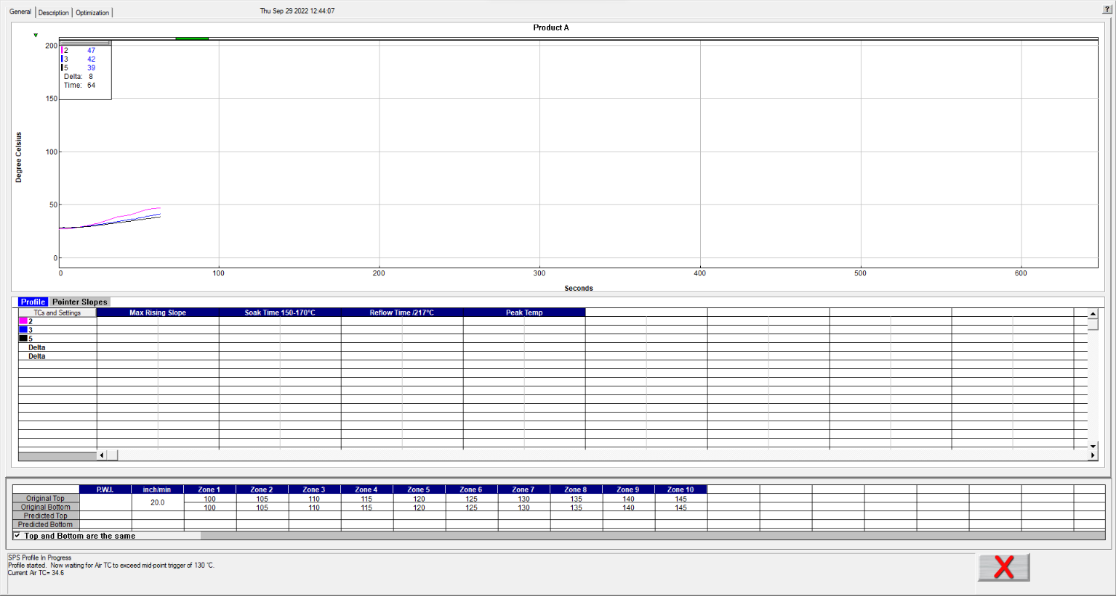

Live profile status

Oven temperature settings and conveyor speed.

Temperature plots

Live temperature readings and Delta

Profile Board

Figure 34: Live Profile Graph Display

The live profile graph screen shows the real-time plot of the product as it travels through the oven. See Figure 34. This will only appear for wireless models. During the live profile, all of the tabs on the screen are deactivated and are inaccessible to you. The only action that you can take at this point (besides waiting for the profile to complete) is to cancel the profile by clicking on the **red X** button. This will bring you back to the main menu.

The bottom area of the screen displays the status of the profile:

1. Waiting for the Air TC to exceed the start trigger temperature.
2. Profile started- Waiting for the Air TC to exceed the midpoint trigger temperature.
3. Profile will stop when all thermocouples drop below 110 Celsius.
4. Profiler currently retransmitting.
5. Profiler retransmission successful.

**During the live profile:**

(Wireless models only.)

* The live profile is plotted on the graph.
* The current temperatures for each thermocouple and the Delta between them are displayed in a small window in the upper-Left hand corner of the profile graph. The elapsed time is also displayed.
* The Board Tracking shows where the object being profiled is at in the oven.

### Profiler Temperature Triggers

RPI software uses temperature triggers for the profilers to determine when the profile begins, and when it ends. The use of temperature triggers makes it so that you do not have to worry about starting the profile at a specific point or time. Instead, the profile begins at the same temperature and ends at the same point each time you profile, making the profile data collection process consistent.

|  |  |  |  |  |  |  |  |
| --- | --- | --- | --- | --- | --- | --- | --- |
| **Solder Reflow** | |  | **Cure** | |  | **Semiconductor** | |
| Profile start | 33ºC/92ºF |  | Profile start | 33ºC/92ºF |  | Profile start | 33ºC/92ºF |
| Mid trigger | 130ºC/266ºF |  | Mid trigger | 100ºC/212ºF |  | Mid trigger | 130ºC/266ºF |
| Profile end | 110ºC/230ºF |  | Profile end | 80ºC/176ºF |  | Profile end | 110ºC/230ºF |

Table 1: Default temperature trigger values for various Application types

The default trigger values should be fine for most processes. The Profile start-trigger is determined by the Maximum Product Temperature at Start of Profile setting in the Global Preferences screen. The start trigger value is always 2ºC above this setting.

### Change The Profiler Temperature Trigger Settings

To change the profiler temperature trigger settings, close the software and then launch the configuration software tool.

**RPI configuration software tool location:**

C:\RPI\ConfigurationProgram.exe

In the *User Settings* tab enter the new temperature trigger settings for each application type; Reflow, Cure, Semiconductor then select the *Apply*, or *OK* button to implement the changes.

Note: The separation between the Midpoint and Stop Trigger temperatures must be at least 10ºC/18ºF.

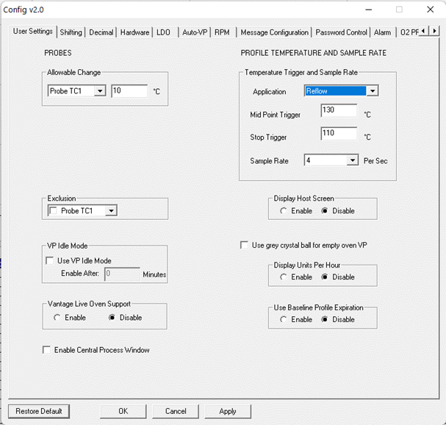

Figure 35: RPI configuration software tool, changing temperature triggers

## Profile Retransmission

**Note**: For users of profilers with wireless capability.

While the profiler transmits the live profile data to the computer running the RPI software, it simultaneously stores the profile data in its onboard memory.

Once the KIC profiler detects that all of the thermocouples have cooled below the profile-end trigger value, it will begin retransmitting the profile data. When retransmission begins, the KIC profiler will send the profile in data packets. The retransmission status appears at the bottom of the screen. See Figure 36.

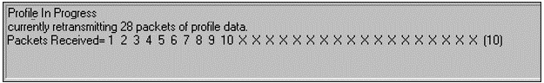

Figure 36: Wireless models profile retransmission

If you have a Data logger version, you must remove the KIC profiler from the oven and thermal shield and then connect the download cable to the KIC profiler. The profile data will automatically begin downloading to the RPI software.

**Caution**: The profiler and your product may be hot when exiting the oven. Use gloves when handling.

When all of the data packets have been received, the software will display a message asking you to turn the profiler off, click *OK*. **Failing to turn the profiler OFF will drain the battery.**

After the KIC profiler has completed its retransmission, the next message will ask if the thermocouples are still firmly attached to the board. Click *OK* and you are brought to the Graph screen, with the profile and statistics displayed for the current profile run. If any of the thermocouples used became unattached or has developed a loose connection to the board, select **NO**. If you choose **NO**, the profile CANNOT be used as a baseline profile for Virtual Profiling.

* If the Air thermocouple was more than 10C cooler than any other TC, you will get an error message. At this point you must check to see that the Air thermocouple is plugged into the first channel on the KIC profiler and that all the other thermocouples are firmly attached to the product. Then you will have to rerun the profile.
* If the message, *Waiting for the board to exit* appears, wait until a ‘*Turn off X5/K2’* message appears and follow any subsequent messages that may appear.

Next, the software will automatically analyze the profile data and presents the profile and statistics.

## View The Profile And Statistics

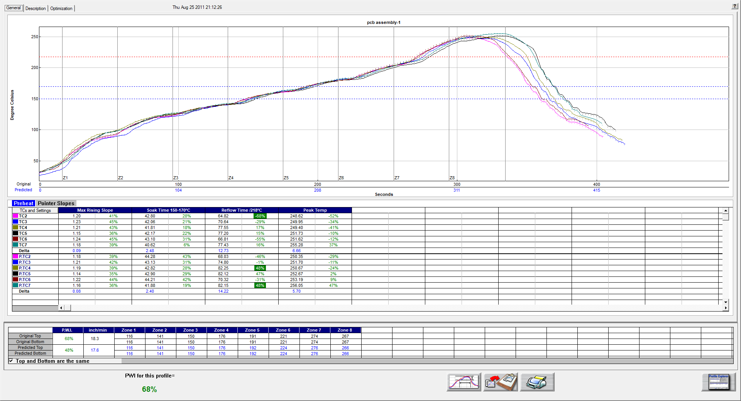

Figure 37: Profile General Tab – Shows graph, statistics, and recipe

### General Tab

The General tab shows the profile graph, profile statistics, current, and predicted recipes. To enlarge the graph portion of the General Tab, simply double click on the graph. To enlarge the statistics portion of this screen, double click on the statistics. See Figure 37.

**Note**: If you have run a profile that meets the Virtual Profile criteria, then the “Start Virtual Profiling” button will appear once the profile has completed. Click the Start Virtual Profiling button to start Virtual Profiling for this product.

### The Graph Controller

The *Graph Controller* allows you to modify the view of the profile graph. Opening the Graph Controller, left-click on the *TCs and Settings* button on the column header in the Statistics table alternatively left-click anywhere just outside the left side, or bottom of the profile graph.

**Auto scale –** The Auto Scale feature will automatically adjust the X and Y axis scales to fit all of the data in the profile graph. When the Auto Scale feature is disabled, you must manually input the minimum and maximum scale settings for the X and Y axis scales of the profile graph.

Figure 38: Graph Controller

**TCs**

The TCs section is a list of the thermocouples used for the profile. In the event that you wish to view the profile without a particular or multiple thermocouples, you can deselect individual thermocouples, or deselect the “All” check box, and choose only the thermocouples you wish to view. The software recalculates the PWI and updates the profile statistics based on the remaining thermocouples selected. You must select at least one product thermocouple.

**TCs Line Thickness** – The menu lets you select from five different thicknesses for the TC lines drawn on the graph.

**Grid –** Enables/disables the view of the X and Y axis scales.

**Reference lines –** These lines represent any temperatures referenced in the selected Process Window.

**Zone lines –** Enables the view for the oven zone lines on the profile graph.

**Predicted TCs only** - Removes the Original profile plot from view, displaying only the prediction profile plot on the graph.

**Zero decimal** – When viewing the Examine tool, this setting enables or disables the decimal display. When unchecked, the software will display one decimal point.

**Internal temp** – Enables the view of the profiler’s internal temperature profile plot on the graph.

**Display Detailed PWI** – With this unchecked, you will only see the “overall” PWI for the profile. It will not display the individual TC PWI values.

**Extra Cooling Slope** – Enabling this feature displays multiple Cooling Slope measurements which are customizable by the user selecting the *Config* button.

**Floating O2 PPM display** – When the *O2 Live* option is purchased, you can enable/disable a window on the graph that shows the O2 measurement recorded during that profile.

**Slope Between/Time Between/Peak Between** – These selections control which calculations will be displayed in the *Pointer Slopes* tab of the Statistics table when pointers are added onto a profile graph (see below for additional details on pointers).

### Graph Option Menu

To view the graph option menu, right-click anywhere within the profile graph area.

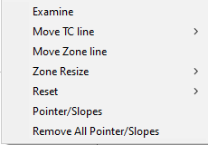

Figure 39: Graph Option Menu

#### Examine Line

The Examine line feature displays the temperature for the location of the pointer on the profile graph.

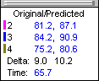

Figure 40: Graph Pointer

Wherever the pointer is moved across the profile, the following data appears:

* The first column is the actual temperature for each TC.
  + The second column is the temperature of the predicted profile data – based on setpoint or belt speed changes.
  + The Delta T for both actual and predicted TC data.
  + The time during the profile at which the pointer is placed

#### Move TC Line

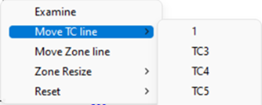

Figure 41

The Move TC line feature allows you to manually move the thermocouple plot on the profile graph. Moving the plot lets you fine-tune the profile or make corrections in the event the RPI software did not properly display the plot. See Figure 41.

Select the individual thermocouple you wish to move and then click and drag the highlighted plot and move it to the desired location on the profile graph. See Figure 42.



Figure 42: Move TC Line

#### Move Zone Line

The *Move Zone line* feature lets you manually move the zone separation lines on the profile graph. You can use this feature to fine-tune the profile or make corrections in the event the software did not properly display the zones.

#### Zone Resize

Select to move the first line (Zone beginning) or the Last line (Zone ending) (See Figure 43) and then click and drag it to the desired location on the profile graph. See Figure 44.

Figure 43: Zone Resize



Figure 44: Move Zone Line

#### Reset

|  |  |
| --- | --- |
| The Reset feature will reset the profile and undo any changes you have made to the graph using the Graph Option Menu. Select the TC Line, or Zone Line option. See Figure 45. | Figure 45: Reset |

The software will automatically calculate, and display in the statistical chart, the Delta for both the original and predicted profile data for all TCs for all Statistics. This is the range of the highest to the lowest value for any given specification. This information is strictly being displayed and is not factored in to the PWI value and is not used in the Navigator or Auto-focus calculations.

#### Pointer Slopes

The *Pointer/Slopes* selection allows you to place multiple pointers on the graph screen, manually move them to specific points of interest, and calculate various statistics at and between the pointers. Select *Remove All* to clear all the pointers from the graph. The *Pointer Slopes* tab in the statistics table shows all of the selected pointer calculations. To change which values are displayed, open the *Graph Controller* window.



To add pointers to the graph, choose the *Pointer/Slopes* selection from the menu then left click on the graph to place a pointer at a given location. Continue left clicking at other locations to add up to six (6) pointers.

To edit the location of a pointer, you can click and hold the blue arrow at the bottom of the pointer and drag to a specific location. If you want the pointer at a more exact location, you can right click on the blue arrow and the following menu will display:





The *Edit* feature will allow to specify an exact time location for each of the pointers. The *Remove* feature allows for removal of a single pointer.

### Profile Screen Buttons

There are four buttons at the bottom of the profile screen:

|  |  |
| --- | --- |
| bt-NAVint_Proc-menu | **View/Edit Process Window –** Choose this button to either view or edit the process specification(s) for the product used in this profile. |
| bt-NAVint_Copy2Clipbd | **Copy to Clipboard –** Choose this button to copy the profile data to the windows clipboard. You can then paste the data to a different application. |
| bt-NAVint_Print | **Print –** Choose this button to print a copy of the profile that is currently on your screen. |
| bt-NAVint_Check | **Green check button –** When finished viewing or analyzing the profile select this button to either run another profile with this product or return to the RPI main menu. You return to the Profile Explorer if the profile was opened from there. |

### Exit The Graph Screen

|  |  |
| --- | --- |
| Upon exiting the graph screen, a message asks you “Do you want to run a profile with this product?”  If you select **No**, you return to the RPI main screen or the Profile Explorer if the profile was originally opened from there. | Graphical user interface, application  Description automatically generated  Figure 46 |
| If you select **Yes**, you will need to choose from the Original, or Predicted recipe settings.  **Original –** The same recipe settings used when this profile was originally run.  **Predicted -** The recipe settings as predicted by Navigator, or a standard prediction that you manually input. | Graphical user interface, application  Description automatically generated  Figure 47 |

For both the original and predicted recipe settings, the software will automatically send the selected recipe information to the oven controller. If there is no communication between the RPI software and the oven controller, RPI displays a dialog box showing the recipe information. You must manually enter this recipe information in the oven control software.

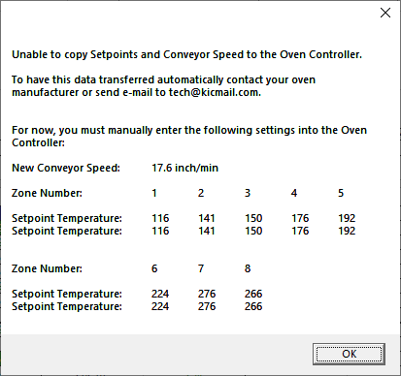

Figure 48

RPI software automatically applies the changes to the Run a Profile –Enter Setpoints screen. You will exit to theRun a Profile –Enter Setpoints screen. If you are running on the oven controller PC, and the oven is compatible with the RPI software the oven recipe will automatically be updated.

#### Save Changes to the Profile

|  |  |
| --- | --- |
| Any changes to the Description Notes or the Process Window can be saved with the profile. This will permanently update this profile with the changes. Changes to the Process Window saved here only save the changes with the profile. To save the changes to Process Window file see next dialog box. See Figure 49. | Graphical user interface, application  Description automatically generated  Figure 49 |

#### Save Changes to the Process Window

|  |  |
| --- | --- |
| If you have made changes to the Process Window from the Graph screen you can save these changes when you exit the graph screen. The Process Window will permanently have these changes whenever it is used to profile from this point forward. | Graphical user interface, application  Description automatically generated  Figure 50 |

The RPI software will take you to the Edit Process Window screen in order to save the changes that you have made.

The first dialog – “Do you want to run a profile with this product?” will appear each time you exit the graph screen. Click on **No** if you do not wish to profile.

You are sent back to the RPI main menu if you had just completed running a profile. If you opened the profile from the Profile Explorer, you are returned to the Profile Explorer. The other two dialogs will only appear if changes are made to the Description notes or Process Window.

### General Tab Buttons

|  |  |
| --- | --- |
| bt_Inspection_Start | **Start Virtual Profile –** If your profile meets Virtual Profile criteria, this button will appear. Choose this button to start Virtual Profiling using the displayed profile as a baseline. |
| bt-NAVint_Proc-menu | **View/Edit Process Window –** This lets you view the Process Window specifications and limits. |
| bt-NAVint_Copy2Clipbd | **Copy to Clipboard –** This button will copy the profile data to the clipboard for use with third-party software such as a spreadsheet application, or SPC software. |
| bt-NAVint_Print | **Print –** This button will print the current profile. For more information about printing, see the section titled [Profile Printing](#_Printing).  **Note**: If you wish to print a tab besides the General tab, pressing F9 on your keyboard will print the contents of any screen in the RPI software. |
| bt-NAVint_Check | **Green check button –** Select this button to run another profile or to exit. |

### Description Tab

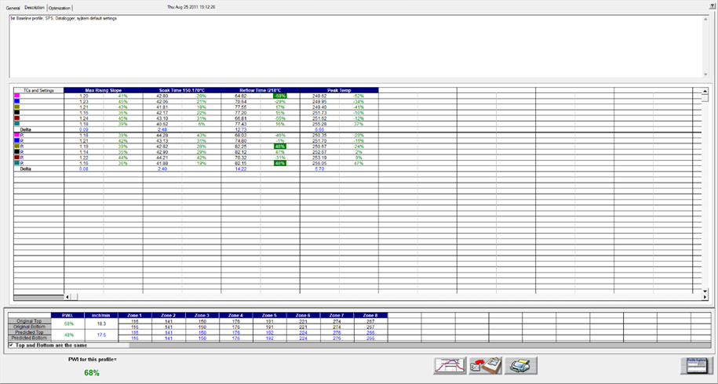

Figure 51: Profile Description Tab – Shows Description notes, statistics, and recipe

The Description tab shows the profile description notes, Profile Statistics, current and predicted recipes.

#### Description Tab Buttons

|  |  |
| --- | --- |
| bt-NAVint_Proc-menu | **View/Edit Process Window –** This lets you view the Process Window specifications and limits |
| bt-NAVint_Copy2Clipbd | **Copy to Clipboard –** This button will copy the profile data to the clipboard for use with third-party software such as a spreadsheet application, or SPC software. |
| bt-NAVint_Print | **Print –** This button will print the current profile. For more information about printing, see the section titled [Profile Printing](#_Profile_Printing).  **Note**: If you wish to print a tab besides the General tab, pressing F9 on your keyboard will print the contents of any screen in the RPI software. |
| bt-NAVint_Check | **Green check button –** Select this button to run another profile or to exit. |

## Profile Optimization With Navigator

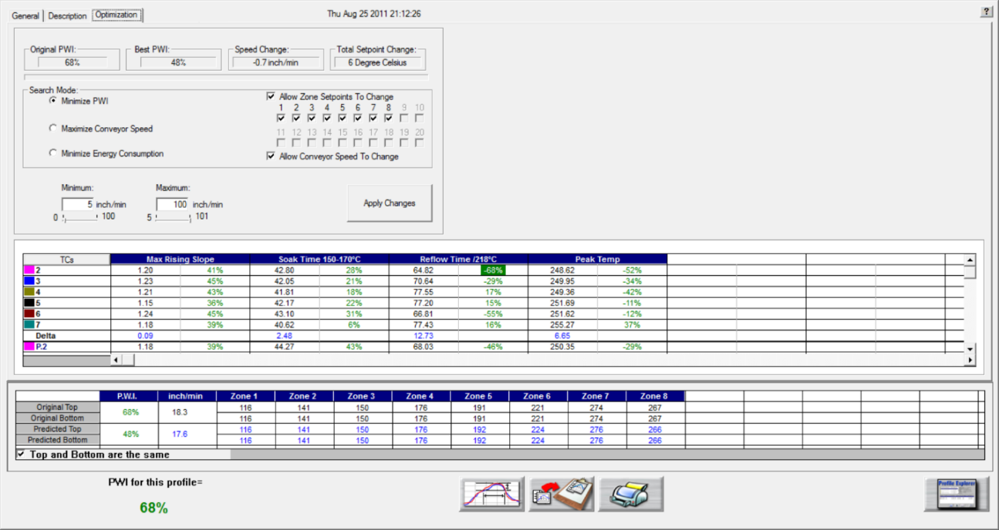

Figure 52: Profile Optimization Tab

The *Optimization* tab allows you to set the search parameters for Navigator. Thesoftware will search through millions of setpoint and conveyor speed combinations to find the optimal oven settings for each product. These optimization calculations are based on the selections you make on this tab. See Figure 52.

**Original PWI** – The Process Window Index for the original profile

**Best PWI** – The best Process Window Index that can be found based on the oven recipe optimization constraints selected.

**Speed change** – The total change to the conveyor speed for the best oven recipe found.

**Total setpoint change** – The sum of all setpoint changes for the best oven recipe found.

### Search Mode For Optimization

* **Minimize PWI** – Search for the combination of setpoint temperatures and conveyor speed that will minimize the Process Window Index.
* **Maximize conveyor speed** – Search for the setpoint temperatures that will maximize conveyor speed.
* **Minimize energy consumption** – Used by the Power software feature. The software search for the oven settings that will minimize the power consumption of the oven by finding oven setpoint solutions with slower conveyor speeds and lower temperature settings.
* **Allow zone setpoints to change** – This option will determine if Navigator will include zone setpoint changes when predicting new solutions. It also allows you to exclude individual zones from suggested changes.
* **Allow conveyor speed to change** – Choose whether to allow Navigator to vary the conveyor speed. If you choose this feature, you can set the minimum and maximum speeds.

### Conveyor Speed Constraints

As long as the *Allow Conveyor Speed to Change* feature is selected, these options are available.

**Minimum** – Select the minimum conveyor speed you would like Navigator to recommend for new products.

**Maximum** - Select the maximum conveyor speed you would like Navigator to recommend for new products.

## Manual Profile Prediction

The RPI software has automatic (Navigator), and manual prediction capabilities. Manual prediction gives you the flexibility to easily predict changes to the oven settings (temperature settings, conveyor speed), and view the results without having to spend the time actually running unnecessary profiles. This feature is very helpful to you, minimizing the time spent fine-tuning or developing a thermal profile.

### Make Changes

To predict changes to the oven settings, or modify the Navigator prediction results, click on the zone you wish to change. In the example below, zone 1 has been selected. See Figure 53.



Figure 53: Prediction Settings

Type the new temperature setting, and then press Enter.

The Navigator prediction tool will predict the results of that change, and then automatically update the PWI, predicted Statistics, and the profile graph. The new predicted results appear on the graph in a dotted-line format. This format lets you quickly determine the difference between the original and predicted profiles.

**Note**: When separate Top and Bottom setpoints are used, the Navigator prediction will maintain the same delta between the Top and Bottom setting that was used in the original profile.

## Set Different Top And Bottom Setpoint Temperatures

|  |  |
| --- | --- |
| The RPI software lets you enter different top and bottom setpoint temperatures prior to running a profile by unchecking “Top and Bottom Setpoints are the same”. See Figure 54.  Notice how the top of zone 8 is set to 267 and the bottom is set to 257. | Figure 54: Enter Oven Setpoints and Conveyor Speed |

Once the profile is downloaded, and the Navigator prediction is done, it will maintain the same differential in temperature between the top and bottom zone, as shown below in Zone 8:

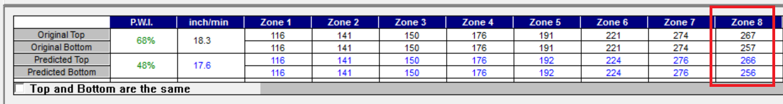

Figure 55: Same Differential in Temperature Between the Top and Bottom Zone

### Profile Graph Display



***Predicted*** profile plot (dotted lines)

***Original*** profile plot (solid lines)

Figure 56: Profile Graph Display

The PWI for the profile appears in the bottom-Left corner of this screen. See Figure 57. If the measured PWI is below 100%, the value appears in a green font. If the measured PWI is 100% or higher, the value appears with a red font. This enables you to easily identify whether the profile is in or out of spec.

 

A PWI under 100% is acceptable

A PWI above 100% is unacceptable

Figure 57: Profile PWI

### Exit The Graph Screen

|  |  |
| --- | --- |
| The following message appears whenever a profile is closed: “Do you want to run a profile with this product?” See .  If you select **No**, you return to the RPI main screen or the Profile Explorer if the profile was originally opened from there. | Graphical user interface, application  Description automatically generated  Figure 58 |
| If you select **Yes**, you will need to choose from the Original, or Predicted recipe settings. See .  **Original –** The same recipe settings used when this profile was originally run.  **Predicted -** The recipe settings as predicted by Navigator, or a standard prediction that you manually input. | Graphical user interface, application  Description automatically generated  Figure 59 |

For both the original and predicted recipe settings, the software will automatically send the selected recipe information to the oven controller. If there is no communication between the RPI software and the oven controller, RPI displays a dialog box showing the recipe information. You must manually enter this recipe information in the oven control software.



Figure 60: Oven Controller Communication Error

RPI software will automatically apply the changes to the Run a Profile –Enter Setpoints screen. You will exit to theRun a Profile–Enter Setpoints screen. If you are running on the oven controller PC, and the oven is compatible with the RPI software the oven recipe will automatically be updated.

The first dialog – “Do you want to run a profile with this product?” will appear each time you exit the graph screen. Click on **No** if you do not wish to profile.

You are sent back to the RPI main menu if you had just completed running a profile. If you opened the profile from the Profile Explorer, you are returned to the Profile Explorer. The other two dialogs will only appear if changes are made to the Description notes or Process Window.

#### Save Changes To The Profile

|  |  |
| --- | --- |
| Any changes to the Description Notes or the Process Window can be saved with the profile. See . This will permanently update this profile with the changes. Changes to the Process Window saved here only save the changes with the profile.  To save the changes to Process Window file, see next dialog box. | Graphical user interface, application  Description automatically generated  Figure 61 |

#### Save Changes To The Process Window

|  |  |
| --- | --- |
| If you have made changes to the Process Window from the Graph screen, you can save these changes when you exit the graph screen. The Process Window is updated and utilize these changes whenever it is selected for profiling from this point forward. | Graphical user interface, application  Description automatically generated  Figure 62 |

If you select “Yes” the RPI software will take you to the Edit Process Window screen to save the changes that you have made.

If your oven is capable of communicating with the RPI software, you will see different dialog boxes.

* If you answer yes, a dialog box will appear displaying the amount of time until the oven acknowledges the recipe change request. Select OK. See Figure 63.

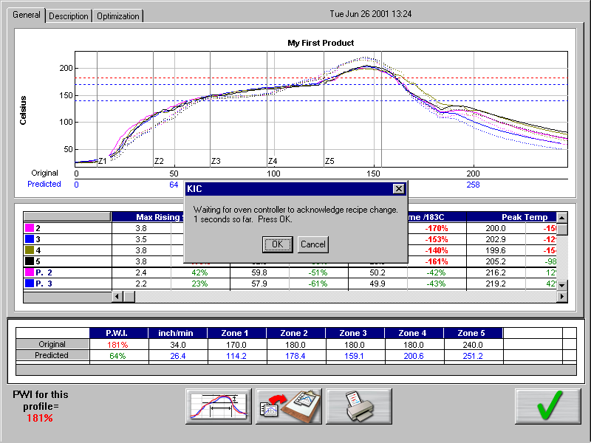

Figure 63: Oven controller acknowledge recipe change request

When the oven has received the new recipe information, a confirmation dialog box will appear. See Figure 64.



Figure 64: Oven Controller Recipe Change Confirmation

**Note**: Oven controller: If nothing happens within several seconds, check the oven controll software to make sure there are no error messages or errors that will cause the system to hang.

# Profile Explorer



The Profile Explorer is a powerful and simple data file management tool. For each unique product name you use when profiling, the software will create a folder with the same name. (See Figure 65.) The software saves all the profiles run using that product name in that folder.

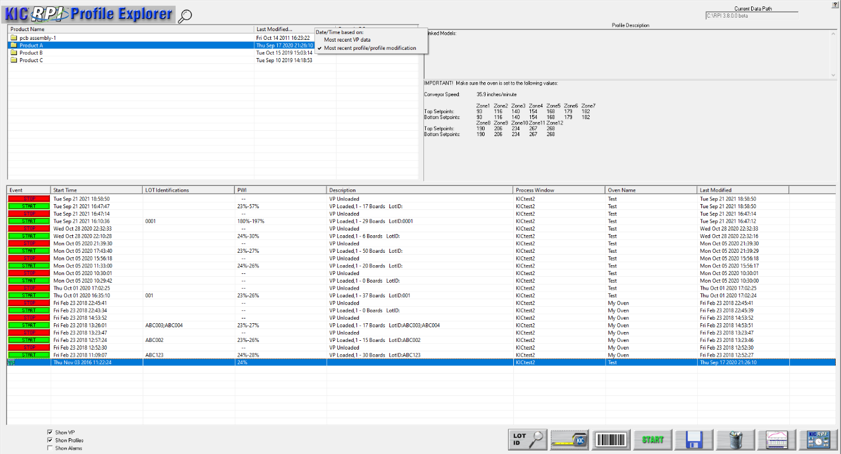

This field is only active when running in ***History*** mode.

Lot Identification Search

This button will only display when running in ***Production*** mode.

Lot Identification Column

Figure 65: Profile Explorer

The list of product folders is in the upper left of the Profile Explorer. Click on the magnification glass button at the top left to search for a product name.

* By default, the time/date listed in the *Last Modified* column will show the date/time of the last completed VP. Alternatively, you can select the time/date to be based only on baseline profiles by right-clicking on the *Last Modified* button and selecting *Most recent profile/profile modification*.
* **View a profile** - Click on a product folder to display the profiles that have previously been run for any product. Highlight the profile you wish to view and then select the Graph button at the bottom of the screen or double-click the profile to display it.

**Note**: Once the profile appears on screen, you can use the Control + Up Arrow to view the next profile, and Control + Down Arrow to display the previous profile.

* The profile section can be sorted by clicking on any of the column headers. Single clicking on a profile will display the Profile description in the upper right corner.
* Double-clicking the profile will display the graph and statistics for that profile. Clicking the “Display Graph…” button can also do this.

**Note**: If the profile is labeled as “Bad” or if, for any reason, the RPI software cannot display it, the profile is automatically copied to the Clipboard so that you can use a third-party app such as MS-Excel to view the data.

## Find VP Production Run Data By Lot ID Code

RPI software lets you search for Virtual Profile production runs based on the Lot ID code. If you do not know the complete code, you can use the asterisk symbol (\*) as a wildcard to begin searching with a partial code.

1. On the Profile Explorer screen, click on the **Lot ID** button. 

The *Lot ID* search screen appears:

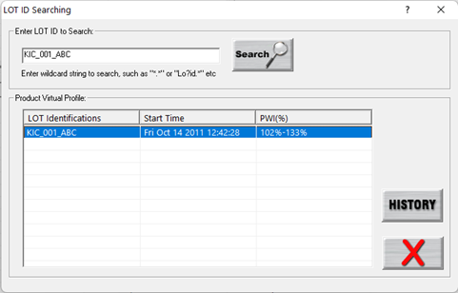

1. In the Lot ID search screen, type the code (Case Sensitive) in the **Enter LOT ID to Search** field.
2. Click on the **Search** button.

Matching VP production runs appear listed in the table.

1. Mouse over the row in the table to display pertinent data from the production run in a tooltip popup window:

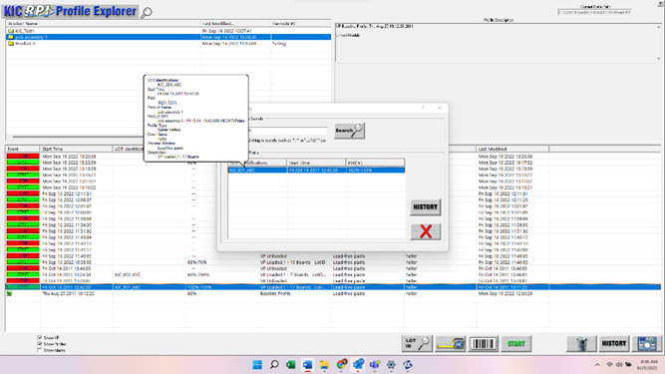

1. Highlight the row and click on the **History** button to display the virtual profile historical data.

## Browse For Historical Data

The current data path for the data viewed in the Profile Explorer appears in the upper-right corner. This is grayed out if running in production mode. It is active, if you clicked on the, I am not going to Profile or Virtual Profile button (enabling History mode), when first launching the RPI software.

**The data path can be changed but must be done through the** \RPI\Log\KIC2000DataPath.kiccfg file.

To view historical Virtual Profile data from the same PC while Virtual Profiling is live, you launch a separate KIC Host.exe file located: C:\RPI\AppForViewerforViewer\KICHost.exe. This will open a separate Profile Explorer that lets you browse through the history of any product including the one currently running VP. Historical data is available for any boards that have already exited the oven.

**Note**: This feature was designed to allow you to view RPI historical data stored in a different directory on the same computer or on remote PC over a network.

## View Historical Data Over A Network (History Mode)

While in *History* mode you can view all collected data over a network from any PC with RPI software loaded.

|  |  |
| --- | --- |
| **Step 1** - From your remote PC, start the RPI software, and click on the “*I am not going to Profile or Virtual Profile*” button. See Figure 66.  **Step 2** - The software will open up normally. When the main screen appears, click the Profile Explorer button. | Figure 66: Product Tracking Initialization |

**Step 3 -** Now, a Browse button is enabled in the upper right-hand corner of the Profile Explorer screen. See Figure 67 below:

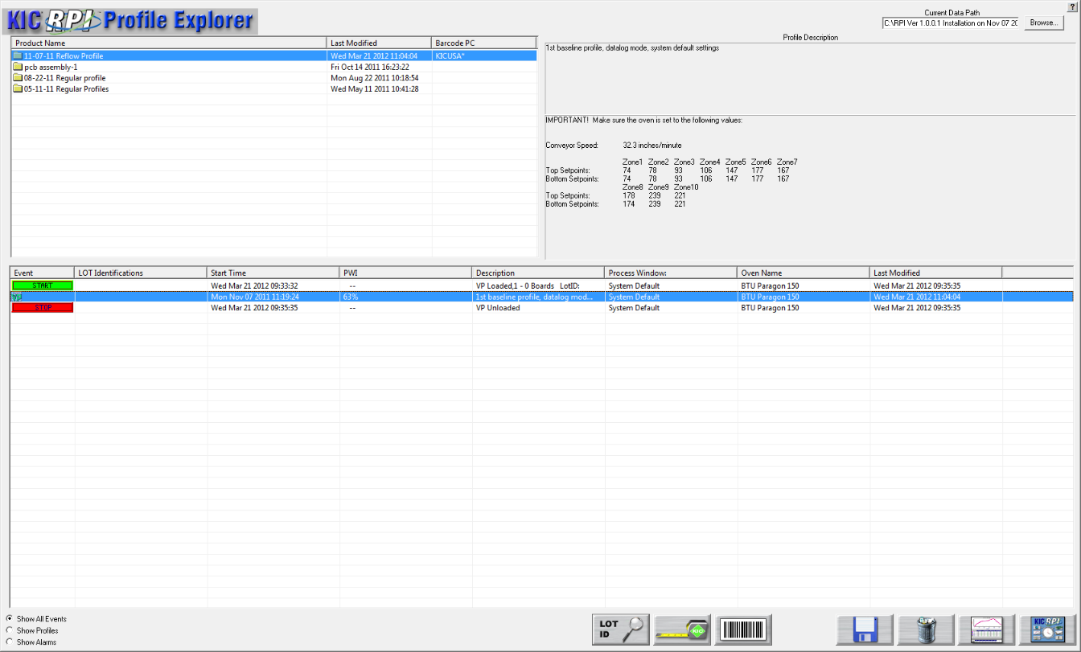

Figure 67: Profile Explorer – Browse Data Path

You can click the Browse button and point to the root directory where your profiles are stored. Keep in mind that you want to direct it to the root directory of the main “Profiles” folder.

For example: if the profiles are stored in a directory named ***F:\RPI\Profiles\Board A****,* you would direct it only to the ***F:\RPI\*** folder.

## Profile Explorer Buttons

|  |  |
| --- | --- |
| bt-NAV_measure | **Product Dimensions –** Gives you an opportunity to enter product dimensions for products that have already been profiled. Once product dimensions have been entered, the Auto Focus library is updated. This increases the likelihood of in spec profiles and decreases the number of profile passes. |
| b | **Process Traceability Barcode –** Click on the Barcode button. A dialog box pops up with a field to enter the barcode value with a Search button next to it. Below this is a field that will list the time, date, and PWI for that barcode if it exists for the chosen product. Either double-click the particular listing or highlight it and click on the View Selected Profile button. |
| bt_Inspection_Start | **Start Virtual Profiling –** Click this button to start Virtual Profiling. The RPI software will always use the latest qualifying profile as the baseline profile needed to start Virtual Profiling. |
| b | **Save Selected Profile –** Click this button to save an event or profile to the location of your choice, either hard disk, network drive, or floppy disk. |
| b | **Delete –** Click this button to delete an event or profile. |
| b  b | **Display the Graph and Statistics for this profile –** Click this button to display the graph and statistics for the selected profile. If you have an event other than a profile, the Display Graph and Statistics button will change to a Charts button. |
|  | **Lot ID history search –** Click on this button to search for a VP production run based on the Lot ID. |
| bt_Profile_Group | **Profile Grouping utility –** When Profile Grouping is enabled, you can click this button to link different product models with defined baseline profiles that can run in VP. |
| graphic_104q | **Return to KIC Main Menu –** Click this button to return to the RPI main menu screen. |

### Profile Explorer Checkboxes

At the bottom-left of the Profile Explorer are checkboxes to select what information to display:



**Show VP –** Display all VP Start and Stop events for the selected product.

**Show Profiles –** Display the Profiles for the selected product.

**Show Alarms –** Display the Alarm state changes for the selected product.

**Note**: Double click any event to view the details including alarm event history. If two alarm/alert acknowledgements appear at the same time, only one will appear in Profile Explorer.

## Profile Explorer – Virtual Profiling

The profile that meets Virtual Profiling criteria will be displayed with a green VP  overlaying the standard profile icon.

The software will always use the most recent qualifying profile as the Virtual Profile -Baseline profile.

### View Virtual Profile Data

1. Select your product folder from the upper left- corner of the Profile Explorer.

This will display the profiles and events for that product.

1. Choose a Virtual Profile event.

### Profile Explorer Event Icons

#### Profile Icons

 **Profile –** This icon appears for any valid profile that does not fit Virtual Profile criteria.

 **Virtual Profile Capable –** This icon appears for the most recent Virtual Profile capable profile.

### Virtual Profile Event Icons

The RPI Profile Explorer will display an event icon for any event that occurs while Virtual Profiling is running and only when Virtual Profiling is running. These events include:

 **VP Start –** This icon appears when Virtual profiling is enabled.

 **VP Stop –** This icon appears when Virtual Profiliing is disabled.

#### Alarm Icons

 **In Spec. – Alarm state change –** This icon appears when the Virtual Profiling alarm state changes back to Ready. There are three ocassions when this icon may appear:

* Back into Spec
* Back into Control
* Process Temperatures Back to Normal

 **Warning – Alarm state change –** This icon appears when the Virtual Profile alarm state changes to Warning. There are three ocassions when this icon may appear:

* Cpk Warning
* Significant Process Temperature Variation
* Process Is Likely to Go Out of Spec Soon.

 **Out of Spec. – Alarm state change –** This icon appears when the Virtual Profile alarm state changes to Out of Spec. There are nine ocassions when this icon may appear:

* Process temperatures are Out of Spec
* Product length is different from the Virtual Profiling baseline profile
* Missing barcode (Process Traceability only)
* The number of barcodes that have not been read. (Process Traceability only)
* Encoder stopped, or changed signifigantly.
* Oven recipe no longer In-Spec
* eTPU lost communication

 **Warning Acknowledged –** This icon appears once the operator acknowledges the Warning alarm state change.

 **Alarm Acknowledged –** This icon appears once the operator acknowledges the Out of Spec. alarm state change. Not all alarms require acknowledgement.

#### Communications Icons

 e**TPU Communication Error –** This icon appears if the software loses communication with the eTPU.

 e**TPU Communication Restored –** This icon appears when the software re-gains communication with the eTPU.

 **Process Traceability** **Barcode failure –** This icon appears if the software detects a board in the oven but does not read the barcode for that product.

## History Data Files

As the software process Virtual Profiles, it logs data files to a *Profiles* folder, that later can be analyzed. It automatically stores these *Event* and *VPdata* files associated with each specific product to a *History* folder.



## Insert Data Files From An Outside Source

If you receive RPI data files via disc or email, you can copy them to the **RPI\Profiles** folder in Windows Explorer. The next time you enter the Profile Explorer screen the software will automatically create folders for those profiles based on the profile name and put the profiles in the folders.

## Rename Profiles

In situations that require it, you have the ability to edit the profile name. This can be especially useful when products are very similar, but have different names. Once the profile has been optimized, it can be renamed and used as a baseline profile for similar products if the need arises. This eliminates the need to re-profile similar products unnecessarily.

**Note**: Renaming a profile includes the name that is embedded in the profile that shows up on the printout

1. Manually create a new folder in the C:\RPI\Profiles folder using the new product name.
2. Copy the desired profile into this new folder.
3. A folder with that new Product Name will appear in Profile Explorer.
4. When you open that profile, it will display in the software with the new Product Name

* The new profile name will appear on all the screens (Profile Explorer, General Tab, Charts Tab, and Troubleshooting Tab). The new name will also appear in the data that is copied to the Clipboard.
* None of the files on the PC are actually renamed, when viewing the profiles in Profile Explorer, they all look the same. However, profiles run after the name has been changed will use the new product name as part of their file names.

**Note**: Virtual Profiling is most accurate for products that have their own baseline profile.

# Virtual Profiling

Virtual Profiling (VP) is a means of reliably predicting the thermal profile *of every board in a production run* based on a comparison of real-time temperature and conveyor speed data against a *baseline* profile established by an earlier profiler run through the oven. For a given product, this baseline needs to represent an optimum oven recipe with a good PWI value and a quality soldering result.

During the profiler run, RPI software simultaneously collects temperature data from the board and from the probes installed in the oven at product level. The software calculates a mathematical correlation between these temperature readings and stores this data as part of the baseline profile.

Once the baseline is established, the RPI software goes into monitoring mode, recording real-time belt speed and probe temperature data as a production run of similar boards passes through the oven. Comparing real-time data to the baseline profile, RPI algorithms accurately extrapolate a simulated thermal profile, or *Virtual Profile*, for each board. RPI updates and saves this VP profile data as each board exits the oven, creating a valuable quality assurance record of each production unit.

In monitoring mode, the software displays each board’s profile chart and a table of data based on its process window. Other screens show PWI and SPC control charts. When oven data varies significantly from the baseline profile, RPI displays appropriate warnings to system operators.

**Note**: Before you start Virtual Profiling, ensure all of the RPI system hardware is properly installed and configured.

## Get A Valid Baseline Profile

Virtual Profiling makes use of a special profile, called the *baseline* profile, as the data model for its predictions. The software requires that you first establish this baseline before it enables Virtual Profiling. The baseline profile should represent your optimum oven recipe for your product and needs to meet the Virtual Profile criteria shown below:

* The PWI must be below the Maximum PWI to allow the VP value as set in Global Preferences.
* The conveyor speed measured by the encoder must be within 20% of the specified conveyor speed.
* Probe temperatures must be valid; if any probe thermocouple reports a range of greater than 30°C between adjacent readings (every 2.5 seconds), the RPI software will consider them invalid.

If your profile meets the above criteria, it can work as a baseline profile. The baseline profile will display differently in the Profile Explorer screen—the profile’s icon will have an overlying green VP. 

If you suspect the current baseline profile needs replacement by a newer version that more closely matches current production conditions, the software lets you create a new baseline during ongoing production. As long as this *verification profile* meets VP criteria, it can become the new baseline profile. See [Verify The Virtual Profile](#_Verify_The_Virtual).

### Integrate Empty Oven Data

For a baseline to work as a good predictive model, it needs to use temperature data that reflect both board present and *board absent* states along the length of the probes. To obtain this data most efficiently, KIC recommends running the profiler board with similar *boards moving ahead of it and an empty conveyor behind it.* The downstream flow of boards stabilizes the oven temperature and gives a good approximation of normal production conditions. As the profiler board exits each oven zone, the probes can measure the temperature when a board is not present. The software can integrate this comparative data for a more accurate predictive capability. The oven should remain empty until the profiler board completely exits the process chamber.

**Note**: Be aware of the potential to put the system into a state where the software lacks sufficient empty oven data to make reliable VP predictions. The condition can occur during a verification profile run where you insert the profiler board into an ongoing production flow. With other boards both ahead of and behind the profiler board, no interval for gathering empty oven data occurs. A grey crystal ball indicates an unable to predict state. See [Monitor Production In Live Mode](#_Monitor_Production_In).

## Create/Load A Virtual Profile

There are several ways to begin Virtual Profiling:

1. Open the Profile Explorer. Select your product folder in the upper-left corner. This will display the profiles and events for the selected product. If you have a profile that meets Virtual Profiling criteria, the profile icon is overlaid with a green VP. This qualifying profile (baseline) will always be the most recent profile that meets Virtual Profiling criteria (only one profile can qualify as the baseline).

No need to highlight the baseline profile, simply click the Start Virtual Profiling button. This will start Virtual profiling for the selected product.

|  |  |
| --- | --- |
| 1. If you have run a profile that meets the Virtual Profile criteria, then the *Start Virtual Profiling* button will appear once the profile has completed. Click the button to begin Virtual Profiling for the indicated product. | bt_Inspection_Start |
| 1. If you have enabled the Profile Grouping utility, click the link button to associate groups of product models with a baseline profile and to select an individual model for a Virtual Profile production run. When using the Profile Grouping utility, the Start Virtual Profiling button does not appear on the Profile Explorer screen. | bt_Profile_Group |

**Caution**: Your software security key must be connected prior to enabling Virtual Profile mode. If the key is removed from the computer while Virtual Profiling mode is enabled an alarm message appears.

**Tip**: If your oven is capable of communicating with the software, a dialog box will appear notifying you that Virtual Profile is starting and the oven recipe will be changed automatically.

If your software is not communicating directly with the oven controller, the software will display the Baseline profile recipe. Make sure the oven is set to the exact recipe settings.

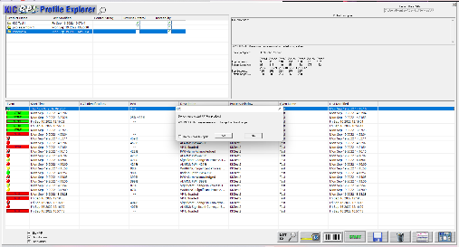 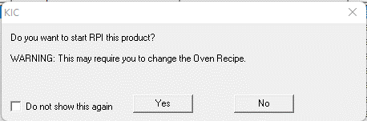

Figure 68: Profile Explorer – Start Virtual Profiling

If your oven is capable of communicating with the software and the current oven recipe matches the Baseline profile recipe, a dialog box will appear telling you that the recipe is already set correctly. See Figure 69.

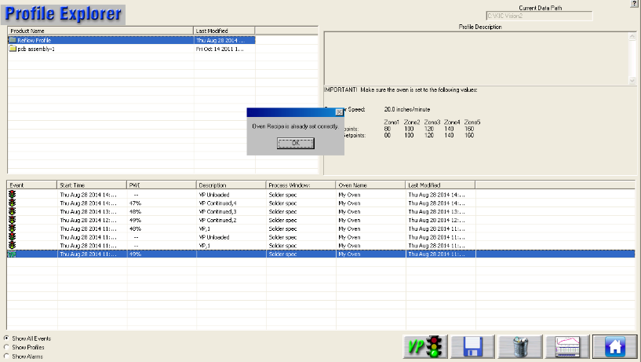 

Figure 69: Virtual Profiling – Oven Recipe Set Correctly

**Tip**: Oven Controller: If nothing happens within several seconds, check the oven control software to make sure there are no error messages or errors that will cause the system to hang.

### Virtual Profiling With Process Control Barcode Capability

If you are using the Process Control barcode capability, you must start the Virtual Profile from the Profile Explorer. You are prompted to enter the Process Control barcode string - the “\*” being the rest of the sequential or changing data and the string is the common data for that product series.

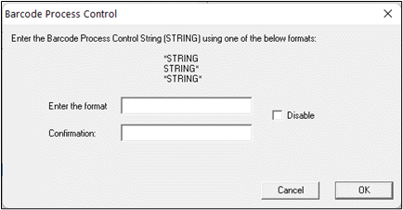

**Note**: If your oven is capable of communicating with the RPI software, a dialog box will appear notifying you that Virtual Profile is starting and the oven recipe is changed automatically.

If your RPI software is not communicating directly with the oven controller, the software will display the baseline profile recipe. Make sure the oven is set to the exact recipe settings.

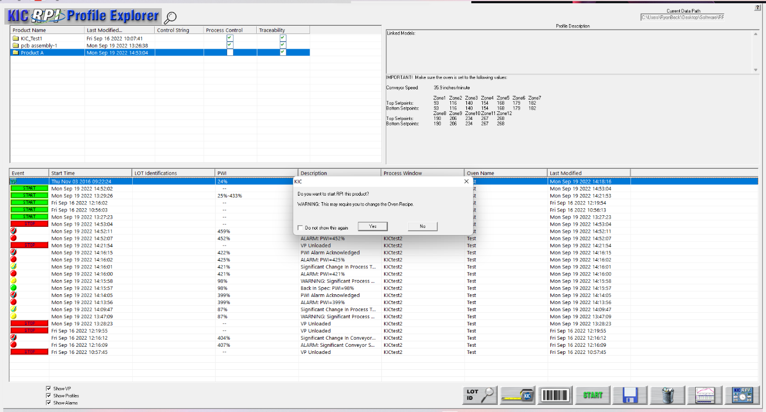

Figure 70: Profile Explorer – Start Virtual Profiling

If your oven is capable of communicating with the RPI software and the current oven recipe matches the baseline profile recipe, a dialog box will appear telling you that the recipe is already set correctly. See Figure 71:

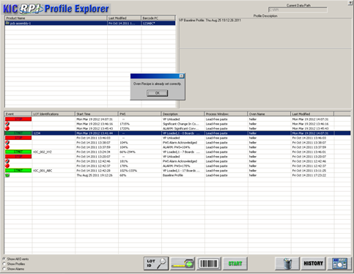

Figure 71: Virtual Profiling – Oven Recipe Set Correctly

**Note**: Oven Controller: If nothing happens within several seconds, check the oven control software to make sure there are no error messages or errors that will cause the system to hang.

## Use the Profile Grouping Utility

RPI includes a utility that lets you identify and group together different products that share the same thermal profile. For example, one might use a physically identical printed circuit board to manufacture many distinct product models. The manufacturer needs to specifically identify and track all the different models, but the thermal process specifications used to solder or cure them is identical throughout the product range. Once a successful process window setup is identified for one model, RPI lets you *link* that setup with other models that can use the same process and thus save the time and cost of entering the same setup specifications repeatedly. In Virtual Profile mode, the baseline profile of a *parent* *product* can be matched to multiple *child models*, permitting smooth production transitions between models.

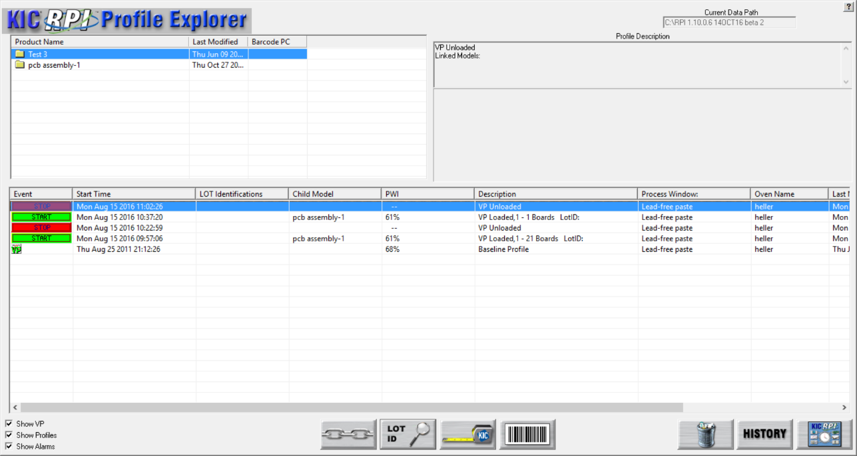

Start Button no longer displayed

Profile Grouping

Child Model Column

You enable the *Profile Grouping* functionality by adjusting settings in the **KIC2000UserSettings.kiccfg** file. Once accessing the APPLICATION CONFIGURATIONS section of the file, make sure the settings are as shown below:

[APPLICATION CONFIGURATIONS]

EnableProfieGrouping=1

### Use Wildcard Characters to Identify Child Models

Anticipating the need to group closely named product models, the software lets you substitute the asterisk (\*) symbol as a universal *wildcard* character when adding models to a group or linking them with a specific profile. You can use wildcards in any position within the model name string.

|  |  |
| --- | --- |
| 1. On the Profile Explorer screen, click the **Profile Grouping Utility** button. |  |

The *Profile Grouping Utility* screen appears.

1. Select the **Grouping** tab.

The Grouping tab screen appears, displaying a pull-down list of products that already have defined in-spec, baseline profiles:



1. From the **Baseline Profile** list, select the product to which you want to link models.
2. In the **Add New Model** field, type in a model name (using wildcards as appropriate), and click the **Add** button.

The model name appears in the Linked Models list

1. Repeat the steps for any additional models that you want to link to that baseline.

**Note**: The **Remove** button will delete any selected model that was mistakenly included in the list.

### Use the Utility with Virtual Profiling

When Profile Grouping is enabled, you can only start Virtual Profiling by using the utility to identify properly linked product/model pairs. The normal Virtual Profile *Start* button no longer appears on the Profile Explorer screen.

#### Load A Specific Model

While many models can be grouped together in association with a baseline profile, *only one at a time can be processed in Virtual Profiling.* The software provides an interface for *loading* a specific model into VP, paired with a specific product baseline. The software does a search through the existing baseline profiles and grouped models to seek a matched pair. The search can yield results of *match*, *no match* and *multiple matches*. The procedure below describes how to resolve all possible outcomes into a product baseline/single model pairing that can run in VP.

|  |  |
| --- | --- |
| 1. On the Profile Explorer screen, click the **Profile Grouping Utility** button. |  |

The *Profile Grouping Utility* screen appears.

1. Select the **VP Load** tab.

The *VP Load* tab appears:

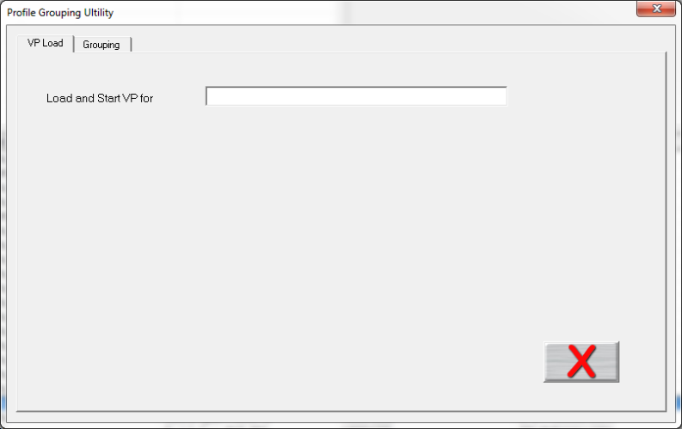

1. In the **Load and Start VP for** field, either type in a model number or use a barcode scanner to input an identification string.
2. Press the **Enter** key to start the software search for linked pairs of product baselines and models:

|  |  |  |
| --- | --- | --- |
| If the software finds a single linked product/model pair, they appear as linked on the screen, together with the VP Start button: | C:\Users\dklueck\Desktop\Matched pair Good to VP screen.png | 5a. Click the **VP Start** button to start Virtual Profiling with the selected model. |

|  |  |  |
| --- | --- | --- |
| If there are multiple matches, the Matched Model Links screen appears, displaying pull-down lists for products and models. | C:\Users\dklueck\Desktop\Matched Model Links screen.png | 5b. Select a product/model pair from the pull-down lists and click the **green check** (OK) button to return to the VP Load tab screen and start Virtual Profiling with the selected model. |
| If there is no match, the software displays a message about the model and a Link button. | C:\Users\dklueck\Desktop\No match message Detail.png | 5c. Click the **Link** button. |

The *Matched Model Links* screen appears:



1. Input the model number and select a product baseline profile from the **Product Name** pull-down list.
2. Click the green check (OK) button.

The VP Load screen reappears with the newly linked product/model pair displayed:



1. Click the VP Start button to begin Virtual Profiling with the selected model.

#### View The Linked Model On Other Screens

During Virtual Profiling, the name of the linked model appears in several places in the user interface. On the Profile Explorer screen, all linked models for a selected profile appear at the top of the screen and in the Child Model column:

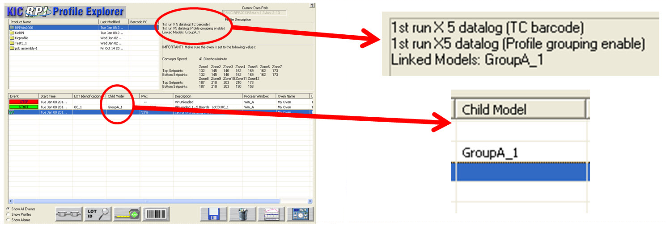

The name also appears at the top of the profile data screen.

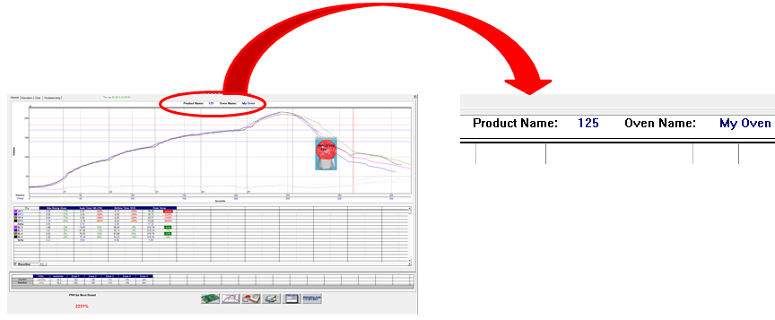

# Monitor Production In Live Mode

In VP *live mode*, the RPI software displays real-time data for the VP it generates for every production board processed. The software displays the data in various charts, graphs, and statistical tables.

|  |  |
| --- | --- |
| During live mode, it also displays a crystal ball indicator that shows the current Virtual PWI, and Cpk values for your process as measured by the software. The crystal ball indicator appears continuously while VP is enabled. You can move the crystal ball, but not close or minimize it. See Figure 72.  The crystal ball color will indicate the current Virtual Profiling status:  **Green**  Ready  **Yellow**  Warning  **Red**  Alarm  **Grey**  Unable to Predict | Green crystal ball2  Figure 72: Virtual Profile Crystal Ball indicator |

**Note**: A VP status message appears when you place the mouse pointer over the crystal ball.

## How to Avoid The Grey Crystal Ball

While a green crystal ball reports the system as VP-capable, and yellow/red alert you to problems, the grey color indicates that the software has insufficient data to make useful VP predictions. The condition can occur during a verification profile run where you introduce the profiler into an ongoing production flow. With boards both downstream and upstream of the profiler, the system lacks necessary data obtained by sampling empty oven zones. To avoid the grey status KIC recommends running the profiler with no boards following behind. For more information, see [Integrate Empty Oven Data](#_Integrate_Empty_Oven).

## Use the Index Screen

The software provides a *Reflow Process Index* screen that displays a comprehensive summary of production quality-assurance information. The “*Index”* screen is the default live-mode screen.

|  |  |
| --- | --- |
| 1. On the Profile Explorer screen, click on the **Start** button.   The *Index* screenappears*:* | bt_Inspection_Start Description: Description: C:\Users\dklueck\Desktop\Profile Explorer launchRPI Index screen.png |

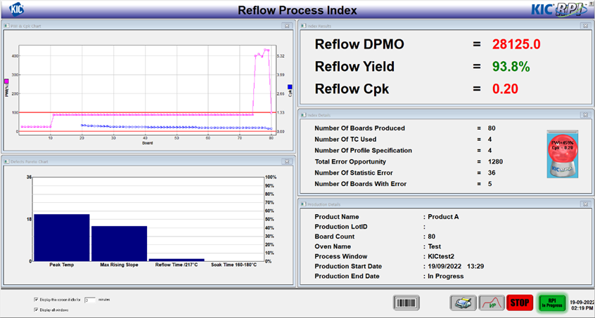

You can customize the screen appearance, closing different chart displays as needed.

The screen shows the statistics for the ongoing reflow operation, including Defects Per Million Opportunities (DPMO). It displays panels for index and production details and shows capacity and defect data in charts. Values, calculations, and chart displays update automatically as boards exit the oven.

Check boxes in the bottom left corner of the Index screen let you control the overall appearance of the Index screen.

|  |  |
| --- | --- |
| Clicking the top checkbox enables an automatic return to the Index screen after a specified amount of idle time spent on another screen. Similar to a screen-saver, you can enter the number of minutes delay before returning in the provided screen. |  |

By default, the Index screen first appears with a set of five chart/detail windows, some of which you may close as you work with the screen. Selecting the *Display all windows* checkbox restores the Index screen to its original five-window appearance.

### Access the Live Profile Data From the Index Screen:

|  |  |
| --- | --- |
| 1. At the bottom of the *Index* screen, click the **VP** button.   The VP live mode screen appears, displaying its default General tab.   1. Click the **Description**, **Chart**, or **Troubleshooting** tab to display its associated screen. | Description: C:\Users\dklueck\Desktop\Exit to old style VP live mode screens button.png    Description: C:\Users\dklueck\Desktop\VP screen from RPI Index screen.png |

**NOTE:** If desired, the Index Screen can be turned off so that the graph screen will display automatically when a VP is first started. Contact tech support at [tech@kicmail.com](mailto:tech@kicmail.com) for assistance.

## Live Mode - General Tab

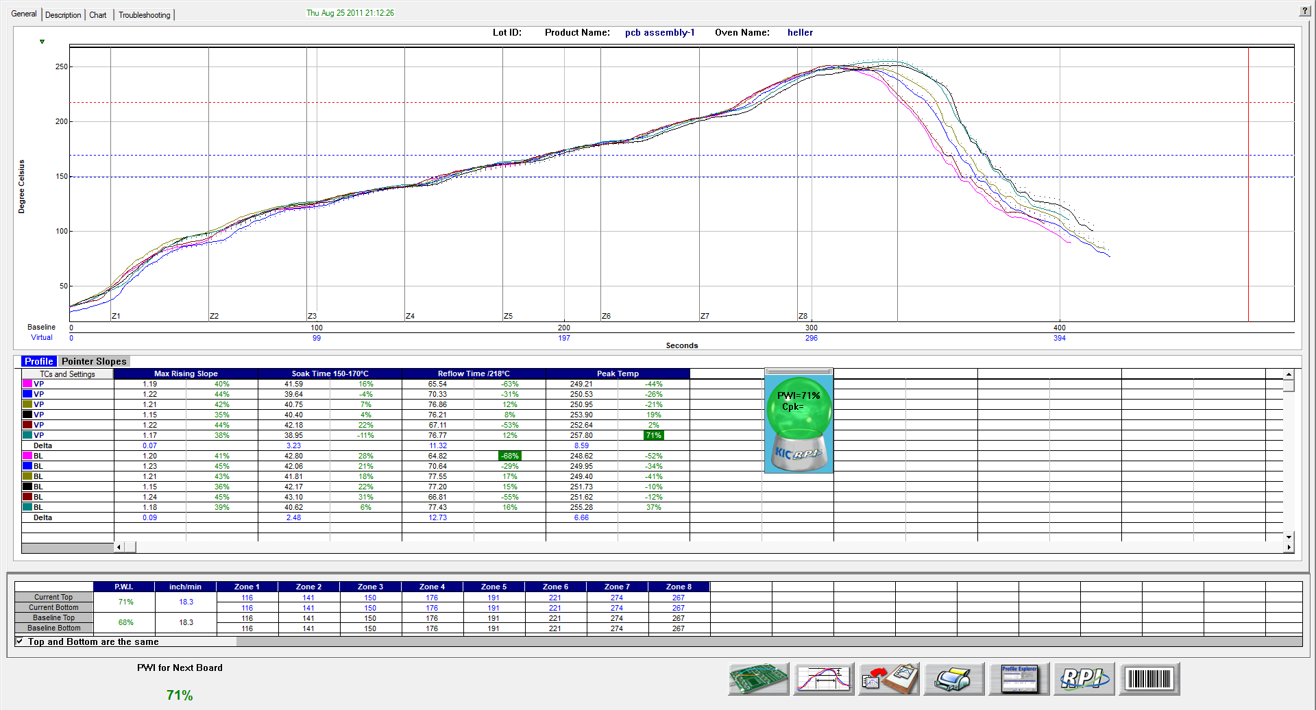

Figure 73: Virtual Profiling – General Tab

On the live-mode screen, the software displays both the baseline and virtual profile. To distinguish between the two, the baseline profile appears in a solid line format, while the virtual profile appears in dashed lines.

**Note**: To enlarge the graph portion of the General Tab, simply double click on the graph. To enlarge the statistics portion of this screen, double click on the statistics.

### Profile Statistics

As shown in Figure 73, the Virtual Profile and baseline statistics appear in a table below the profile graph. Below the statistics, the Virtual Profile (Current) and baseline profile recipes appear. These recipes should match identically. The current PWI appears in the bottom-left corner. The PWI for the last board to exit the oven will not be displayed; go to the Charts tab to view this information.

### Board Sensor Indicator

|  |  |
| --- | --- |
| The software indicates the physical location of the board sensor in or near the oven entrance by a small triangle above the graph.  When the sensor first detects a board, the on-screen indicator changes color from green to red. The indicator stays red as long as the board remains beneath the sensor.  When using a dual lane single system, a triangle icon sensor indicator appears next to each tracking lane. |  |

### Graph Controller

|  |  |
| --- | --- |
| The Graph Controller allows you to modify the view of the RPI profile graph. See Figure 74. To open the Graph Controller, Left-click on the TC column header in the Statistics table or Double Left-click, anywhere just outside the profile graph.  **Auto scale –** The Auto Scale feature will automatically adjust the X and Y-axis scales to fit all of the data in the profile graph. When the Auto Scale feature is disabled, you must manually input the minimum and maximum scale settings for the X and Y-axis scales of the profile graph.  **TCs –** You cannot disable or rename a TC in a live Virtual Profile. You can only perform this function on the Baseline Profile. Those changes would then be reflected in the Virtual Profile display.  **TCs Line Thickness** – The pull-down menu lets you select five different thicknesses for the TC lines drawn on the graph. | A screenshot of a cell phone  Description automatically generated  Figure 74: Graph Controller |

**Grid –** Enables/disables the view of the X and Y-Axis scales.

**Reference lines –** Enables the view of Reference Lines displayed on the profile graph. These lines represent any temperatures referenced in the selected Process Window.

**Zone lines –** Enables the view for the oven zone lines on the profile graph.

**Predicted TCs only** - Removes the Original profile plot from view, displaying only the prediction profile plot on the graph.

**Zero decimal** – When viewing the Examine tool, this setting enables or disables the decimal display. When unchecked, the software will display one decimal point.

**Internal temp** – Enables the view of the KIC profiler’s internal temperature profile plot on the graph.

**Display Detailed PWI** – With this unchecked, you will only see the “overall” PWI for the profile. It will not display the individual TC PWI values.

**Extra Cooling Slope** – Enabling this feature displays multiple Cooling Slope measurements which are customizable by the user.

**Floating O2 PPM display** – When the *O2 Live* option is purchased, you can enable/disable a window on the graph that shows the O2 measurement recorded during that profile.

**Slope Between/Time Between/Peak Between** – These selections control which calculations will be displayed in the *Pointer Slopes* tab of the Statistics table when pointers are added onto a profile graph.

### 

### Automatic Calculation Of Delta T + Delta (Or Range) For All Statistics

The software will automatically calculate, and display in the statistical chart, the Delta for both the original and predicted profile data for all TCs for all Statistics. See Figure 75. This is the range of the highest to the lowest value for any given specification. This information is strictly being displayed and is not factored in to the PWI value and is not used in the Navigator or Auto-focus calculations.

### Examine Tool

|  |  |
| --- | --- |
| You can also view the Delta T (∆T), or Delta Temperature, at specific points across the profile by right mouse clicking on the graph. This will bring up a pointer and a chart will appear in the upper left corner of the graph. See Figure 75. | b  Figure 75: Examine Tool Display |

Wherever the pointer is moved across the profile, the following data appears:

* The first column is the actual temperature for each TC, Original.
* The second column is the temperature of the predicted profile data – based on setpoint or belt speed changes.
* The Delta T for both actual and predicted TC data.
* The time during the profile at which the pointer is placed

### Board Spacing

It is best to maintain at least a 1” space between production boards that enter the oven. A 1-inch gap insures that the RPI system will accurately count and track boards through the oven. In the event that two boards become pushed together leaving no space, the system should be able to detect the correct number of boards processed.

If the board length as determined by the system differs by more than 15% from the baseline-product length while Virtual Profiling – live, an alarm can appear after a specified amount boards.

The number of boards to trigger an alarm on can be adjusted if needed, contact KIC Technical Support for help, [tech@kicmail.com](mailto:tech@kicmail.com).

## Live Mode - Description Tab

|  |  |
| --- | --- |
| The Description tab displays the profile Description notes for the baseline profile. See .  You can edit these notes by clicking in the description area.  Below the description area, the Virtual Profile and Baseline Statistics, and recipes are displayed. In the bottom-left corner, the current PWI appears. Enlarging the description area and statistics are not possible while viewing this tab. | Graphical user interface, application, table  Description automatically generated  Figure 76: Virtual Profiling – Description Tab |

## Live Mode - Charts Tab

|  |  |
| --- | --- |
| The Chart tab will display a control chart for the overall profile PWI, and each individual process specification, as defined in the Process Window setup. See Figure 77.  The alarm limits for each specification appears on each chart using red horizontal lines.  Each time a board is detected exiting the oven, the RPI software will plot a data point for each product thermocouple on each chart. The chart data will coincide with the live Virtual Profile data.  The RPI software will update the overall PWI for each chart and calculate the Cpk and display the results above each chart. | Figure 77: Virtual Profiling– Chart Tab, all charts |

**Note**: You can enable or change the Cpk alarm values in the “Global Preferences” screen before you start Virtual Profiling.

Above the control charts is a bar display showing the board sensor location. Similar to the General tab, when a board is detected under the sensor, the indicator color will change from green to red as long as the sensor detects a board. This display also shows the current location and number of boards in the oven. In the bottom-left corner, the current PWI appears. If the Barcode capabilities are enabled, the barcode number for the current board appears in the lower-left-corner as well.

### View Chart Data

To view individual chart data, click inside the chart area of your choice. This will display that particular chart in a full screen view. See Figure 78.

Move the mouse pointer over the chart data, a display box will appear. This display box data includes barcode number, PWI, Cpk, date, and time for each board. The date and time for the last board to exit the oven appears at the bottom of the full screen chart in Blue text. See Figure 78.

Click in the chart area to return to the regular Chart tab view.

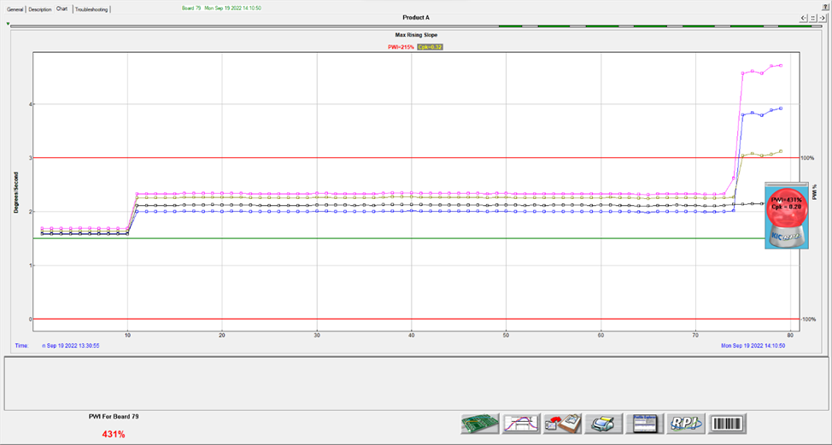

Figure 78: Virtual Profiling – Chart Tab, zoom chart

## Live Mode- Troubleshooting Tab

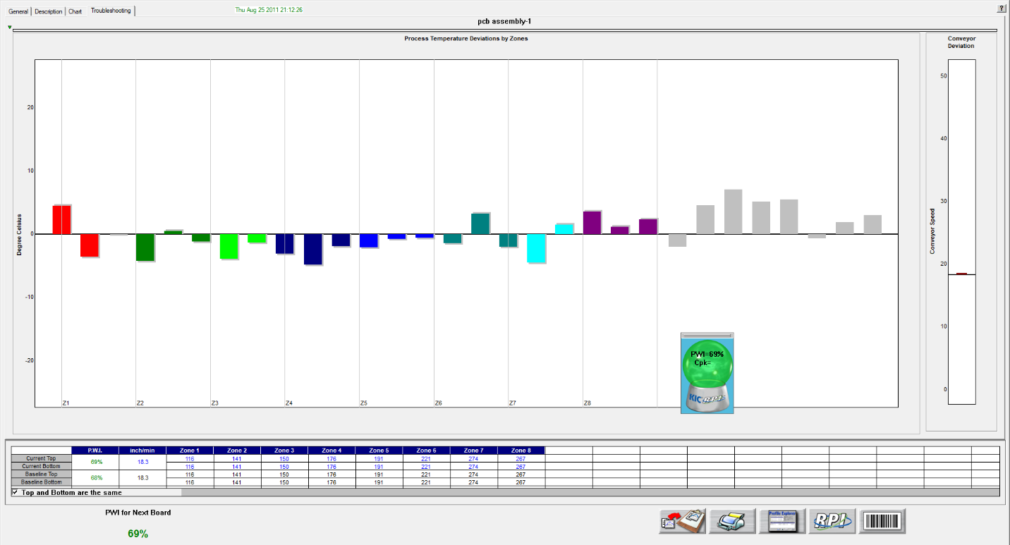

Figure 79: Virtual Profiling – Troubleshooting Tab

The Troubleshooting tab will display the probe and conveyor speed deviation on charts. The probe deviation is measured against the baseline profile – probe data. This data is updated for every board. In the bottom-left corner, the current PWI appears. See Figure 79.

**Tool tips –** Moving the mouse pointer over the deviation chart data will enable tool tips that show the deviation value for each of the probes. Moving the mouse pointer over the conveyor speed chart will show the baseline profile conveyor speed, and the conveyor speed for the last board to exit. See Figure 80.



Figure 80: Probe Deviation Value Display

## VP Live Mode Buttons

While in Virtual Profiling - live mode the software displays several buttons at the bottom of the screen.

|  |  |
| --- | --- |
| bt-NAV_Run-profile | **Run Profile –** Select this button to run a Virtual Profile Verification profile. The software may require you to run a Verification profile if it has determined that the current VP is no longer accurate. |
| bt-NAVint_Proc-menu | **View/Edit Process Window –** This lets you to view the Process Window specifications and limits in a read-only format. |
| bt-NAVint_Copy2Clipbd | **Copy to Clipboard –** This button will copy the profile or Virtual Profile data to the clipboard for use with third-party software such as a spreadsheet application, or SPC software. |
| bt-NAVint_Print | **Print –** This button will print the current profile.  **Note**: If you wish to print a tab besides the General tab, pressing F9 on your keyboard will print the contents of any screen in the RPI software. |
| graphic_104p | **Profiler Explorer –** This button will take you to the Profile Explorer screen. You can view profile and Virtual Profile event data. This feature is especially useful to ascertain which alarms have occurred and have been acknowledged during production. There is only one button at the bottom, which will return you back to Virtual Profiling - live mode. |
| bt_ReturnTo_Inspection | **Stop Virtual Profiling –** This button will return you to the *Index* screen where you can then stop Virtual Profiling and return to the Profile Explorer screen. |
|  | **Barcode Queue –** Displays a text box showing the current barcodes yet to be assigned. |

## Virtual Profiling With Barcode Process Control

When virtual Profiling begins, the system displays the Barcode Process Control dialog box shown below:

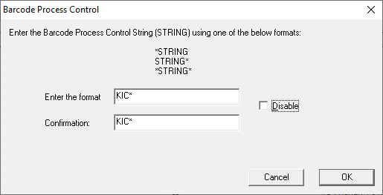

As long as the Process Control function is enabled (Global Preferences), this dialog box appears every time you enable Virtual Profiling.

The dialog box lets you:

1. Enter the Process Control String.
2. Change the Process Control String.
3. Disable Process Control for this Virtual Profile run.

For Process Control your barcode labels are required to contain at least one character (in the same position on each label) – referred to as a “String” - that is common to the all the boards that are processed under that VP. The RPI software reads the incoming barcode string of each board and compares it to that of the Process Control String that was specified. If it does not match the specified string, an alarm is activated, and the process is stopped via the alarm relay device.

In the example above, for this product, all barcodes being read would need to begin with the string “KIC”. The “\*” would represent the rest of the characters in the barcode label and would typically be unique for each individual board.

### Process Control Using The Barcode Product Sensor

|  |  |
| --- | --- |
| RPI systems using a Barcode Product Sensor (BPS) and Process Control barcode function will have the ability to activate an alarm if a products barcode label is not read.  When the BPS detects a product whose barcode label has not been read, or the BPS is tripped accidentally, an alarm is activated and the process is stopped via the alarm relay. Alarm 5C appears. See Figure 81.  Control buttons on the screen let you:   * Manually reenter the barcode, using the keyboard or a handheld scanner * Rescan the barcode with a mounted scanner * Continue production without the barcode * Remove the board from the line. | Figure 81: Alarm #5C |

Or, if the BPS was tripped accidentally, you can select Delete. The Delete function cancels the barcode string entry altogether.

## Read Barcodes With A Product Traceability Scanner

If you use a Product Traceability Scanner (PTS) to read barcode labels while running VP, you will get a barcode recorded along with a PWI for every board that passes thru the oven. You enable this function by selecting *Traceability* under Barcode tab in the Global Preferences.

When installed on a load conveyor, the PTS reads barcode labels as the products enter the oven. If the barcode label is not read, the process is stopped before the product enters the oven. This method requires an eTPU, and load conveyor in front of the oven in order to function properly.

RPI systems using a BPS and a PTS at the oven entrance will have the ability to activate an alarm if a products barcode label is not read or is damaged.

|  |  |
| --- | --- |
| When the BPS detects a product whose barcode label has not been read, or the BPS is tripped accidentally, an alarm is activated and the process is stopped via the alarm relay. Alarm 5A appears. See Figure 82.  Control buttons on the screen let you:   * Manually reenter the barcode, using the keyboard or a handheld scanner * Rescan the barcode with a mounted scanner * Continue production without the barcode * Remove the board from the line. | Figure 82: Alarm #5A |

## Verify The Virtual Profile

The *Virtual Profile* is a prediction of the process profile (inside the oven) generated from a model created when the Baseline profile was run. A *verification* *profile* is a comparison run against the Virtual Profile model. If you think the process has changed significantly or you have purposely changed the recipe, running a verification profile lets you verify the prediction model. This comparison can either verify that the process profile is still within specification or create a new baseline profile based on the recent changes.

The verification profile updates the Baseline profile for the current Virtual Profile, ensuring that its prediction model yields the most accurate possible results, using the most recent profile. The software always recognizes the latest in‑spec profile as the Baseline for any Virtual Profile.

The software recognizes when the process temperatures change significantly as compared to the current Baseline profile, and then prompts you to run a verification profile. You can intentionally run a verification profile at any time during Virtual Profiling Live Mode.

**Note**: The software will only accept a verification profile as a new baseline if meets the standard VP criteria. See [Get A Valid Baseline Profile](#_Get_A_Valid).

|  |  |
| --- | --- |
| 1. Verify that VP is running in live mode 2. Select the Run Profile button at the bottom of the VP live screen. See Figure 83. | bt-NAV_Run-profile  Figure 83: Run Profile Button, VP Live Mode Screen |
| 1. The software displays a message asking if you want to run a verification profile with: See Figure 84.  * If you choose **No**, the software will return to the previous screen. * If you choose **Yes**, the software will begin stepping through the run profile routine. | Figure 84 |

1. Verify the following before profiling:

* The profiler is on and ready to profile.
  + If a Transmit model – Receiver or Base Station is plugged into computer.
  + If a Datalogger model – The profiler is plugged into the download cable and download cable is plugged into the computer.
* Profiler batteries and internal temperature are at the proper levels to profile.
* All thermocouples attached to the profiler are below the defined product start temperature.

**Note**: Depending on the settings on your profiler and in the software, you may have to initialize your profiler. (The RPI software lets you know when this is necessary.) To initialize the profiler, connect it with the supplied cable to the RPI computer, and turn on the power. Click **OK** when the software displays the message that the initialization was successful.

1. To begin profiling, click the Start Profile button (green traffic light).

Once the verification profile is complete, the KIC profiler has downloaded the profile data that meets Virtual Profile criteria, the RPI software will display the dialog box shown below. See Figure 85.



Figure 85: This dialog box will display the PWI and the  
predicted PWI for the verification profile.

Alternatively, if the profile is out of spec, the dialog box shown below will appear stating that the PWI is too high. See Figure 86.

If you choose to continue running Virtual Profiling, you will receive WARNING #2, “The last profile was out of spec”. In which case, you would need to run profiles until an in-spec profile is achieved before the software lets you continue Virtual Profiling.



Figure 86: Out of Spec Verification profile

The dialog box will present two choices:

1. **Continue Virtual Profiling –** If the verification profile meets Virtual Profiling criteria, it will automatically be used as the new baseline profile. If you choose this option, the software will update the baseline and continue Virtual Profiling, using the verification profile as a new baseline profile.
2. **Unload Virtual Profile and go to Prediction mode** – If the verification profile does not meet Virtual Profiling criteria or is out of spec, it can’t be used for Virtual Profiling. If you choose this option, you can predict changes to the profile in order to bring the profile back within its process specification. You will have to run at least one more profile in order to produce a profile that meets Virtual Profiling criteria.

**Note**: For an explanation of VP criteria, see [Virtual Profiling](#_Virtual_Profiling).

## Historical Mode

The RPI software has a historical mode feature. This feature allows you to view Virtual Profile data for any board processed when the RPI system has been running. Open the Profile Explorer and select any event other than a profile**.** The *Display the Graph and Statistics for this profile*buttonwill change from a single graph button display to a HISTORY button display, indicating there is Historical data associated with selected event. See Figure 87 and Figure 88.

|  |  |
| --- | --- |
| Figure 87: Profile Explorer–Display Graph and Statistics for this profile | bt_Inspection_History  Figure 88: Profile Explorer–Display Historical Graph and Statistics |

## View Historical Data While Running a Live Virtual Profile

To view historical Virtual Profile data from the same PC while Virtual Profiling - live, you launch a separate KIC Host.exe file located in: C:\RPI\AppforViewer\KICHost.exe. This opens a separate Profile Explorer that lets you to browse through the history of any product including the one currently running VP. Historical data will be available for any boards that have already exited the oven.

## Historical Mode - General Tab

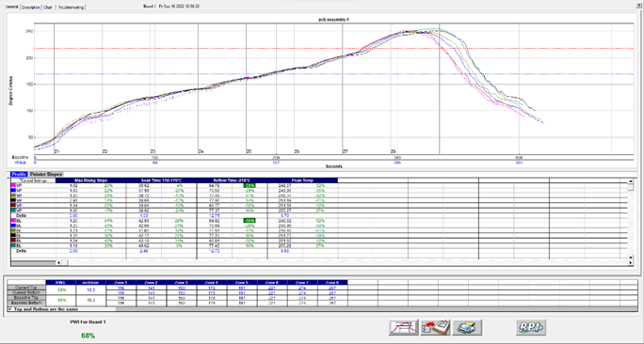

Figure 89: Virtual Profiling History – General Tab

The RPI software will display the baseline profile on the profile graph in a solid line format. Also on the profile graph is the Virtual Profile for the selected board, date/time. The Virtual Profile appears on the profile graph in a dashed-line format. This display method allows you to easily distinguish between the baseline and Virtual profiles.

Below the profile graph, the Virtual Profile and baseline profile statistics are displayed. Uncheck the baseline check box to remove the baseline statistics from view. Below the statistics, the Virtual Profile and baseline profile recipes are displayed.

### Graph Controller

|  |  |
| --- | --- |
| The Graph Controller allows you to modify the view of the RPI profile graph. See Figure 90. To open the Graph Controller, Left-click on the TC column header in the Statistics table or Double Left-click, anywhere just outside the profile graph.  **Auto scale –** The Auto Scale feature will automatically adjust the X and Y-axis scales to fit all of the data in the profile graph. When the Auto Scale feature is disabled, you must manually input the minimum and maximum scale settings for the X and Y-axis scales of the profile graph.  **TCs**  The TCs section is a list of the thermocouples used for the profile. In the event that you wish to view the profile without a particular or multiple thermocouples, you can deselect individual thermocouples, or deselect the “All” check box, and choose only the thermocouples you wish to view. The software recalculates the PWI and updates the profile statistics based on the remaining thermocouples selected. You must select at least one product thermocouple. | Figure 90: Graph Controller |

**Deselecting thermocouples**

If a thermocouple has become disconnected during the profile, the profile results (PWI) may be affected to due above normal peak temperatures and such. This situation may cause the profile PWI value to be artificially inflated due to bad data. In the event a single or multiple thermocouples become disconnected from the product during the profile, you can deselect the affected thermocouple(s). The RPI software recalculates the PWI and updates the profile statistics based on the remaining selected thermocouples. You must select at least one product thermocouple.

**Grid –** Enables/disables the view of the X and Y-Axis scales.

**Reference lines –** Enables the view of Reference Lines displayed on the profile graph. These lines represent any temperatures referenced in the selected Process Window.

**Zone lines –** Enables the view for the oven zone lines on the profile graph.

**Predicted TCs only** - Removes the Original profile plot from view, displaying only the prediction profile plot on the graph.

**Zero decimal** – When viewing with the examine tool, this setting enables or disables the decimal display. When unchecked, the software will display one decimal point.

**Internal temp** – Enables the view of the profiler’s internal temperature profile plot on the graph.

**Display Detailed PWI** – With this unchecked, you will only see the “overall” PWI for the profile. It will not display the individual TC PWI values.

**Extra Cooling Slope** – Enabling this feature displays multiple Cooling Slope measurements which are customizable by the user.

**Floating O2 PPM display** – When the *O2 Live* option is purchased, you can enable/disable a window on the graph that shows the O2 measurement recorded during that profile. See the [O2 Live (Optional)](#_O2_Live) section for details*.*

### Automatic Calculation Of Delta T + Delta (Or Range) For All Statistics

The software will automatically calculate, and display in the statistical chart, the Delta for both the original and predicted profile data for all TCs for all Statistics. See Figure 91. This is the range of the highest to the lowest value for any given specification. This information is strictly being displayed and is not factored in to the PWI value and is not used in the Navigator or Auto-focus calculations.

### Examine Tool

|  |  |
| --- | --- |
| You can also view the Delta T (∆T), or Delta Temperature, at specific points across the profile by right mouse clicking on the graph. This will bring up a pointer and a chart will appear in the upper left corner of the graph. See Figure 91. | b  Figure 91: Examine Tool Display |

Wherever the pointer moves across the profile, the following data appears:

* The first column is the actual temperature for each TC, Original.
* The second column is the temperature of the predicted profile data – based on setpoint or belt speed changes.
* The Delta T for both actual and predicted TC data.
* The time during the profile at which the pointer is placed

## Historical Mode - Description Tab

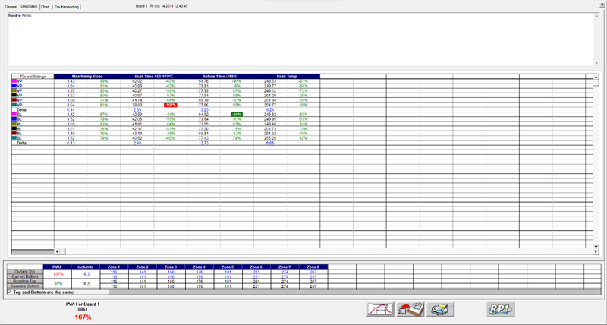

Figure 92: Virtual Profiling History – Description Tab

In Historical mode the *Description* tab displays the Baseline profile description notes (See Figure 92). You can edit these notes by clicking in the description area. Below the description area, the Virtual Profile and baseline statistics, and recipes are displayed. In the bottom-left corner, the PWI (and the barcode number, if enabled) for the selected board appears.

## Historical Mode - Chart Tab

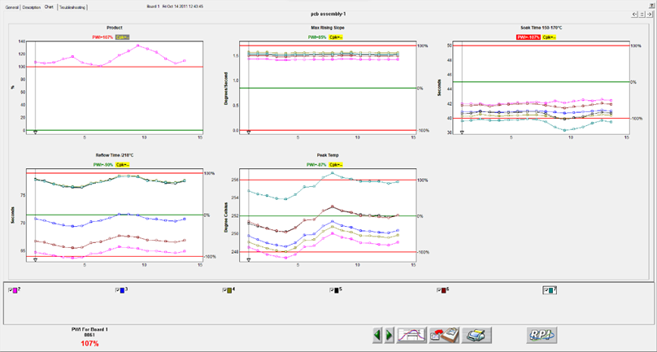

Figure 93: Virtual Profiling History – Chart Tab, all charts

The Chart tab will display a control chart for the overall profile PWI and for each individual process specification with alarm limits as defined in the Process Window setup. See Figure 93. The chart data will coincide with the Virtual Profile data for the selected board, date, and time.

### View Control Charts

Depending on the screen resolution, setting of the computer not all charts may fit within the screen area. Use the buttons in the upper-right corner of the Chart tab to select the number of charts to display and toggle between then.

The control charts hold all of the historical Virtual Profile data for the product you selected in the Profile Explorer. Each data point on each chart represents a board that has passed through your oven.

**Board selector line -** Each chart has a Board Selector Line at specific board #. The board # appears at the top of the screen, along with the date and time that board # was entered into the RPI system. You can move the Board Selector line position by clicking and dragging the small triangle at the bottom of the Board Selector line.

The Maximum PWI and Cpk for the selected board, date and time are highlighted above the corresponding chart(s).

Each chart contains data for every product thermocouple used during the profile. Below the charts you can de-select the TCs that you wish to remove from the control chart display. De-selecting a TC will remove the data for that TC from each control chart. Click the check box again to display the data for that TC. In the bottom-left corner, the PWI (and the barcode number, if enabled) for the selected board appears.

### View Chart Data

While viewing individual chart data, click inside the chart area of your choice to display that particular chart in a full screen format. Move the mouse pointer over the chart data, and a display box will appear. This display box data includes barcode number, PWI, Cpk, date, and time for each board. The date and time for the last board to exit the oven appears at the bottom of the full screen chart.

### History Mode Chart Options Menu



Figure 94: History mode-Chart Options Menu

* **Meter window –** Right click anywhere in the full screen chart area. The Chart Options menu will appear, select Meter Window. This will display a small data box in the upper-left corner of the profile graph. This data box will display the historical – statistic data for any selected board. To select a board move your mouse pointer along the chart data, at each data point the historical – statistic data for that board appears. Right-click in the chart area again and de-select Meter Window to disable this feature.
* **Point protector –** When this feature is enabled, the software will display individual data points for each board. A small square shaped data point represents a production board. A small circle shaped data point represents a profile board. To activate this feature right click anywhere in the full screen chart area. A menu will appear, select Point Protector. This will display the individual data points on each control chart. De-selecting this feature will remove the data points from the control chart, showing only a plot of the same data. By default, the Point Protector is enabled for charts containing 20 boards or less. Click in the full screen chart area again to return to the regular Chart tab view.
* **Event History-** This feature is enabled as a default setting in the software. When viewing the charts tab while in History mode an Event History dialog box appears. The Event History dialog box will contain a list of all alarms and alarm related events that happened during the (selected) Virtual Profile.



Figure 95: Event History dialog box

* **Disabling Event History Display** - Right click anywhere in the full screen chart area. The Chart Options menu will appear, select the Event History option.

#### Charts Tab Buttons

The Charts tab will have two extra buttons found only on this screen:

|  |  |
| --- | --- |
| bt_la | **Scroll backwards in time** – Clicking on the green left arrowhead will result in displaying the *previous* set of virtually profiled boards. |
| bt_ra | **Scroll forward in time** – Clicking on the green right arrowhead will result in displaying the *next* set of Virtually Profiled boards. |

**Note**: Each chart can display a maximum of 200 data points at any given time. Every 200 data points are considered a set of data. A set of data can contain up to 200 data points, or if the production run was stopped before 200 boards were processed, a data set may contain less than 200 data points.

## Historical Mode - Troubleshooting Tab

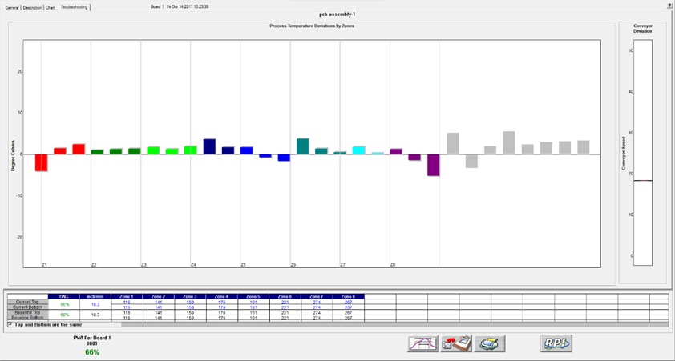

Figure 96: Virtual Profiling History – Troubleshooting Tab

The Troubleshooting tab shows historical probe and conveyor speed deviation. The Board #, date and time appears at the top of the screen. See Figure 96. To change the board #, go to the Charts tab and move the Board Selector Line to a different board (#) number. The PWI for the selected board appears in the bottom-left corner.

There are a total of 30 probe thermocouples inside the oven. On the screen, each zone displays a different color for the probe TCs that are inside that zone.

### Historical Mode Buttons

While in Virtual Profiling - Historical mode, the software displays four buttons at the bottom of the screen.

|  |  |
| --- | --- |
| bt-NAVint_Proc-menu | **View/Edit Process Window –** This lets you view and edit the process window specifications and limits. |
| bt-NAVint_Copy2Clipbd | **Copy to Clipboard –** This button copies the profile or Virtual Profile data to the clipboard for use with third-party software such as a spreadsheet application, or SPC software. |
| bt-NAVint_Print | **Print –** This button will print the current profile as displayed on the General Tab.  **Note**: If you wish to print a tab besides the General tab, pressing F9 on your keyboard will print the contents of any screen in the software. |
| graphic_104p | **Profile Explorer –** This button will return you to the Profile Explorer. Click this button when finished viewing historical Virtual Profile data. |















# Barcode Functions

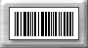RPI software has two main barcode functions, *Process Traceability*, and *Process Control*. For either barcode function, the barcode scanners connect directly to the eTPU-Alarm/Barcode port or to the pigtail connector of the alarm relay-cable if an alarm relay is also being used. The alarm relay is required for use of the Process Control barcode function. Alternatively, a Serial or USB scanner can also be connected directly to the PC running the KIC software. See *[Appendix C – Barcode](#_Barcode_Tab_1)* for more information.

### Process Traceability (PT)

The Process Traceability function enables process traceability with profile data for every product linked to its barcode number. The software will match the barcode number and complete process data to every single production board recorded by the system. The Process Traceability Barcode function can be used with or without the Process Control function.

### Process Control (PC)

The Process Controlfunction enables process control by reading the product barcode label before the product enters the oven and confirms that a specific area of the barcode correlates to a specified product. If the barcode string value matches the current process string value, production continues as normal. If the incoming barcode string value differs from your defined string value, an alarm is activated and the process can be stopped until the operator acknowledges the alarm and takes the proper action. In order to utilize the Process Control feature, your barcode strings need to contain at least one character (referred to as a “String”) that is common to all boards in a production run. For example, when running “Product A”, all barcode labels for “Product A” would be “ABCxxxx”, where “ABC” would represent the common characters (String) on each barcode label, and “xxxx” would represent the rest of the barcode characters, which would typically be unique to each individual board. The common character string can fall anywhere within the barcode. The Process Control Barcode function can be used with or without the Process Traceability function.

### Tigger sensors

Additional control/functionality can be implemented through the use of a separate product sensor and software configuration. Only one of the following two methods below can be configured at a time. The configuration for these is set in the ConfigurationProgram.exe. See [*Appendix C – Barcode*](#_Barcode_Tab_1) for more information.

#### Barcode Product Sensor

The Barcode Product Sensor (BPS) configuration uses an optional product sensor to identify that a product is passing by the barcode scanner. If the product passes the sensor and no barcode or an invalid barcode ID have been read into the software, then the system will post an alarm (Alarm 5C), and when applicable, stop the infeed conveyor. If a valid barcode ID was received, the product will continue moving into the oven.

#### Barcode Stop Sensor

The Barcode Stop Sensor (BSS) configuration uses an optional product sensor for ensuring each products barcode ID has been received. This configuration may be needed when short in-feed conveyors are in use, and there is not enough time to validate the barcode ID before the product reaches the oven. With this configuration, as soon as the sensor is triggered by a product, the in-feed conveyor is stopped. If a valid barcode ID has been received within the set amount of time, the product is released and allowed into the oven. If the barcode ID is missing or wrong, an alarm will be posted.

### Scanner settings

The RPI barcode option is offered as a software only option. You must provide the serial port or USB barcode scanner, support/ utility software, all communication cabling, and mounting hardware.

Here are some important points to consider when planning to use RPI with the barcode option:

1. The barcode reader must have either a 9-pin D-Sub serial connector (RS-232) for communication or be a USB model that can be programmable for Serial Port interface.
2. Barcode readers with Raster scan (multi-scan) are recommended.
3. Barcode reader must be capable of the following communication settings:

**Baud Rate: 9600 bits/sec, Data Bits: 8, Parity: None, Stop Bits: 1**

1. The scanner(s) must be programmed to have both a **Line Feed** and **Carriage Return** after each string is scanned.
2. The scanner must be programmed to generate a single output for each board scanned.
3. You will need the barcode reader utility software in order to configure the barcode reader.
4. Non-standard cabling may be required for multiple barcode applications.
5. When using multiple barcode scanners, the use of prefixes is required.

## Barcode Types

Since the software does not actually read the barcode labels, you can use any barcode type that your barcode scanner is capable of reading. Verify your barcode scanner can read the barcode type prior to KIC installation. Use the manufactures utility, or Windows-HyperTerminal for verification.

### Configuration Overview

1. Program the barcode scanner settings using the software utility that is provided by the scanner manufacturer to configure the barcode scanner. If you do not have it, contact the scanner manufacturer.
2. Select desired functions/settings in the Barcode tab of the Configuration Program, and then enable the barcode option(s) in Global Preferences. The RPI Hardware Status screen will help you verify your barcode reader is connected properly.
3. Test the hardware connection.

### Configure and Test the System

There are multiple ways to determine if the barcode scanner(s) hardware is configured properly and communicating with your RPI system. The first is using the Hardware Status screen, a second is using the eTPU Utility, and the third is using the Barcode-Log file.

**Note**: Make sure your system is properly installed and configured before you attempt to test your barcode hardware.

#### Configuration

Start by ensuring that the Barcode software key is properly connected to your PC. Verify the software key is correctly installed by viewing the Hardware Status screen. Confirmation appears in the Software Key field.

If you do not see confirmation displayed, check the following:

* Check to make sure software key is properly installed and correctly seated.
* Check to make sure the key you have is programmed for Barcodes.
* Check to make sure the USB port is functional.



Figure 97: Global Preference – Barcode Option Tab

Open the RPI software. From the main menu, select the Global Preferences button, and then select the Barcode tab. Select the Barcode option(s) that apply.

There are several possible barcode hardware configurations. The correct barcode configuration will depend on the KIC hardware and barcode labeling technique. For barcode type configuration details, see the section titled [Barcode Types](#_Barcode_Types_1). For testing purposes, select any barcode option.

Choose the **green check** button to save your settings and return to the main screen.

### View Barcode Data On The Hardware Status Screen

**Hardware Status** – Once a barcode function is enabled, a barcode field is added to the Hardware Status screen as seen below.

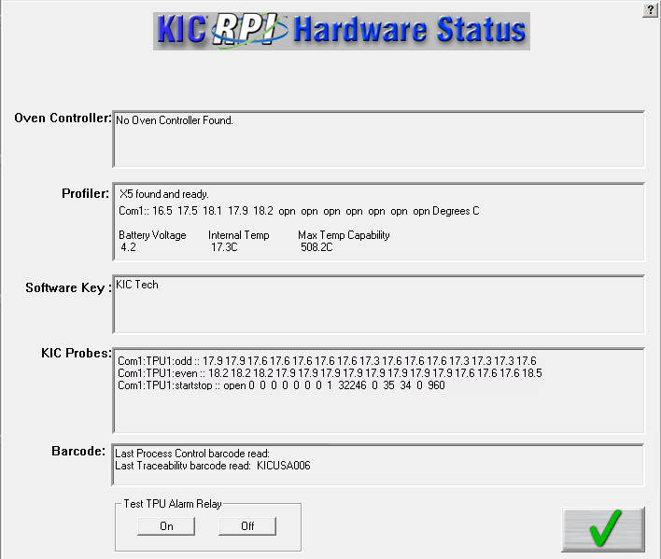

Barcode field

Figure 98: Hardware Status

In the Barcode section, the last barcode read appears. In order to view the barcode value, the conveyor must be moving. The barcode information will not display until the encoder begins pulsing.

### Test Sensor Inputs With eTPU Utility

The eTPU Utility (*C:\RPI\Flash&Test eTPU* ) is a program that lets you test all of the sensor inputs, including the Barcode Product Sensor (BPS) or Barcode Stop Sensor (BSS) and the barcode scanner itself. Click “Start eTPU” to begin reading the BPS or BSS sensor input and the Barcode Reader scan.

**Barcode Product Sensor:** Activate the Barcode Product Sensor or Barcode Stop Sensor. The “Barcode Product Sensor” display will change from “OPEN” to “CLOSED” when activated.

If Sensor fails to change, there may be a problem with a sensor or its wiring. Check to make sure the eTPU is properly communicating with the eTPU Utility software.

**Barcode Reader:** With the Barcode reader powered ON and connected to the eTPU, scan a barcode. The scan results appear in the “Last Barcode Read” field.

If the Barcode read fails, check the connections, and verify the barcode reader setting as previously described.

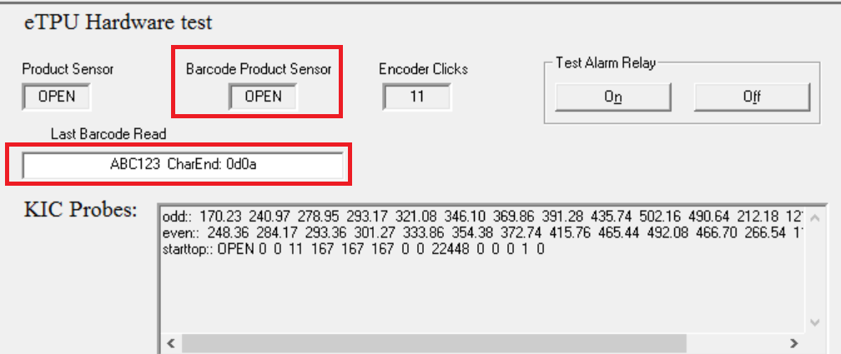

Figure 99: eTPU Hardware Test

### Test With The Barcode Log Configuration File

**Barcode Log** - You can also verify that the barcode feature is configured properly or for troubleshooting purposes by viewing the Barcode-Log file. If the barcode scanner hardware is connected and functioning properly, the system generates a log file. Every barcode value read by the system is logged and viewable.

To view the barcode-log file go to C:\RPI\Log\barcodeLog.txt. This file will list the date, time, and barcode value for each barcode read through the eTPU. This information will also be displayed in the KIC Host screen.

### 

## Scanner Installation

There are several ways to configure the system for use with barcodes. The correct configuration will depend on the KIC hardware, and barcode labeling techniques used in your process. Contact KIC Technical Support for more information.

### Install Scanners on the Load Conveyor

For the Process Control barcode function, it is necessary to install the barcode scanner(s) directly to the load conveyor. The load conveyor-power input is connected to the alarm relay. The alarm relay controls the load conveyor, thereby controlling the flow of product into the oven. When a Process Control or any other critical alarm is activated, the power to the load conveyor is cut, stopping the flow of product into the oven. This ensures that no products enter the oven under alarm conditions.

The installation positions of the Scanner(s) and BPS or BSS sensors are determined by your hardware set up and operational needs. Below are some guidelines for installation of barcode scanners and BPS or BSS. See Figure 100



Figure 100: Barcode Scanner Installation Guidelines

## Virtual Profiling And Barcodes

**Note**: The barcode option requires a software key in order to function. The software key must always remain connected during use.

### Process Control

There are two methods for defining the characters of a barcode string that will be used for Process Control – Wildcard (default) and Parsing. See [*Appendix C – Barcode*](#_Barcode_Tab_1) for how to change between methods.

**Wildcard -** When Virtual Profiling is started, the system produces the Barcode Process Control dialog box which gives you the opportunity to: Enter the Process Control String, Change the Process Control String, or Disable Process Control for this Virtual Profile run.

If the Process Control function is enabled (Global Preferences) and the Wildcard method is selected (Configuration Program), this dialog box will appear every time Virtual Profiling is enabled. See Figure 101. Enter the barcode control string that is specific to the product family that is running. The software reads the incoming string and compares it to that of the specified Process Control String, for every product. If the string values differ, an alarm is activated, and the process is stopped via the alarm relay device.



Figure 101: Barcode Process Control dialog

**Parsing** – Whereas with the Wildcard method, the Control String characters must be sequential, using the Parsing method allows you to specify characters in any position of the string to be the Control String.

In Profile Explorer, right click in the *Control String* column for a given product and choose *Add Control String*:



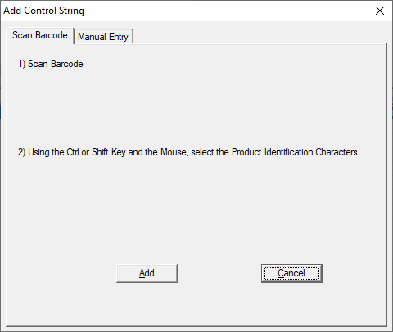

A window will open for selecting/defining the characters of the control string.

There are two methods available for adding the control string:

* Scan Barcode
* Manual Entry

Choose ‘Scan Barcode’ if an actual scanner and barcode are to be used. Choose ‘Manual Entry’ to type in the control string characters.

**Scan Barcode Method**

Scan a barcode for the selected product and the full string will be displayed in the window. Hold down the Ctrl or Shift key and select the individual characters that will be the *Control String* for this product family. Click *Add* to save this *Control String* to the product:

**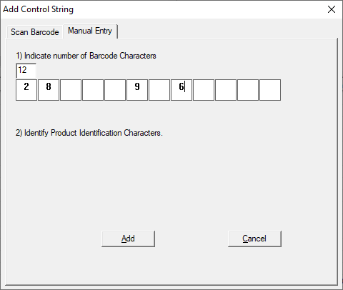**

**Manual Entry Method**

Enter the number of total characters in the barcode string. Then type in **ONLY** the characters that will be the *Control String* for this product family. Click *Add* to save this *Control String* to the product:

The *Control String* column will now display the defined string for that product name:



With the Parsing method, you also have the ability to add more than one *Control String* for a given product by repeating the same steps above. You can remove a *Control String* for a product by right-clicking and choosing the *Edit Control String* selection.

### Barcode Product Sensor (BPS)/Barcode Stop Sensor (BSS) operation

RPI systems using the optional BPS or BSS and Process Control barcode function will have the ability to activate an alarm if a products barcode label is not read.

When the BPS or BSS detects a product whose barcode label has not been read, or the sensor is tripped accidentally, an alarm is activated and the process is stopped via the alarm relay. Alarm 5C appears. See Figure 102.

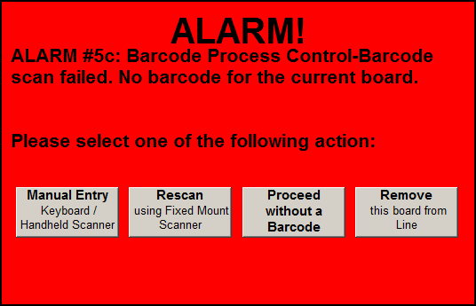

Figure 102: Alarm 5C

Control buttons on the screen let you:

* Manually reenter the barcode, using the keyboard or a handheld scanner
* Rescan the barcode with a mounted scanner
* Continue production without the barcode
* Remove the board from the line.

### Read Barcodes With A Product Traceability Scanner

If you use a Product Traceability Scanner (PTS) to read barcode labels while running VP, you will get a barcode recorded along with a PWI for every board that passes thru the oven. You enable this function by selecting *Traceability* under Barcode tab in the Global Preferences. When installed on a load conveyor, the PTS reads barcode labels before the products enter the oven. If the barcode label is not read, the process is stopped before the product enters the oven. This method requires an eTPU, alarm relay, and load conveyor.

RPI systems using a BPS or BSS and Process traceability barcode function (PTS at oven entrance) will have the ability to activate an alarm if a products barcode label is not read or is damaged. When the BPS/BSS detects a product whose barcode label has not been read, or the sensor is tripped accidentally, an alarm is activated and the process is stopped via the alarm relay. Alarm 5a appears. See Figure 103.

Control buttons on the screen let you:

* Manually reenter the barcode, using the keyboard or a handheld scanner
* Rescan the barcode with a mounted scanner
* Continue production without the barcode
* Remove the board from the line.

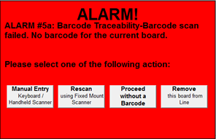

Figure 103: Alarm 5a

## Enable Barcoding Per Product

You have the ability to turn on or off the Process Control and Traceability functions on a per product basis. When the Barcode feature is active, in Profile Explorer you will find checkboxes for the two different functions to the right of each product folder. These checkboxes allow you turn on/off the feature independently for each product:

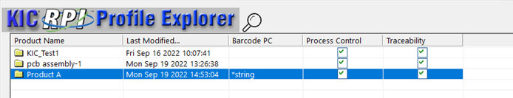

## 

## Display the Current Barcode Queue

A button for the barcode queue is available on the Index, Graph, Description, Charts, and Troubleshooting screens during a live VP. This allows a user to remove a product and its associated barcode string from the line before the product enters the oven. The software will display this button even if all barcode options are disabled.

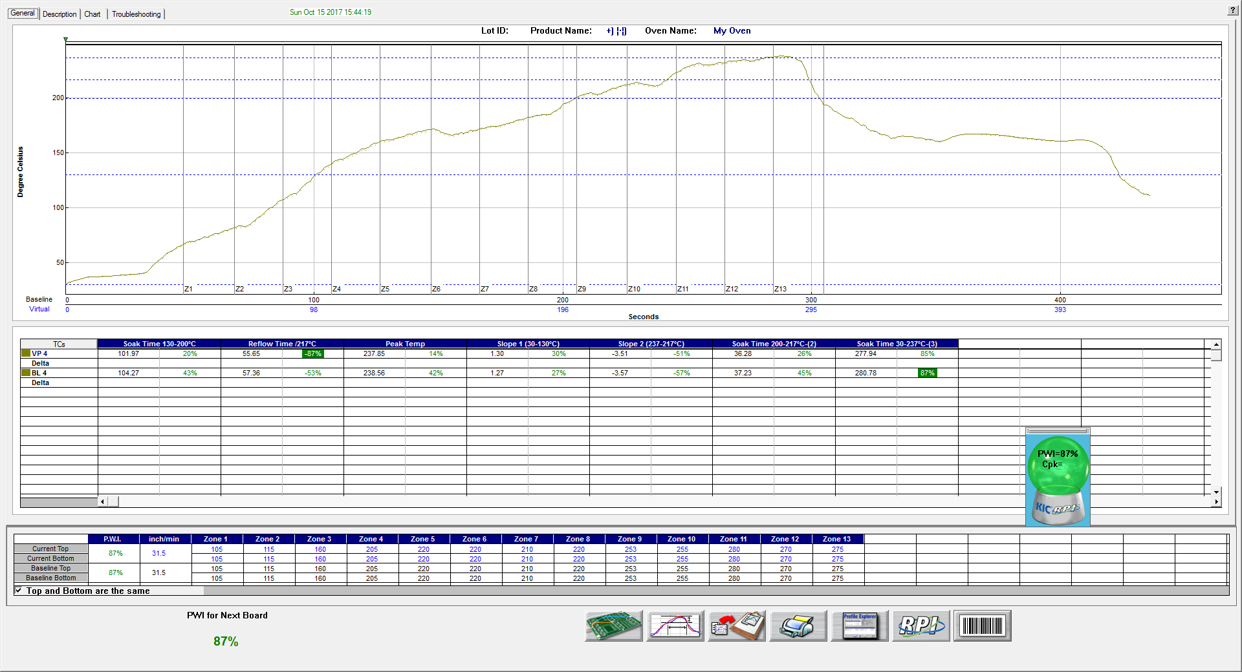

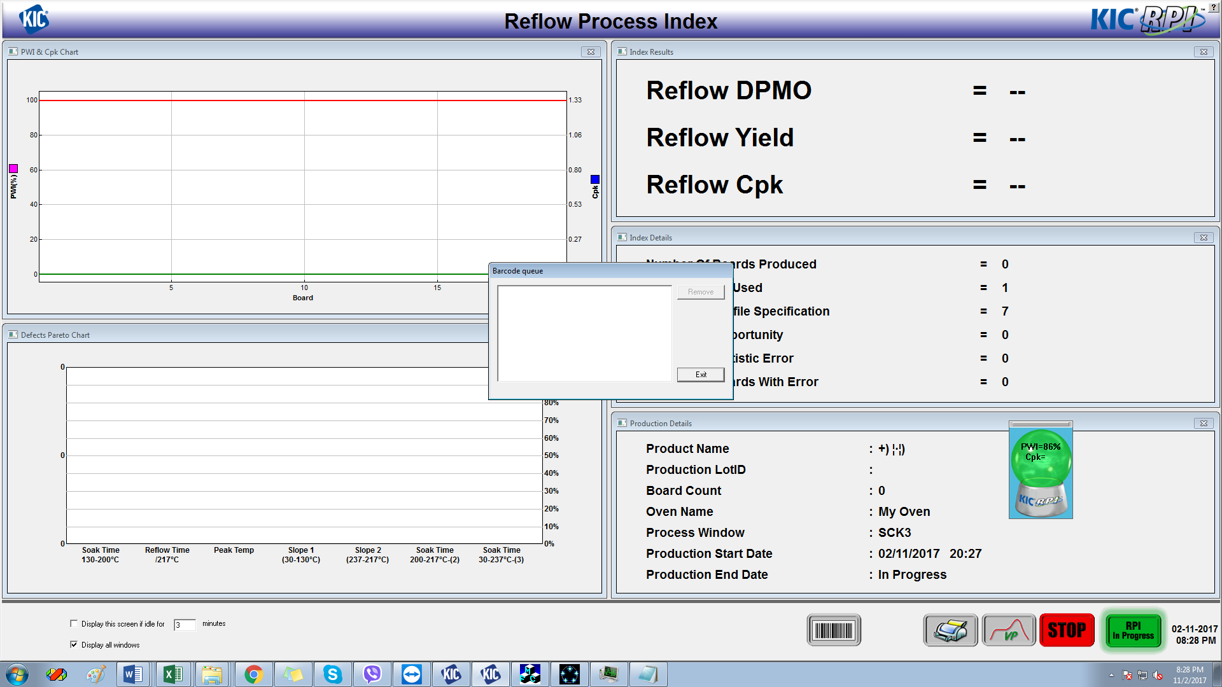

When hovering the mouse over the button, a tool tip “Display Barcode Queue” will display:



### Barcode Queue Dialog

Click the button to open the **Barcode Queue**; this dialog box displays the current barcodes in order. The next barcode to be assigned to a board appears at the top of the list. A barcode is automatically removed from the list after the board has completely passed the entrance board sensor.



Notice that the **Remove** button is disabled until the user clicks a barcode, the **Remove** button becomes active.



### Remove Barcode

Follow these steps to remove a barcode:

1. Click the barcode that matches the board to be removed
2. Click the **Remove** button
3. Click **Yes** on the KIC dialog that asks you to “*Confirm you want to delete this barcode string from the queue*?”   
   Clicking **No** returns the user to the Barcode queue window.



The software then removes that string from the queue and the next string in line will be assigned to the next board.





## View Barcode Traceability Information For Barcodes Previously Run

Barcode information is collected for all the boards that pass through the oven. Barcode information is stored only when Virtual Profiling is running. After the barcode is read, the software will display the barcode value in the bottom-Left corner of the Virtual Profile screen until the next board’s barcode is read. When viewing historical VP data, the selected board’s barcode number is also displayed in the bottom left corner of the screen. See Figure 104.

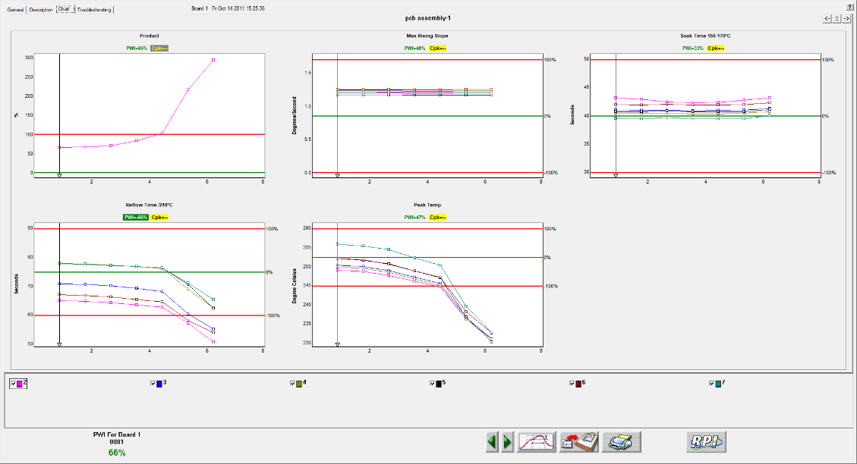

Barcode value display for most recent read by the system or selected board if viewing historical *Virtual Profile* data.

Figure 104: Virtual Profiling – Chart Tab

## Search For Barcode Entries

In the Profile Explorer screen, there is a Barcode button located at the bottom of the page. Select this button to search for specific bar-coded products and view their profile information for the date/time they were processed.

Click on the product folder you want to search and then click on the Barcode button. A dialog box appears with a field to enter the barcode value with a Search button next to it. See Figure 105. You can enter the value using the keyboard, or by selecting the scanner check box and then using the barcode scanner to scan the actual barcode.

Below this is a field that will list the time, date and PWI for that barcode, if it exists for the chosen product. Either double-click the particular listing or highlight it and then click the View Selected Profile button. This will bring you to the Historical Virtual Profile graph for that particular board. If you click on the Charts tab, the Pointer Line will coincide with that particular board for all the charts as well.

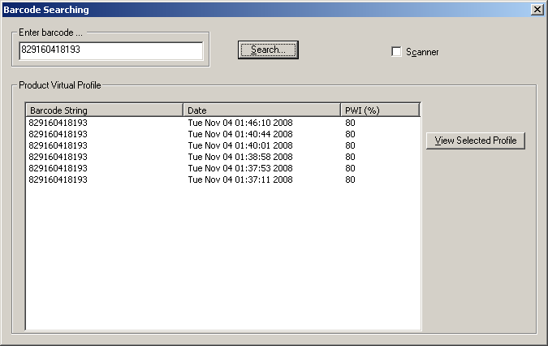

Figure 105: Barcode Search

## Live Data Output And Barcodes

The Live Data Output (LDO) function will output the thermal process data to a file. The thermal process data will include barcode information for every board when the Live Data Output feature is enabled. See the [Live Data Output](#_Remote_Process_Monitor_(RPM)) section in this manual for more information.

Below is an example of the KIC\_RPI\_LiveDataOutput.txt file that is generated by the system when LDO is active. See Figure 106.

**Note**: the tables below were created by importing the LDO data file into Microsoft Excel.



**Barcode data for each board**

Figure 106: Example Live Data Output text file

# Live Data Output

The Live Data Output (LDO) feature outputs Virtual Profile (VP) data in real time for use by third-party applications such as Line Balancing/Production Monitoring Host or SPC software. This data includes barcode information (where applicable) and all relevant profile data, statistics, and limits. There are several different LDO formats that can be chosen from. Examples of these formats will be shown later in this section.

**Output of the LDO file data** –When the VP is running, the statistical data from each newly completed Virtual Profile is written to the LDO file when the board exits the oven.

**Viewing LDO data** – LDO is designed to output data only and is not meant as a historical database. It is intended to be used with third party software that collects the LDO data while the Virtual Profile is running-live. If you are not running third party software to collect the LDO data, and wish you to view historical data, this can be accomplished from within the actual KIC software in use.

**LDO destination** – The location where the LDO output file is written to can be specified by the user in the *ConfigurationProgram.exe* utility.

**Note**: For the Live Data output to function, the appropriately programmed USB dongle key must remain connected to the PC at all times during use. You can verify whether or not you have the LDO feature by viewing the Software Key panel in the Hardware Status screen.

**An LDO output file example**

Below is an example of the type of data included in the LDO output file:

Process Info:

Product Name:

Profile Board\_Soldered TCs

Process Window Name:

\_\_\_\_63\_37\_\_\_\_

Oven Name:

My Oven

Oven Recipe Name:

Conveyor Speed Units:

inches/minute

Temperature Scale:

Celsius

Number Data Points to Calculate CpK:

10

Number of TCs:

6

Number of Statistics:

4

Statistics Limits:

LOW

TARGET

HIGH

Max Rising Slope

0

2.3

3

Soak Time 100-170C

60

120

Reflow Time /183C

45

90

Peak Temp

205

225

Baseline Profile Info:

Profile Start Time:

Thu May 09 12:00:23 2015

Baseline PWI:

81%

Conveyor Speed (Setpoint):

36

Conveyor Speed (Measured):

36.09

Zone Number:

1

2

3

4

5

6

7

Top Setpoints

124

149

157

155

180

225

234

Bottom Setpoints

124

149

157

155

180

225

234

Barcode

Date and Time

Product

PWI

Conveyor

Max Rising Slope

PWI

CpK

Speed

TC2-data

TC2-PWI

TC2-CpK

TC3-data

TC3-PWI

TC3-CpK

c9876d

Thu May 09 12:08:11 2015

75.9

-1000000

35.8

2

-13.5

-1000000

2.1

-7.3

-1000000

ABC123+=-

Thu May 09 12:09:39 2015

75.7

-1000000

35.8

2

-13.3

-1000000

2.1

-7.1

-1000000

12345

Thu May 09 12:13:12 2015

74.6

-1000000

35.8

2

-13.8

-1000000

2.1

-7.2

-1000000

1234565

Thu May 09 12:15:05 2015

75.8

-1000000

35.8

2

-13.9

-1000000

2.1

-7.2

-1000000

Thu May 09 12:18:27 2015

73.8

7.17

35.8

2

-12.9

85.43

2.2

-6.3

84.6

Figure 107: Live Data Output text file

## LDO Formats

There are several standard LDO formats to choose from:

* TSV or CSV format for WordPad
* TSV format for Excel
* 1 Board 1 File (TXT format)
* 1 Board 1 File (XML format)
* 1 Board 1 File (CSV format)

The following are specialized output formats and not typically selected by most users:

* KP Data Only (CSV)
* XML Format A
* XML Format A2
* CUSTOME LDO
* 1 Board 1 File – TXT – Alternate/Custom

## Details of Output Files

### TSV and CSV for WordPad

* The output file type is a .TXT
* TSV format is Tab delimited; CSV format is Comma delimited
* The output file is first generated when the VP is started
* File is appended as each board exits and VP is calculated
* The default output file name is KIC\_RPI\_LiveDataOutput.txt
* The user can choose to define their own specific output file name
* When default or user defined naming is selected, output file is overwritten when product changeover occurs
* File name format can also be set to: PRODUCT\_YYMMDD\_HH-MM-SS.txt
* When this naming is selected, a new file is generated when product changeover occurs

### TSV for Excel

* The output file type is a .TXT
* Format is Tab delimited
* The output file is first generated when the VP is started
* File is appended as each board exits and VP is calculated
* The default output file name is KIC\_RPI\_LiveDataOutput.txt
* The user can choose to define their own specific output file name
* When default or user defined naming is selected, output file is overwritten when product changeover occurs
* File name format can also be set to: PRODUCT\_YYMMDD\_HH-MM-SS.txt
* When this naming is selected, a new file is generated when product changeover occurs

### One board per file (TXT format)

* The output file type is a .TXT
* Separate individual file is generated as board exits oven and VP is calculated
* File name is ProductName\_OvenName\_YYMMDD\_HH-MM-SS\_BarcodeString (Barcode string included when applicable)
* User cannot change file name – with exception of not including barcode in file name

### One board per file (XML format)

* The output file type is a .XML file
* Separate individual file is generated as board exits oven and VP is calculated
* File name is ProductName\_OvenName\_YYMMDD\_HH-MM-SS\_BarcodeString (Barcode string included when applicable)
* User cannot change file name – with exception of not including barcode in file name

### One board per file (CSV format)

* The output file type is a .CSV file
* Separate individual file is generated as board exits oven and VP is calculated
* File name is ProductName\_OvenName\_YYMMDD\_HH-MM-SS\_BarcodeString (Barcode string included when applicable)
* User cannot change file name – with exception of not including barcode in file name

### One board per file – TXT - Alternate

* Similar to ‘standard’ one board per file TXT output
* Adds lines for ‘customer name’ (taken from Profile Description); separate lines for Date and Time boards entered and exited; which TC had highest PWI

### One board per file – TXT - Custom

* Similar to ‘standard’ one board per file TXT output
* Does not include temperature specs in specifications (Reflow\_Time instead of Reflow\_Time\_/218)

**Note:** Examples of each of the available output file types can be found in the C:\RPI\Sample LDO files folder or click the ‘Open’ button next to a selection.

## Graphical user interface, text, application Description automatically generatedConfigure LDO

1. With the KIC software shut down, browse to the C:\RPI folder and run the ConfigurationProgram.exe application, and select the LDO tab.
2. Check the ‘Enable Live Data Output’ checkbox at the top
3. Select the desired Format
4. The type of Format chosen will affect what naming structure for file will be used (See Details of Output Files above).
5. Select the output file destination path by clicking on the *Browse* button. This needs to be a location on the local drive.
6. ‘Max File Size’ lets you specify how large the LDO output file can get before a new one is started.
7. Select ‘Include Alarm Events’ to record into the output file any warnings or alarms.

If one of the Tab or Comma Separated formats is selected, and a VP is running for an extended amount of time, once the maximum file size is reached, a new file will be generated, and the new file name will be appended with a \_# as shown in the example below:

**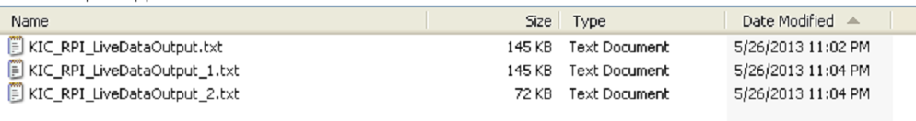**

### Include Alarm Events in the Output File

When *Include Alarm Events* is selected, any alarm and/or warning events that occurred while a board was in the oven will be saved into the output file along with the board data.

**Alarm Event LDO Output File Examples**

Below are examples of the Tab Separated and One Board per File outputs with the *Include Alarm Events* enabled:



Tab Separated One Board per File

## Delete Accumulated LDO Files

In time, accumulating LDO files can take up too much hard disk space and need to be deleted. The software provides an *Auto Delete* function that lets you specify time intervals for automated file purging. You can specify a maximum number of days–up to 1827 (five years)–that the system retains the files before automatic purging. You can also select a time in the 24-hour cycle for the system to automatically check for files that exceed the maximum day limit.

1. In the RPI folder, double-click on the **AutoDelete** icon. 

The Auto Delete LDO files screen appears:



1. Click in the *Max days to exist* field, and type in a new value.



|  |  |
| --- | --- |
| 1. Use the drop-down list to select an hour during the day to check for old files.   C:\Users\dklueck\Desktop\Auto Delete LDO time to check2.png   1. Click the Apply button. | C:\Users\dklueck\Desktop\Auto Delete hour list exposed.png |

# Dual Lane Systems And Functionality

The automatic system can monitor production through dual lane reflow ovens. This section will define the unique capabilities of the dual lane configuration.

A *Dual Lane-Dual System* configuration uses two instances of the software application to track different recipes through the oven.

The *Dual Lane-Single System* tracks two lanes of the same recipe with one instance of the software.

A radio button display during the installation routine lets you choose between the standard configuration or one of the dual lane setups.

**Note**: For more information about the hardware components of the system, see the *Automatic System Hardware Installation Manual* (TFS-330210-000).

## Dual Lane Dual Systems

A dual system installation features two distinct instances of the RPI software and a complete duplication of the thermal management hardware. Dual systems include *two*:

* Pairs of probes
* Encoders
* eTPUs
* Board sensors

|  |  |
| --- | --- |
| Each RPI instance receives data from its own associated eTPU. Each stores its logged data and executable subroutines in separate folders identified as either *front rail* or *back rail*. (The front rail designates the lane closest to the lifting cover of the oven—the back rail designated the lane closest to the hinge of the oven cover.) | C:\Users\dklueck\Desktop\DSC09143b.jpg |

The two instances of the software permit using different recipes in each lane. In the desktop toolbar, each RPI instance is represented by its own icon – F for Front Rail and B for Back Rail.



## Dual Lane Single Systems

The single system configuration uses only one RPI instance. An installation includes one set of thermal management hardware supplemented with *an additional product sensor*. One product sensor is associated with each lane.

The single system uses the same recipe on both lanes but tracks two flows of product across the user interface. When in Live Mode, the white rectangle icons track two boards through channels at the top of the General, Chart data, and Troubleshooting tab screens:



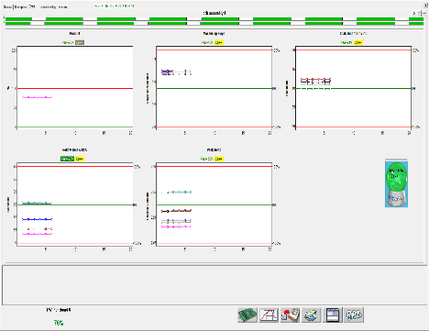 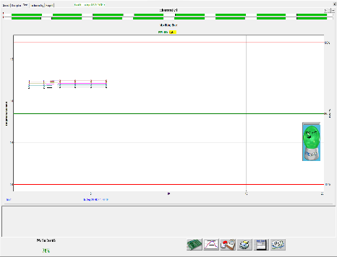 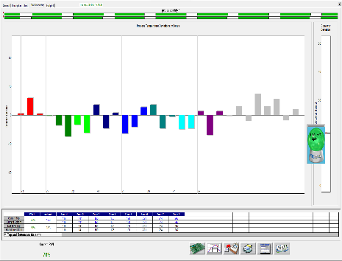

The system calculates a separate data set for each board. It accumulates historical data in a manner just like a single lane oven. A “Lane Identifier” will be saved with the data from each board for identifying which lane the particular board was processed in.

## Configure Dual Lane Systems

During the software installation, you will have the option to select what type of system will be in use:

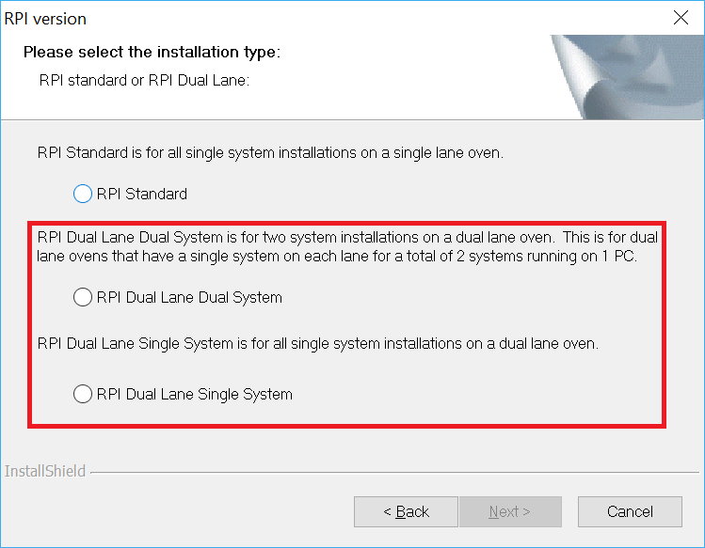

You would select “*Dual Lane Dual System*” if there is a complete system installed on each lane of the oven.

You would select “*Dual Lane Single System*” if there is only one system installed across the two lanes of the oven.

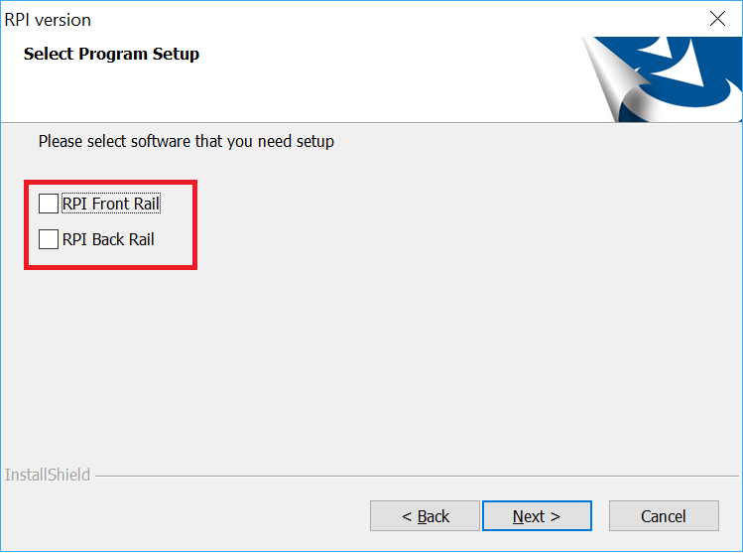

When “*Dual Lane Dual System*” is selected, as noted previously, there will be two separate software directories used – one for the “Front” and one for the “Back”. You will be able to choose whether you want to install the software for either one, or both directories.

### Dual Lane Configuration

Additional settings for a Dual Lane system configuration can be found in the *ConfigurationProgram.exe* located in 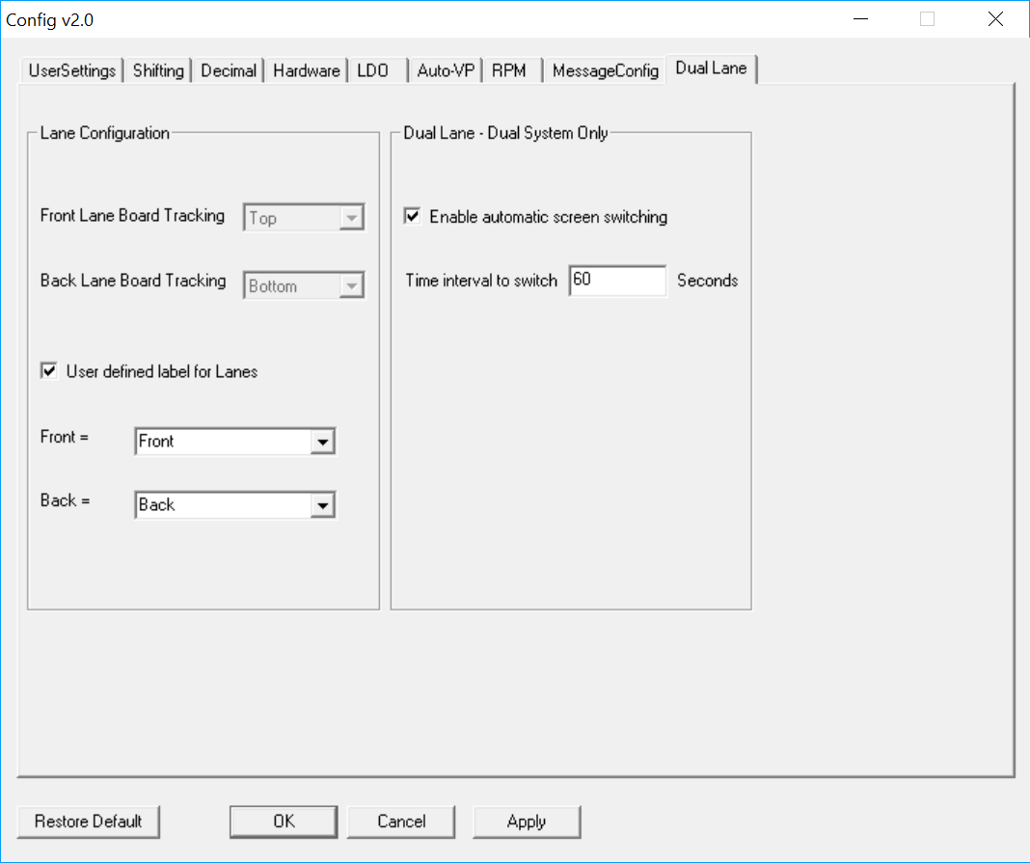the *C:\RPI directory*.

***Lane Configuration*** – For a Dual Lane-Single System, this section allows you to specify the position of the Board Tracking display in the software for each lane.

***User defined label for Lanes*** – By default, the software will label the lanes “Front” and “Back”. When the checkbox is checked, the drop-down menu allows you to select alternate designations for the lane names.

**NOTE:** The Front Lane is always the lane closest to the front side of the machine.

***Dual Lane – Dual System Only*** – When a Dual System is in use, there are two instances of the RPI software running – one for each lane. By default, a user must select the lane they want to see on the screen at any given time.

When selecting this checkbox, the user can define an interval for the software “automatically” to switch over to the other lanes display after no input from the mouse cursor. **Note**: *Automatic switching will only occur when both lanes are running a live VP.*

**Note: For Dual Lane Dual System installations, the settings in this configuration utility must be entered into both install directories – C:\RPI Front Rail and C:\RPI Back Rail.**

On Dual Lane Dual Systems, when you select *User defined label for Lanes*, the selection chosen will display as a watermark on the Index, General, Description, Charts, and Troubleshooting screens. See example below:

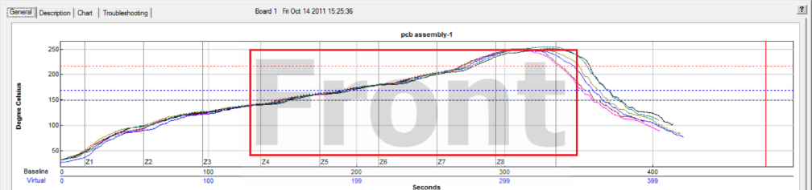

#### Configuring to profile

The profiler can only communicate with one lane at a time, so you must select which lane you want the profiler to connect to. Disconnect then reconnect the profiler (or Smart Dock/Base Station where applicable). A pop-up menu will display in the lower right of the screen allowing you to select which lane to connect to. Repeat these steps to change to the other lane.

# Vacuum Reflow Oven Systems And Functionality

Vacuum reflow ovens typically include an extra chamber in between the heated and cooling sections of the oven. During production, the PCB travels into the vacuum zone, the chamber is sealed off from the rest of the process tunnel, and a vacuum is drawn. The chamber is opened, and then the PCB continues into the cooling section and exits the oven. The purpose of adding a vacuum chamber to the process is to reduce voiding in the formation of the solder joints. The RPI system can be integrated into select\* vacuum reflow ovens. This section outlines the unique capabilities of the *RPI Vacuum* system.

\* *Contact KIC to check for compatibility with your machine*

In addition to the other functionality described in this manual, the *RPI Vacuum* system includes:

* Process monitoring capabilities throughout the entire process, including the vacuum zone
* Time duration PCB spent in vacuum zone automatically saved with each profile
* Time duration PCB spent in vacuum zone automatically saved for each PCB during production
* A dynamic graphical display of the vacuum zone for each PCB (based on the time each PCB spent in the chamber)

Note: Software communication with the applicable oven controller software may be required for the *RPI Vacuum system.*

## RPI Vacuum System Hardware

The *RPI Vacuum* system incorporates custom built thermal probes unique to the vacuum ovens which allow for monitoring the heated zones, vacuum chamber, and cooling section to provide complete monitoring of the PCB through the process.

## RPI Vacuum System Functionality

During profiling, the system identifies the duration that the PCB spent in the vacuum chamber, and the graphical display of the vacuum zone is drawn to match this time. A window is also displayed (and saved with the profile) showing how much time, in seconds, the PCB spent in the chamber.

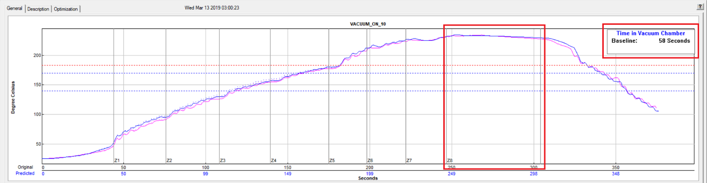

On vacuum ovens, even if the vacuum chamber is not in use, the software will still display the vacuum zone on the graph, and show the time spent in that zone (based on length of zone defined and conveyor speed setpoint).

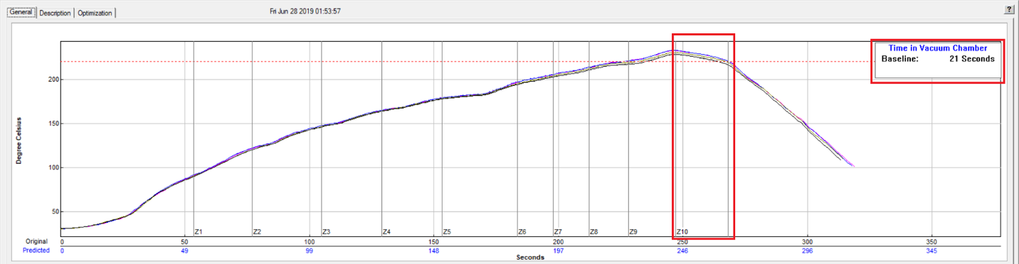

During production, as with systems installed on non-vacuum ovens, the live-mode screen displays both the baseline and virtual profile information. To distinguish between the two, the baseline profile appears in a solid line format, while the virtual profile appears in dashed lines.

The window showing the *Time in Vacuum Chamber* includes both the time from the baseline profile as well as the time the current production PCB spent in the chamber:

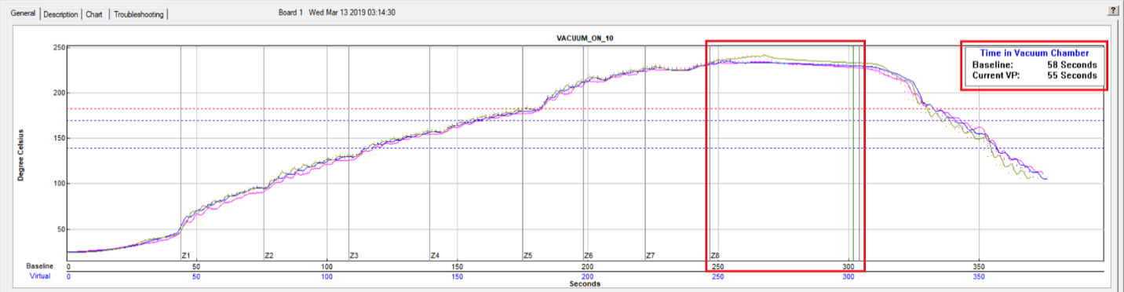

Additionally, a green line (*End of Vacuum Zone Indicator*) appears on the graph representing the calculated end of the vacuum zone. Depending on the time a given PCB spends in the chamber, this green line will shift forward or back to show the relative ‘size’ of the zone. More time in the chamber equates to a ‘longer’ zone, and less time a “shorter” zone.

As you can see in the example below, this PCB spent approximately 26 seconds less in the chamber than the baseline, so the green *End of Vacuum Zone* indicator is shifted forward to represent this ‘shorter’ zone size. Due to this, you can also see the VP (dotted lines) shows an earlier drop in the TC temperatures compared to the baseline:

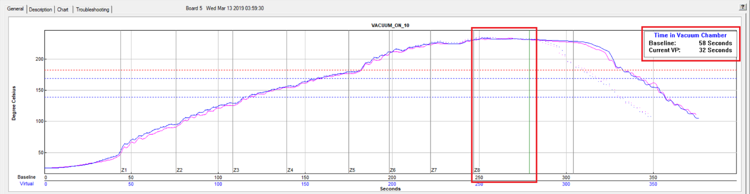

In this example, the baseline profile spent much more time in the chamber, so the display of the vacuum zone is extended to represent a ‘longer’ zone:

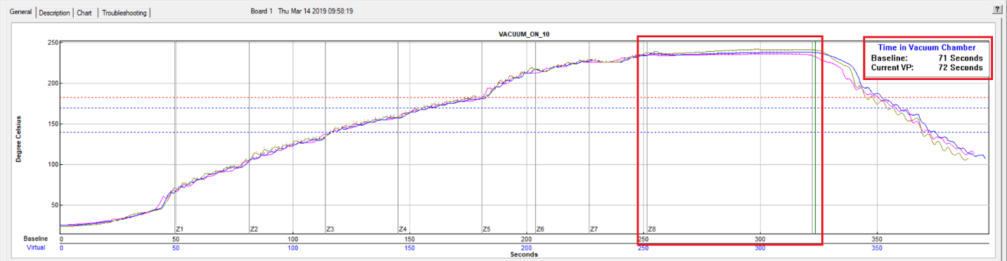

### Additional Warning for Vacuum Process

On *RPI Vacuum* systems, an additional warning can be enabled for users who want to be notified if the time that production boards spend in the vacuum chamber varies too much from their baseline profile setup.

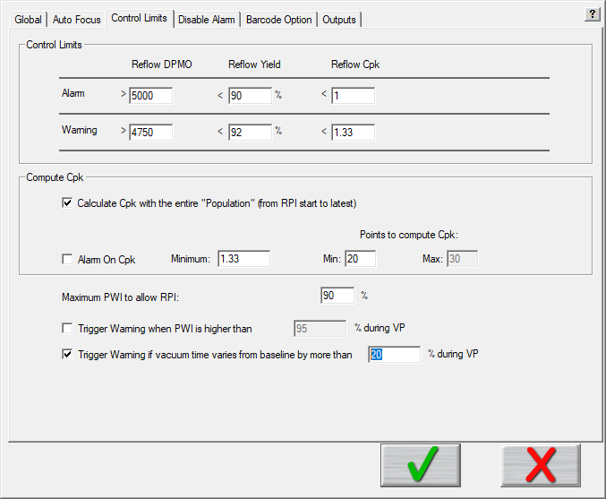

To enable this feature, access the *Global Preferences/Control Limits* tab and select the checkbox for – ‘*Trigger Warning if vacuum time varies from baseline by more than’.*

Enter the percentage of variation in time you will allow before the system should display the warning message.

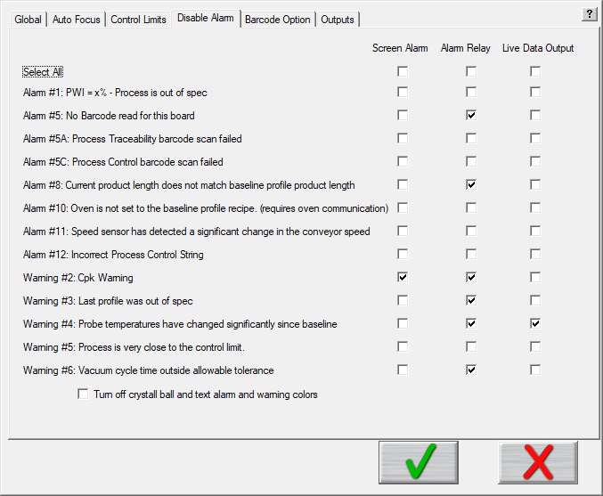

Additionally, you can select the *Disable Alarm* tab to further customize what happens if this warning occurs.

**NOTE:** Selecting a checkbox on this screen DISABLES the particular function.

By default, the warning message will appear on the screen (checkbox not selected), the Alarm Relay will NOT be activated (checkbox selected), and the warning will be included in Live Data Output files (when LDO is in use and enabled).

Click the **green checkmark** button to save any changes and return to the RPI main screen.

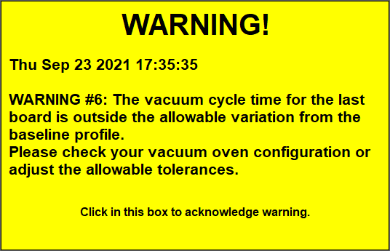

**Example of Warning Message**

When this feature is enabled, and the time in the vacuum chamber varies from the baseline time by more than the allowable percentage, the following warning message will be displayed when the board exits the oven and the Virtual Profile is calculated:

### Additional Board Sensing Logic for Vacuum Process

On some dual lane vacuum reflow machines, stoppers may be used by the oven manufacturer to sync up the products in the two lanes before allowing them to enter into the heated zones. In these configurations, a special function can be enabled which will alter the standard board sensor operation so that if a product is stopped (and is underneath the board sensor), the board sensor will only detect it as a single product.

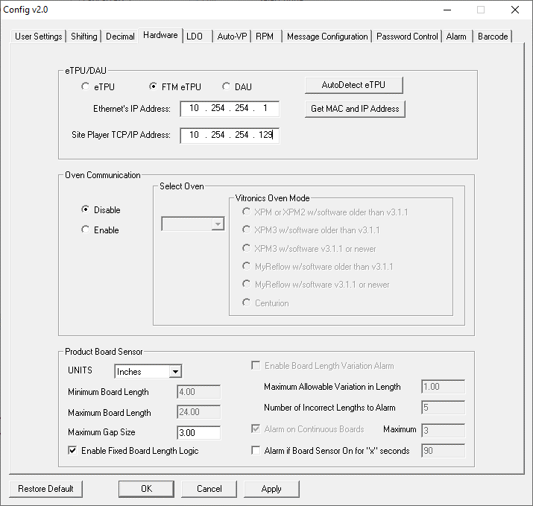

To enable this feature, shut down the software and open the *C:\RPI\ConfigurationProgram.exe* application.

On the Hardware Tab, select the Enable Fixed Board Length Logic checkbox. When this feature is enabled, you can also enable an alarm notification to alert you if the board sensor is triggered too long (board stuck, improper sensor function, etc.). *Select the Alarm if Board Sensor On for “x” seconds* checkbox and then enter the amount time delay before the alarm should be generated. Click *Apply* and *OK* to save your changes and exit the Configuration utility.

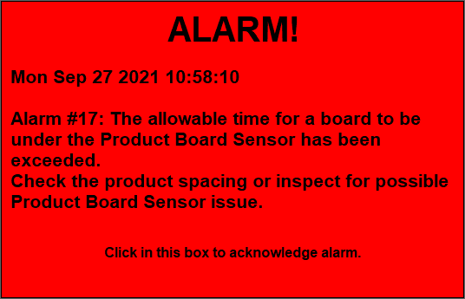

**Example of Alarm Message**

When this feature is enabled, and the board sensor is triggered longer that the limit set, the following alarm message will be displayed:

# Run RPI without the Board Sensor

For some applications, such as semi-conductor processes where product is positioned at various locations across a mesh conveyor belt, or other situations where you do not want to or cannot track each individual product entering the process, you have the ability to setup the system to calculate the Virtual Profile based on specified time frequency.

When configured in this method, every “X” number of seconds, a VP will be calculated and displayed on the screen. There will be no board tracking across the top of the screen, and there will be no identification possible of whether there was product in the machine or not when each VP is calculated.

To enable this functionality:

1. Close the software if open.
2. Using Windows Explorer, open the file: C:\RPI\Log\KIC2000UserSettings.kiccfg (If necessary, select *NOTEPAD* as the application for opening the file)
3. In the [PROPHET] section, find the lines:

[PROPHET]

ChartVPDataWithoutBoardSensor=0

ChartVPDataWithoutBoardSensor: Enable/Disable the board sensor (0=Enable, 1=Disable).

1. Change the line to:

[PROPHET]

ChartVPDataWithoutBoardSensor=1

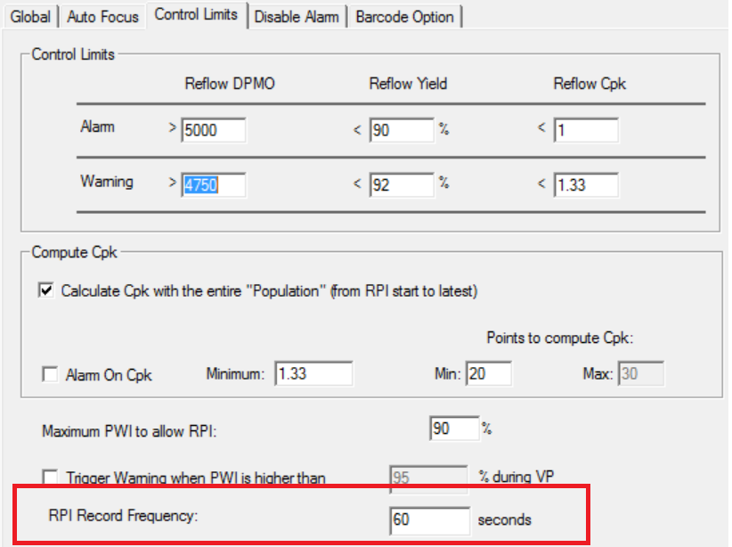

1. Save your changes and close Notepad.
2. Restart the software.

Once the software is running, select Global Preferences/Control Limits and you will see a new section at the bottom of the screen called “RPI Record Frequency”. In this selection, you can specify how often the VP will be calculated. You can enter any value from 10 to 100000 seconds.

## Preload the Oven

Without a Board Sensor, the software cannot sense the product, so there is no way for the system to know when products are present and not present. Therefore, there is no compensation for product load on the oven by the software.

In order to produce a profile that best represents the production conditions, it may be necessary to pre-load the oven with products, so that the collected profile data most resembles that of a production piece.

If the baseline profile is run without pre-loading the oven, you may see a rise in PWI, or even some alarms associated with oven change since the baseline profile, once Virtual Profiling is activated, and production has begun.

# Remote Process Monitoring

**Note**: The software key must remain connected at all times during use for RPM capabilities to function.

KIC Remote Process Monitoring (RPM) enables customers to view real-time thermal process data and process status for any RPI on their reflow or cure ovens from any authorized computer on the network.

* The RPI provides valuable thermal process information in real-time. The RPM can supply this information to all relevant decision makers wherever they happen to be in the factory. The results are better data management, efficient process management and oversight, and faster reaction to thermal process issues in the factory.
* RPM provides superior information sharing for the factory as a whole. RPI monitors, controls, and displays at the oven, the thermal process information for a single oven. RPM will, on a single screen, show all the pertinent data for all the ovens in the factory on any authorized computer on the network.
* RPM translates complex process issues into a very easy to understand format. Quality managers, production managers, engineering managers, and line supervisors will, for the first time, access meaningful factory-wide quality and productivity information for the thermal process in real-time without the need for staff meetings, lengthy reports, interpretation, and unnecessary visits to the factory floor

RPM is comprised of three main software applications, and one optional software component:

1. **RPI software:**

The RPM for the RPI data is a dongle-protected software option. This software runs on the RPI system on a computer at the oven. RPM’s main function is to send data over a network to the KIC Server software.

While RPM is enabled, a separate application called WatchDog runs in the background continuously monitoring the connection between each RPI system and the KIC Server(s).

1. **KIC Server software:**

The KIC Server software is installed onto a computer or drive on the network and acts as a host for all RPI systems running on the network with the RPM output. It automatically connects to all the RPIs that are running RPM and passes on the data to any authorized computer on the LAN that is properly logged on. A maximum of 100 ovens per KIC Server is possible. The KIC Server has a setup menu for creating and editing user names and passwords for KIC Viewer users.

1. **KIC Viewer software:**

The KIC Viewer is installed on any remote computer on the network (i.e. at your desk) and is used to view the data from all RPI systems connected to the KIC Server. This is done by logging on to the KIC Server.

1. **Win VNC:**

Win VNC is a third party software application that allows you to remotely control, or view the history for any RPI client PC on the same LAN. This can be useful for clearing alarms, loading recipes, and system administration.

In full operation, the combined software and systems function as follows: (See Figure 108.)



Figure 108: RPM functional diagram

* Each RPI system at the reflow or cure oven runs in Virtual Profiling mode, monitoring the process and giving real-time profile/process data for each production board. The Virtual Profile data is stored locally on the RPI client PC.
* The Oven Name, Product Name,Process Window Index (PWI), Real-Time Cpk, and current Alarm State (green, yellow, red: with alarm text) are sent to the KIC Server as each board exits the oven.
* The KIC Server accepts the data from allRPIs configured to send data, acting as a host for all the data.
* The KIC Viewerlogs on to the KIC Server and displays the pertinent data for all ovens, on one screen, updating each one as boards exit and new data is sent.

## Configure RPM Output

### RPI Client PC

To enable the RPM feature:

1. Close the RPI software if open.
2. Using Windows Explorer, browse to the C:\RPI folder and run the ConfigurationProgram.exe application.
3. Select the RPM tab
4. Check the “LON in use” checkbox
5. Enter the IP address of the PC that will be running the *KIC Server* application.

LON Oven ID can be left blank, as the *KIC Server* software will automatically assign it a position.

1. Click Apply, then OK to close the Configuration Program.

When the RPI software is launched you will see two icons displayed in the notification area, as shown:

 

**Note**: The RPI icon will change based on the connection state with the KIC Server.

|  |  |
| --- | --- |
|  |  |
| RPI is not connected to a KIC Server | RPI is connected to a KIC Server |

If the RPI is not connected to a KIC Server, check to make sure the KIC Server:

* Hosting mode enabled (KIC Server-click the Start to Host button)
* Displays the communication status of the RPI systems that are connected.

For more details, see the [KIC Server](#_KIC_Server) section of this manual.

### KIC Watchdog

The KIC WatchDog is a software program that runs in the background when RPM is enabled. Its main function is to continuously monitor communication between the RPI client PC and the KIC Server PC.

**Note**: The KIC WatchDog software is not user configurable.

KIC WatchDog automatically starts up when RPI launches with RPM enabled (DO NOT CLOSE IT). The KIC WatchDog’s Icon displays on the bottom right corner as shown below:

KIC WatchDog Icon

RPM Icon

 

## KIC Server

The *KIC Server* software acts as a host for all networked RPI systems running the RPM option. The software connects all these systems and passes their data over the LAN to any authorized, properly logged on computers running the *Viewer* application.

You must install the *KIC Server* software on a LAN-connected PC on the same LAN as the RPI software. This PC cannot simultaneously serve as an RPI client, but it can run the Viewer application. The KIC Server can manage up to 100 ovens and has a menu for creating and editing user names and passwords for KIC Viewer-users. Your RPI installation media includes the KIC Server software, but the application requires the continuous connection of an appropriate software key.

### Install the KIC Server:

**Note**: You must install the KIC Server manually.

1. Browse the RPI installation media for the KIC Server folder.
2. In the KIC Server folder, run the file Setup.exe.

The installation begins automatically.

1. Follow the on screen directions.

**Note**: It may be helpful to copy the KIC Server shortcut to the Windows-Startup folder especially for dedicated-KIC Servers.

### Launch the KIC Server:

1. From the Windows desktop, click on: Start » Programs » KIC » KIC Server

**Or**

1. From Windows Explorer open C:\KIC Server\KICServer.exe

### Icons

Once the KIC Server application is launches, an icon appears in the notification area.

|  |  |
| --- | --- |
| When first launched, the KIC Server application is idle; you must select the Start to Host button in order to enable hosting by the KIC Server. See Figure 109. | Figure 109 |
| Once you select the Start to Host button, the icon will change indicating the KIC Server can accept connections. See Figure 110. | Figure 110 |

### KIC Server Window Functions

The KIC Server window is shown in Figure 111. The screen permits the following six functions:

1. Add new users and passwords for KIC Viewers to connect.
2. Edit/delete users and Passwords
3. View the connection time and IP address for each RPI client PC that is connected
4. View the KIC Viewer-User name and connection time.
5. Maximum number of Ovens - Enter the number of ovens you wish to display in the KIC Viewer window.
6. Start to host – Enables/disables the KIC Servers’ connection mode.

#### Add a new user

1. Enter the new user name.
2. Enter the new password.
3. Select the Add button.

You are added to the list of users. To access a list of users select the List of Users dropdown menu.

#### Change a password

1. Click on the List of Users dropdown menu.
2. Select the user that you wish to modify.
3. Enter the new password for that user.
4. Select the Change Password button.

The user’s password is updated immediately.

#### Delete a user

1. Click on the List of Users dropdown menu.
2. Select the user that you wish to modify.
3. Select the Delete button.

The user account deletes immediately.

Figure 111: KIC Server Window

**Maximum number of Ovens** – This value controls the number of oven boxes displayed on the KIC Viewer screen the maximum number of ovens is 100, minimum 1.

**Start to host** – The KIC Server will not accept connections until this button is selected. You must manually select this button to enable hosting by the KIC Server application.

## KIC Viewer

*KIC Viewer* software lets you remotely view production data from all RPI systems connected to the *KIC Server*. The software is included on the RPI installation media and can be installed on a desktop PC or any computer on the network. It can be installed on a separate PC or on the same PC with the KIC Server or the RPI client.

**Note**: Once installed, you first need to *enable* the application in the configuration file and *connect* to the *KIC Server* before you can launch the application.

### Install the KIC Viewer

You must install the KIC Viewer manually.

1. Browse the RPI installation media for the folder named *KIC Viewer*.
2. In the folder, run the file **Setup.exe**.
3. When the installation begins, follow the on-screen directions.

### Configure the KIC Viewer Application

You can configure the application in two ways:

1. Using the networking path – this method with allow you to view historical data via a separate application called “App for Viewer”.
2. Using a VNC application – this method will allow you to view historical data via the use of VNC software to directly access the RPI Client software/PC.

### Use KIC Viewer by the Networking Path

|  |  |
| --- | --- |
| 1. Close the KIC Viewer application and then open the configuration file at the following location:   C:\Kicviewer\Configure\kwConfigure.kcfgfile – setup:   1. Set **EnableRemoteControl** flag to = **0**. 2. Set**[RemoteControlPC] Enable** flag to = **1**. 3. Select File/Save, then close the file. |  |

### Use KIC Viewer using VNC

|  |  |
| --- | --- |
| 1. Close the KIC Viewer application and then open the configuration file at the following location:   C:\Kicviewer\Configure\kwConfigure.kcfgfile – setup:   1. Set **EnableRemoteControl** flag to = **1**. 2. Set**[RemoteControlPC] Enable** flag to = **1**. 3. Select File/Save, then close the file. | C:\Users\dklueck\Desktop\Enable KICViewer VNC.png |

### Connect to the KIC Server

To connect to a *KIC Server*, enter a valid user name and password from the *KIC Viewer* machine. See the [KIC Server](#_KIC_Server) section for details.

**Note**: It is very helpful to have the IP address of the PC running the *KIC Server* application as this information is required each time a *KIC Viewer* connects to a *KIC Server*.

### Launch the Application

1. From the Windows desktop, click: Start » Programs » KIC » KIC Viewer
2. From Windows Explorer, open C:\KIC Viewer\KICViewer.exe
3. Enter the KIC Server IP address, a valid user name and password. See Figure 112.



Figure 112: KIC Viewer – Connect

The *KIC Viewer* main screen with its toolbar menu appears:



Figure 113: KIC Viewer – Main Screen

#### The KIC Viewer Toolbar Button Menu

|  |  |
| --- | --- |
| KICViewer--Toolbar - View Icon Display Icon view (View)  KICViewer--Toolbar - View Chart Display Chart view (View)  KICViewer--Toolbar - Connect Connect to KIC Server (Connect)  KICViewer--Toolbar - Auto-Update Turn Auto-Screen mode On/Off (View)  KICViewer--Toolbar - Prev Page Display Previous page (View)  KICViewer--Toolbar - Next Page Display Next page (View) | KICViewer--Toolbar - Reload Config Reload Configuration (Configuration)  KICViewer--Toolbar - About About box (Help)  KICViewer--Toolbar - Sort Cpk Asc Sort by ascending Cpk values (Layout)  KICViewer--Toolbar - Sort Cpk Des Sort by descending Cpk values (Layout)  KICViewer--Toolbar - Sort PWI Asc Sort by ascending PWI values (Layout)  KICViewer--Toolbar - Sort PWI Des Sort by descending PWI values (Layout)  KICViewer--Toolbar - Sort Orig Sort by Original order (Layout) |

#### Configuration

1. Reload the configuration – This feature manually reloads the configuration in the event you changes the configuration without exiting the KIC Viewer software.
2. Oven selection – Allows you to turn On/Off the ovens to view. See Figure 114.



Figure 114: KIC Viewer – Activate/Deactivate Ovens

### Icon View

The Icon view provides the oven name, product name, Process Window Index (PWI) value, Cpk value, and alarm state for each product as they exit the oven with RPI. The alarm states are color-coded (green, yellow, red) in accordance with the standard RPI alarm categories. This information is organized as a box per oven. See Figure 115.



Figure 115: KIC Viewer – Icon View

A grey oven box can indicate there is a problem with the oven:

1. The RPI client PC is no longer connected to the KIC Server application.

As soon as the RPI client PC begins running Virtual Profiling again, the oven box will return either green, yellow, or red based on the current conditions in that oven.

If the KIC Server application was closed, each KIC Viewer will wait until the KIC Server is launched again. If for any reason the KIC Viewer does not automatically reconnect, select Connect from the main menu, and enter a valid user name and password to reconnect.

1. The RPI client PC is no longer running Virtual Profiling
2. No products have passed through the oven yet. The icon for each oven will remain the color grey until the first board has passed through the oven.

#### View Historical Data

By right-clicking on an oven box in the Icon View, you can view the history for any oven via the Profile Explorer.

**Note**: In order to use this feature, WinVNC software program must be installed and configured.

#### View History Display

|  |  |
| --- | --- |
| Only the current product folder appears.  If you want to see all products profiled on this oven, then click on the “Browse” button (top right corner). See Figure 116.  Click **OK** in the pop up box asking to select a working folder. Then all of product names appears as shown in Figure 116.  Click on the RPI main screen button to exit View History mode. | Figure 116: Profile Explorer via KIC Viewer |

|  |  |
| --- | --- |
| Figure 117: Profile Explorer | Exit View History  Figure 118: Profile Graph – General Tab |
| Exit View History  Figure 119: Profile Graph – Chart Tab | Exit View History  Figure 120: Profile Graph – Troubleshooting Tab |

The history view provides all the standard RPI information such as all the production event logs, production run data such as statistics, and basic SPC graphs. See Figure 117 thru Figure 120.

### Remotely Control an RPI Client PC

Remote control requires a third party software named VNC. VNC software can be downloaded free from the internet.

Through the software program VNC, you have the ability to control any RPI client that is currently connected to a KIC Server. The remote control feature is only active when VNC Server is installed, and running on the RPI client PC. This can be useful for clearing alarms, loading recipes, and system administration.

|  |  |
| --- | --- |
| Right-click on an oven box, a menu appears. Select Remote Control RPI PC. A password dialog box appears. Enter the VNC Server password. See Figure 121.  As long the RPI, KIC Server, KIC Viewer and VNC Server software are properly configured, you will have direct-remote control of the selected RPI client PC via VNC Viewer software application. | Figure 121: VNC Authentication |
| If the VNC Server application is not running on the RPI client PC, a VNC error message appears stating, “Could not connect to KIC Server”. See Figure 122. | Figure 122 |

Close and exit.

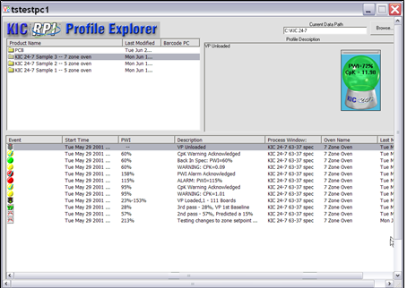

Figure 123: Remote Control Screen

To end Remote Control and return to the KIC Viewer application, manually close the VNC Viewer software application.

### Chart View

The chart view displays the PWI value for each of the last 100 products processed through each oven/ RPI system. See Figure 124.



Figure 124: KIC Viewer – Chart View

In the chart view, right‑click on an oven box to display a full-screen chart for that oven. See Figure 125.



Figure 125: KIC Viewer – Full-screen oven chart view

### WinVNC

Virtual Network Computing (VNC) is remote control software that allows you to view and interact with another computer anywhere on a local network. The two computers do not even have to be the same type or have the same operating system. VNC also has the capability to remotely control any RPI client PC.

WinVNC is a third party software application that is not distributed by KIC. VNC software can be downloaded from the internet

VNC software contains multiple applications including VNC Server. Run VNC Server on the RPI client PC while Virtual Profiling is running in order to view historical data or remotely control any RPI client PC via the KIC Viewer application.

A VNC’s icon appears on the bottom right corner of the monitor. See Figure 126.



Figure 126: VNC task tray icon

### Modify VNC properties:

|  |  |
| --- | --- |
| 1. Double Click on the VNC icon.   The Current User Properties screen (Figure 127) appears.   1. Enter a password for other computer to access this client PC. (You are asked to enter this password each time any KIC Viewer attempts either Viewing History, or Remotely Controlling this RPI client PC) 2. Click the **OK** button. | Figure 127: VNC Properties |

# O2 Live (Optional)

**Note**: The software key must remain connected at all times during use for *O2 Live* capabilities to function.

*O2 Live* is an optional feature that allows you to display an O2 PPM measured value on a profile, or Virtual Profile data. *O2 Live* is not an oxygen analyzer, but an option that allows for the output from a user’s existing analyzer to be read in and displayed by the RPI software. An external interface device connects between the output of the oxygen analyzer, and the PC (USB port) running the RPI software (*See TFS-330210-000 Automatic System Hardware Installation and Maintenance Manual for more details about the interface device)*. This O2 PPM value is available in the following areas of the software:

* Baseline Profile
* Virtual Profile (Live)
* Virtual Profile (Historical data)
* SPC
* LDO
* RPM

## Configuration

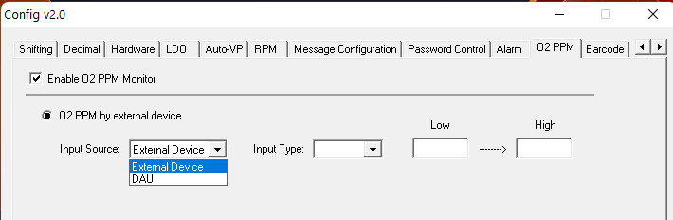

Figure 128: O2 Live Configuration

1. With the KIC software shut down, in the C:\RPI folder, run the *ConfigurationProgram.exe* application and select the ‘O2 PPM’ tab.
2. Select “Enable O2 PPM Monitor”
3. From *Input Source* drop-down menu, choose the option that corresponds with your hardware.
4. From the *Input Type* drop-down menu, choose the option that corresponds with the type of output used on the customer’s oxygen analyzer.
5. The Low and High values will correspond to the minimum and maximum range of the output; e.g. a Low of 0=0 volts, and a High of 500 equals 5 volts.
6. Click the ***Apply*** and ***OK*** buttons at the bottom of the Configuration Program to save changes and close.
7. Restart the RPI software and access the Global Preferences screen.

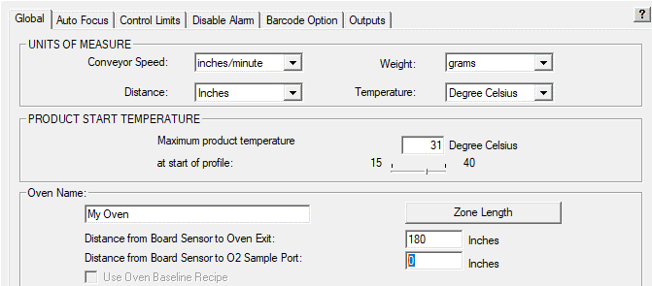

Figure 129: O2 Sample Port Entry

1. Enter the measurement from the KIC Board Sensor to the point inside the oven tunnel where the O2 sampling port is located.

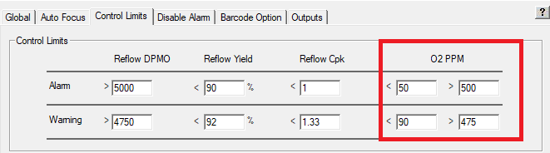

Figure 130: O2 PPM Control Limits

1. Select the *Control Limits* tab to specify the Warning/Alarm limits for the O2 PPM.
   1. You are able to set both minimum and maximum values limits for Warning and Alarm conditions
   2. When the measured value is within the Warning limit range, the O2 display window will be Green in color
   3. When the measured value is outside of the Warning limit range but within the Alarm range, the O2 display window will be Yellow in color
   4. When the measured value is outside of the Alarm limit range, the O2 display window will be Red in color and will trigger the *KIC Alarm Relay* where applicable.



1. The checkboxes in the *O2* column in Profile Explorer allow you to select by product, whether the O2 PPM values will be collected and displayed during VP.

Below are the formulas used for calculating the O2 PPM value depending on type of analyzer output:



Figure 131: O2 PPM formulas

## Operation

When the O2 feature is used, a “floating” window displays on the screen showing the measured value, and is color-coded based on the measured value:



Figure 132: O2 PPM Floating Windows

Below are examples of the O2 PPM display in various areas of the software:



Figure 133: O2 PPM display-VP Graph



Figure 134: O2 PPM display-Charts Tab



Figure 135: O2 PPM display-KIC Host screen

# VP Idle Mode (Optional)

**Note**: The software key must remain connected at all times during use for *VP Idle Mode* capabilities to function.

*VP Idle Mode* is an *optional* feature that allows the KIC software to automatically go into a type of “sleep–mode” during Virtual Profiling when the energy saving function of some newer ovens is in use. When energy savings features are enabled on the oven, the oven control software will typically modify several of the process parameters – such as conveyor speed, blower fan speed, and even zone setpoint temperatures. When this occurs, the KIC software would normally alarm on the detected changes to the process. Using VP Idle Mode allows the software to ignore those changes during energy saving periods, thus eliminating unnecessary warnings/alarms from being activated.

During VP Idle Mode, the crystal ball will be grey, the statistics chart will be blank, no VP data will be calculated, and no process related alarms or warnings will display or be recorded. When the entrance board sensor is triggered, the system will automatically exit Idle Mode and return to normal VP operation.

## Configuration

The feature is enabled by shutting down the software, running the ConfigurationProgram.exe (in the *C:\RPI directory*) and selecting “Use VP Idle Mode” in the area shown below, and entering the amount of time the oven should be empty before entering Idle Mode:

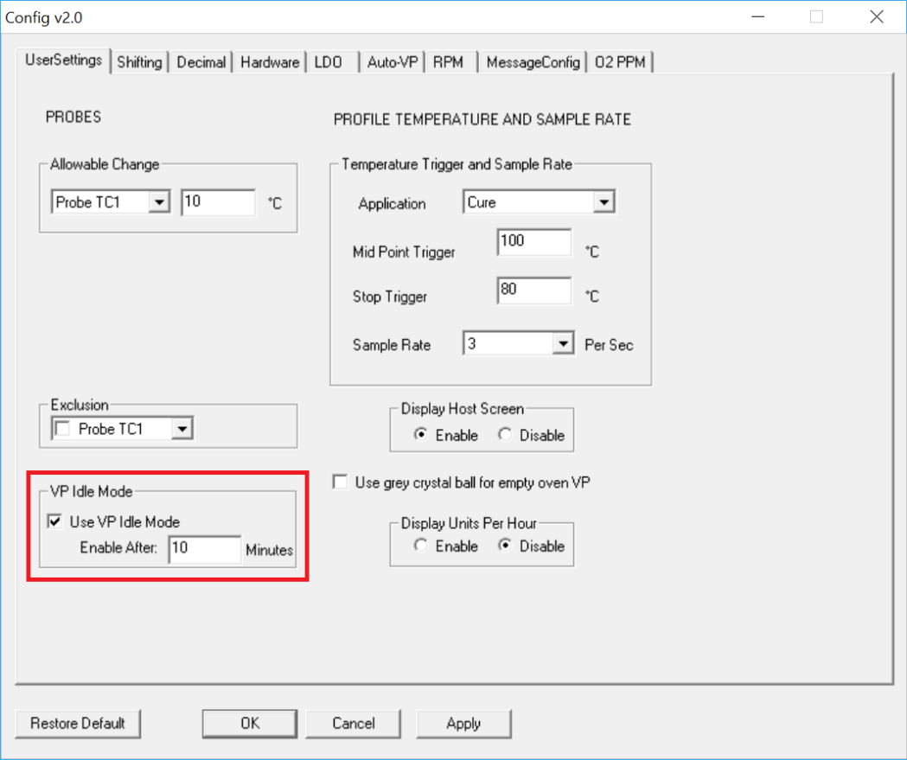

Figure 136: VP Idle Mode Configuration

When VP is running, there will be an additional button on the screen allowing you to manually Enter/Exit VP Idle Mode at any time:



# Centralized Process Window Control (Optional)

This optional feature enables a customer to ensure that every instance of the software is always using the same Process Window files and prevents unauthorized editing of specifications. Many factories may have multiple systems and the same Process Windows may need to be used at any one of those systems. This can lead to mistakes being made during file transfer from one machine to another. Another issue arises when someone makes a change to a specification on one machine, and the change may not be made on others, or the updated file is not copied to all other software. This can lead to varying profile results depending on which PC the data is collected in.

This feature eliminates these situations by ‘centralizing’ the creation and editing of Process Window files through the use of a separate application, accessible only by authorized personnel. All Process Window files reside in a specified central directory, and each instance of the RPI software gets their Process Windows from this location. Additionally, all creation and editing functions of the Process Window within the RPI software are disabled. This ensures that no matter who is running the profile or at which location, the correct, approved Process Window specifications are the only ones available.   
  
**Note**: For the Centralized Process Window Control to function, the appropriately programmed USB dongle key must remain connected to the PC at all times during use. You can verify if you have the optional feature by viewing the Software Key panel in the Hardware Status screen.

Additionally, each instance of the RPI software that you want to use this option on must be connected to your company network and have access to the directory where the Process Windows are saved.

## KIC File Administrator



The *KIC File Administrator* is the application that will be used for creating and editing Process Windows for use with the Centralized Process Window Control option.

**Note**: For the *KIC File Administrator (or KFA)* to function, the appropriately programmed USB dongle key must remain connected to the PC at all times during use. Only authorized users should be allowed to have access to this application.



As an added protection, this application requires a password for use. The default password is *Admin*, but can be changed in the *Settings* menu after logging in.

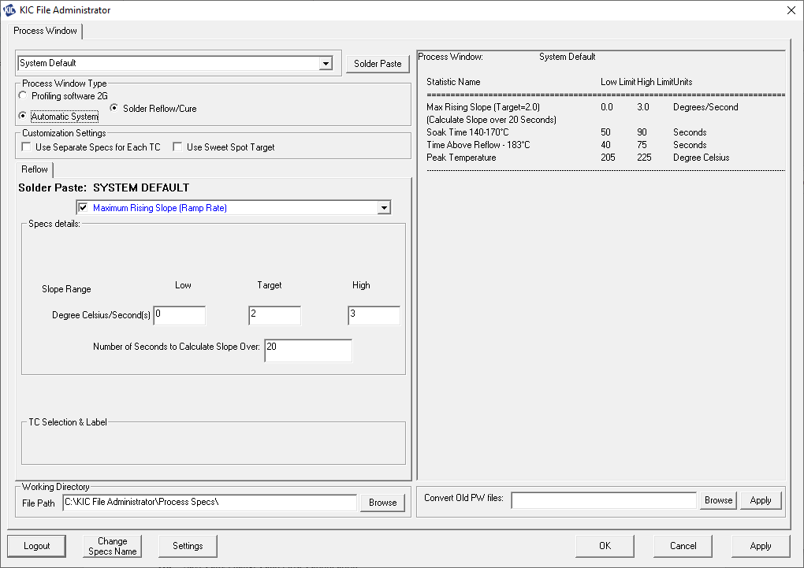

**Drop-down menu** – Displays list of currently available Process Window files. User can also type in a new name if creating a new Process Window.  
**Solder Paste button *–*** Displays list of manufacturers solder paste formulations with specifications

**Process Window Type** – You will need to choose *Automatic System* when creating Process Window files for RPI.

**Working Directory** – This is the network location where you will be saving/storing the Process Window files. By default, it will show the path where the KFA application is located. Use the *Browse* button to point to the desired network directory.

**Convert Old PW files** – This section is used for updating existing Process Window files for compatibility\* with the *Centralized Process Window Control* option*.*

**Login/Logout** – Allows you to display or deactivate all areas of the application.

**Change Specs Name** – Allows a user to change the name of a specification. See *Change Specs Name* section below for details.

**Settings** – Used for setting units of measure (for this application), changing password, inactivity time-out, etc.

**OK** – Saves any changes and closes application

**Cancel** – Ignores any changes made and closes application

**Apply** – Saves changes and keeps open the application

**\***The *Centralized Process Window Control* option uses a unique file format for Process Windows. When the option is in use, the RPI software will only read Process Window files that were created or converted using the *KIC File Administrator* application. ‘Standard’ Process Window files will not be recognized by the RPI software when this option is enabled.

**Working Directory**



As this is the network location where the Process Window files will be stored, and all RPI software installations will need to access this directory, you may need to contact your IT department to identify a proper location for this directory.   
Once a network directory is identified, click on the *Browse* button to select the location. Click *OK* in the selection window, then click *Apply* to save the change. Two subfolders named *Ovens* and *ProcessSpecs* will automatically be generated in the specified directory. All new Process Windows created, and any existing ones that are converted to the compatible format, will be saved into the *ProcessSpecs* folder of this *Working Directory* location.

***Convert Old PW files***



This section enables you to easily convert any existing Process Window files you already have into the updated format so they can be used with the *Centralized Process Window Control* option. To update existing files:

Click on the *Browse* button and point to the *ProcessSpecs* sub-folder of an RPI directory (C:\RPI\ProcessSpecs). Click the *Apply* button. All Process Windows files (.KIC247ProcessSpec) will be automatically copied, converted into the new format (.ASCentralProcessSpec), and then pasted into the *ProcessSpecs* folder of the *Working Directory* on the network. To ensure all of your Process Windows are updated and available, repeat these same steps for each PC where you have the RPI software installed.

***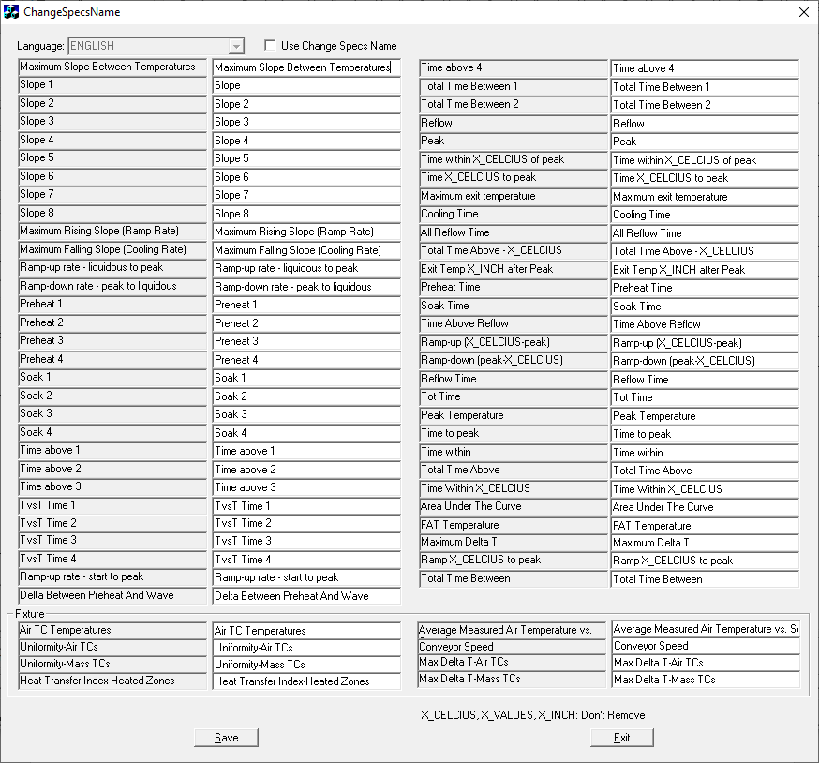Change Spec Name***

This functionality is available for users who need to customize the name of a given specification to meet their internal naming conventions for process specifications. The updated name is what will display in the RPI Process Windows.

If you need to change a specification, check the *Use Change Specs Name* checkbox. From the left side columns (greyed out), locate the specification names you want to modify and type the new name into the corresponding right side column. Click *Save* then *Exit* when you’ve completed your changes.

## Configuration of RPI software

To use the *Centralized Process Window Control* option in the RPI software, a selection needs to be made during the software installation. This will automatically configure the software to use this function. A message will appear on the screen to plug in your USB dongle:



When a valid key with the option included is detected, an additional prompt will appear allowing you to ‘disable’ the CPWC function, or continue with including the CPWC configuration:



After installation of the RPI software is completed, you will also need to specify the network directory where the Process Window files will be retrieved from. This will be done through the *ConfigurationProgram.exe* utility:



1. Shut down the RPI software
2. Browse to the C:\RPI directory
3. Run the *ConfigurationProgram.exe* file
4. In the Process Window Directory section, click *Browse* and select the *ProcessSpecs* folder in the network drive previously specified in the *KFA* utility
5. Click *Apply* and *OK* to save the changes and close the utility

## Operation of RPI software



When the *Centralized Process Window* option is in use, the RPI software will populate the drop-down menu at the top of the screen with ***only*** the Process Window files from the specified network directory. All edit and naming functions are removed. The user can only view the Process Window files.

The Process Window files will automatically be downloaded into the local RPI directory from the specified network location. This ensures that whenever a Process Window needs to be accessed – either from opening the Process Window screen, or from the Run a Profile screen – the most up-to-date version of the Process Windows are always being used.

**Note**: For the *Centralized Process Window Control* to function, the appropriately programmed USB dongle key must remain connected to the PC at all times during use. You can verify if you have the optional feature by viewing the Software Key panel in the Hardware Status screen.

Additionally, each instance of the RPI software that you want to use this option on must be connected to your company network and have access to the directory where the Process Windows are saved.

# Footprint (Optional)

This *optional* feature enables you to view actual oven temperature and conveyor speed measurements in real-time, or when viewing historical data. This tool can be helpful in confirming the stability of a machine or being able to observe the drift of temperature and/or speed under various conditions.

The functionality is activated whenever a *Virtual Profile* is running, which means there is no additional configuration or programming necessary to utilize this feature, so you can begin seeing information as soon as a *VP* is started.

## Live Viewing

When the option is present and a *Virtual Profile* is running, an additional *Footprint* tab will be available in the upper left of the screen.

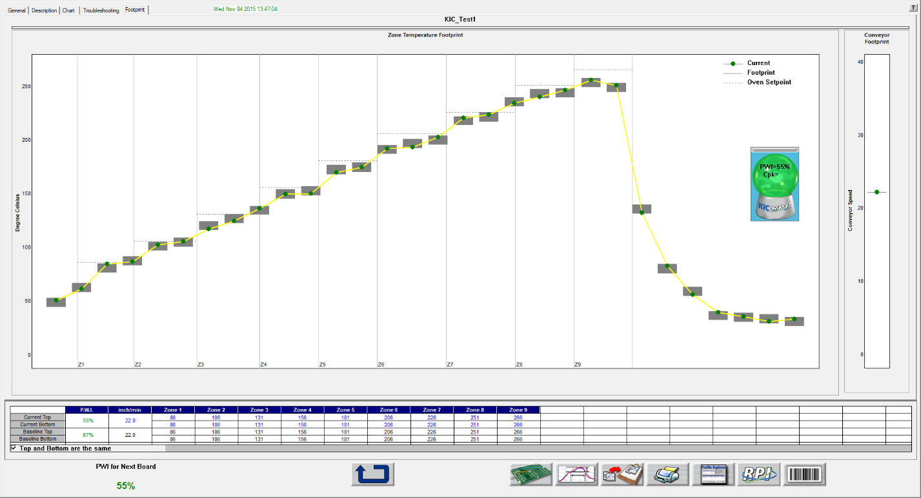

The left side of the screen displays the following temperature related information:

* Current (green dot) – the current live temperature of each of the 30 installed probe thermocouples
* Footprint (gray area) – a representation of the range of temperatures each of the probe thermocouples have measured since starting *VP*
* Oven Setpoint (dotted line) – the setpoint temperature specified for each individual zone (NOTE: This information is for reference only. It is not unusual for the probe thermocouple temperature to be slightly lower than the zone setpoint temperature.)

The right side of the screen displays similar information for the conveyor speed.



The *Reset Footprint* button will temporarily erase the gray footprint area on the screen for both the temperature and speed information. A new display of the *Footprint* will begin after using the reset function. NOTE: The actual variation will still be available when viewing historical data.

## Historical Viewing

When viewing historical *VP* data, you can access the *Footprint* data that was recorded during that time period.

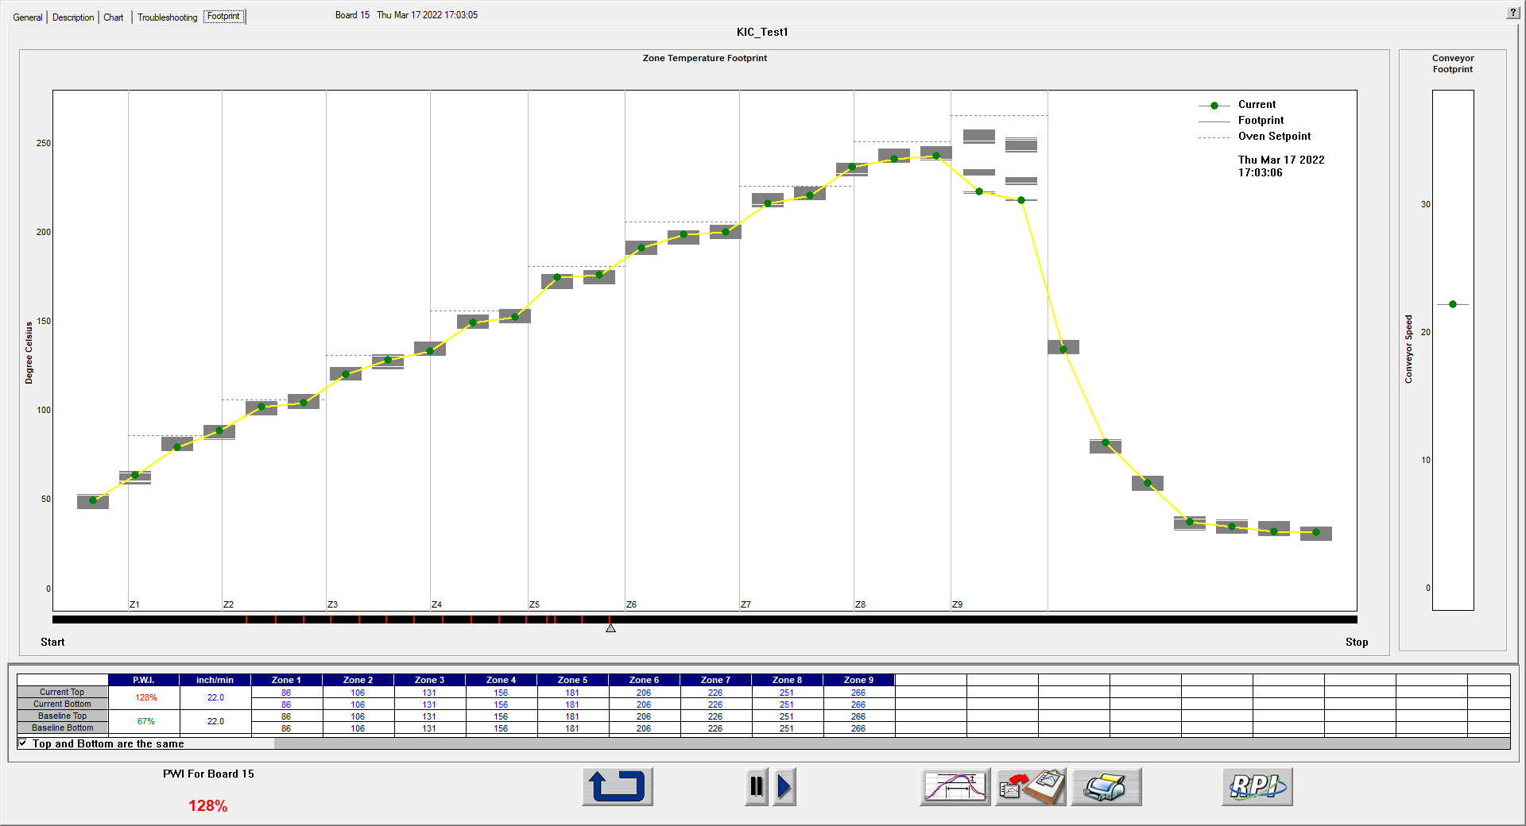

In addition to the capabilities described under ‘Live Viewing’, the following additional functions are available in Historical Viewing:

* Date/Time stamp display on graph – updates as data is replayed
* Play button  toggles between 1x and 10x replay speed
* Pause button  to stop replay
* Timeline – black colored bar at the bottom of the zone display representing the entire timeline for this VP:
  + Start – when the *VP* was started
  + Stop – when the *VP* was stopped
  + Alarm Events – red vertical lines indicate when a system alarm occurred
  + Timeline indicator – small triangle under timeline bar; moves with replay; click and hold to move to specific part of timeline

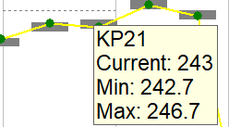

In either live or historical view, you can hold your cursor over an individual probe TC and a pop-up window will appear showing:

* The probe TC number
* Current = current temperature read
* Min = lowest temperature read
* Max = highest temperature read

When the cursor is held over the *Conveyor Footprint* area it will display:

* Current speed
* Slowest speed
* Fastest speed

# Units Per Hour

The *Units Per Hour* (UPH) function can display on the General Tab when VP is running, a count of how many boards (Units) have been processed in the last hour. The number automatically resets back to 0 at the top of the hour.

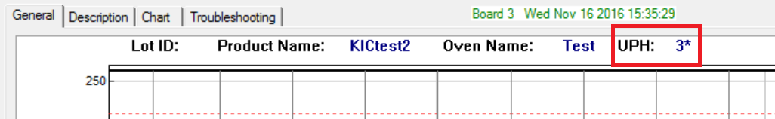

Figure 137: VP Idle Mode Configuration

## Configuration

The feature is enabled by shutting down the software, running the *ConfigurationProgram.exe* (in the *C:\RPI* directory) and selecting “Enable” as shown below:

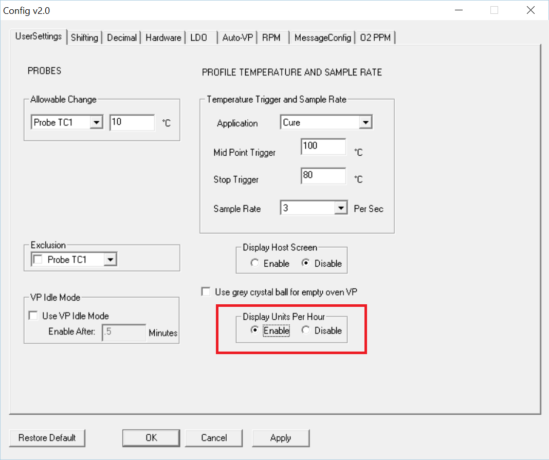

# Auto-VP

*Auto-VP* is an available feature that allows for an automated changeover process. Typically, during a product changeover, an Operator has to manually stop the currently running VP, then go into the oven software and select and load the correct oven recipe for the next product to be processed. Then they must go into the KIC software and select the corresponding product and load that VP. This can sometimes lead to the wrong selection being chosen by the user.

Through the use of barcodes, MES control programs, or oven communication, the *Auto-VP* feature can eliminate the need for Operator intervention in the product changeover process. The proper oven recipe and corresponding VP is automatically loaded based on information sent to the software.

There are multiple configurations of the *Auto-VP* feature depending on the capabilities and processes in place in the factory. Please contact KIC Tech Support to identify if this functionality can be implemented with your system.

# Password Protection

To enable the Password Protection feature, go to the *Global Preferences* screen, select the *Password Protection* check box, and enter the desired password. See Figure 138.

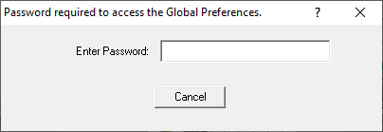

Figure 138: Password Protection

Items that are password protected:

* Global Preferences button on the main screen
* In the Process Window Screen – Saving or deleting Process Windows or changes to Process Windows
* In the Run a Profile first screen – Remove Oven
* In the Profile Explorer – Delete a profile
* In the Profile Graph and Statistics screen – Access to the Optimization tab

You can also configure the software to have different access for different user levels. For more information on additional password protection features, see [*Appendix C: Password Control – Multi User*](#_Password_Control_–).

# Profile Printing

The RPI software will print profiles only from within the profile display screens. Click on the printer icon button at the bottom of the profile display to open the Profile printout setup menu. There are two print formats available – Portrait or Landscape.

## Portrait Mode

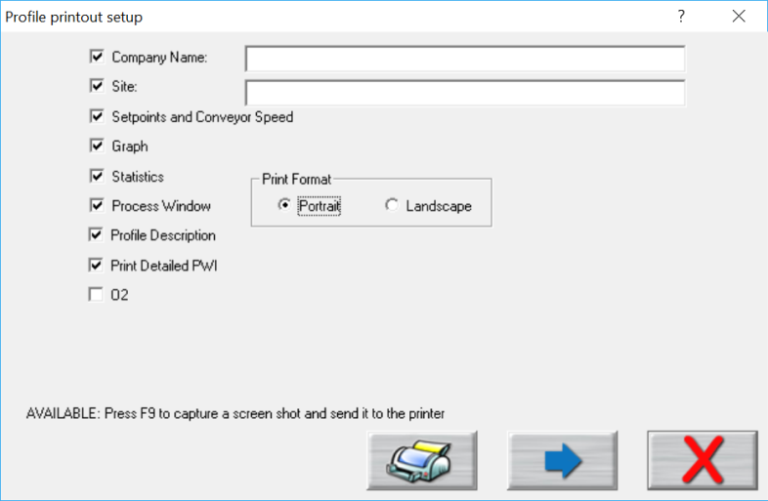

Print

Preview

Print

Cancel

Figure 139: Profile Print Format #1 Options

1. Check the items you wish to include on your profile printout.
2. Press the **Print** button to print the report.
3. Press the **Print Preview Button** to display a preview of the report. See Figure 140.

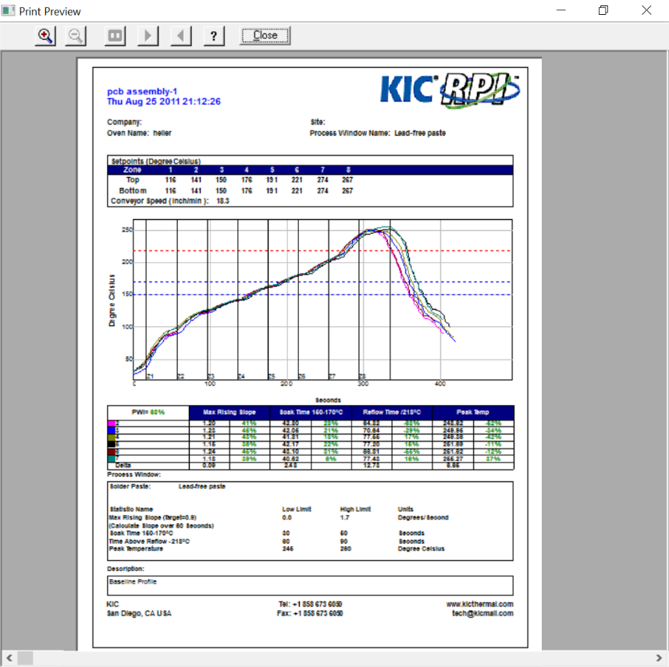

Figure 140: Sample Portrait Print Preview

## Landscape Mode

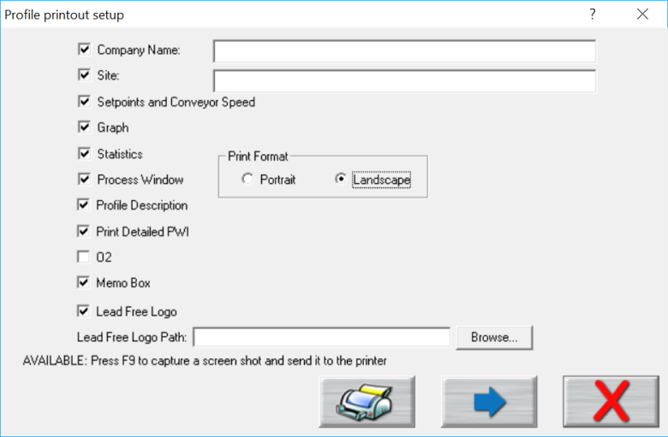

Print

Preview

Print

Cancel

Figure 141: Profile Print Portrait Options

Below are the additional options available with Landscape mode:

* **Memo Box** –Enables/Disables a Memo Box area for Draft, Review and Approval Signatures and Dates.
* **Lead Free Logo** – Enables/Disables the Lead-Free Logo display area.
* **Lead Free Logo Path** – When “Lead Free Logo” is enabled, specify the path to any BMP image file that you want to appear in the Lead Free Logo display area on the report.

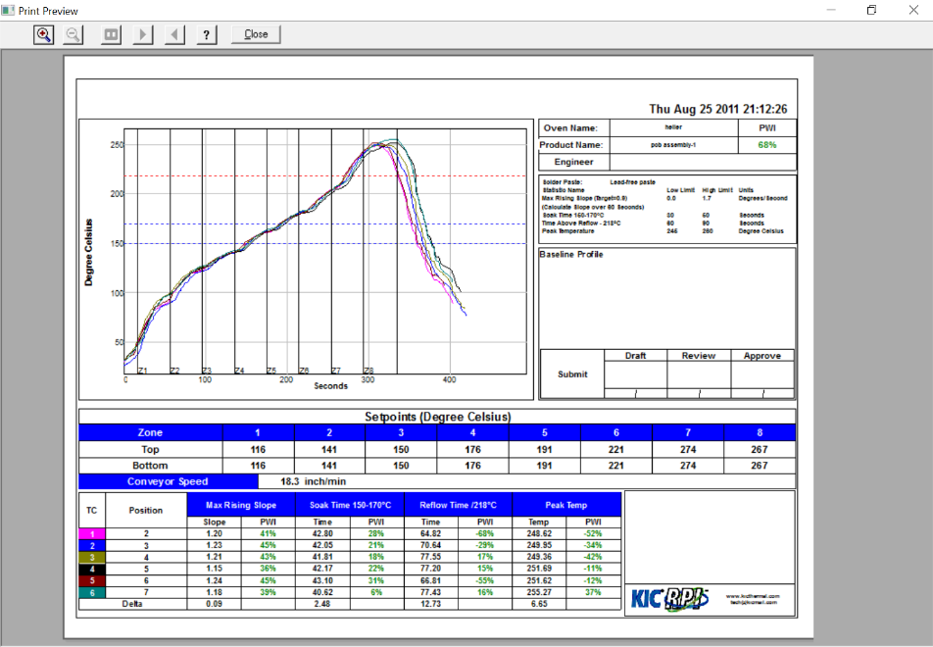

Figure 142: Sample Landscape Print Preview

Optionally, you can print the contents of any screen in the RPI software by pressing **F9** on your keyboard. The **F9** function will not work while viewing the Profile Printout Setup dialog box.

**Note**: Before printing, make sure you have defined a printer for use with Windows.

# Write Data To and View RPI Data Over A Network

**Note**: This feature cannot work in conjunction with RPM.

## Write Data To A Network Drive

The RPI software can be configured to write the collected data (oven files, process windows, profiles and historical VP data) to a network drive location. This would allow data from one or even multiple systems to be stored in one centralized location (Server/Shared Hard Drive).

The first step necessary is to map a network drive from the PC running the RPI software to the desired network location. Due to the multiple varieties of OS and network configurations, KIC cannot detail this step. We recommend you contact your IT/Network administrator for setting this up. Below is a typical example of this setup. See Figure 143.



Figure 143: Example Network with RPI

Once you have mapped the drive, create a folder on the network drive and copy in the following folders from the *C:\RPI directory* – Ovens, Process Specs, and Profiles. Once completed, follow the steps below on the PC where the RPI software is installed:

1. Ensure the KIC software is closed, open Windows Explorer, and locate the file:

C:\RPI\Log\KIC2000DataPath.kiccfg

1. The KIC2000DataPath.kiccfg file will open up in Notepad: See Figure 144.

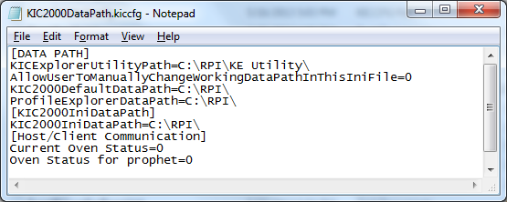

Figure 144

1. Change the line AllowUserToManuallyChangeWorkingDataPathInThisIniFile=0 to the value =1: See Figure 145.

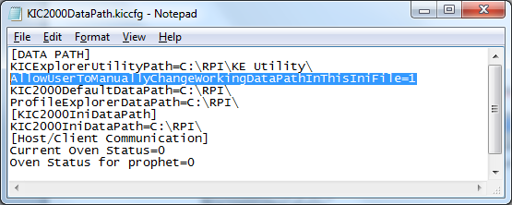

Figure 145

1. Change the line shown below to = the desired network location. **Note:** This will be the main network folder you created and copied the Log, Ovens, Process Spec, and Profiles folders into. See Figure 146.

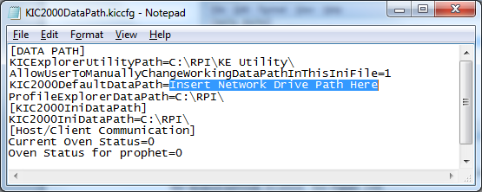

Figure 146

1. Once the DataPath.kiccfg file has been modified with the new locations, choose File/Save from the drop-down menu to save the changes.
2. Close Notepad and start the software.
3. With the software open, go to the Profile Explorer:

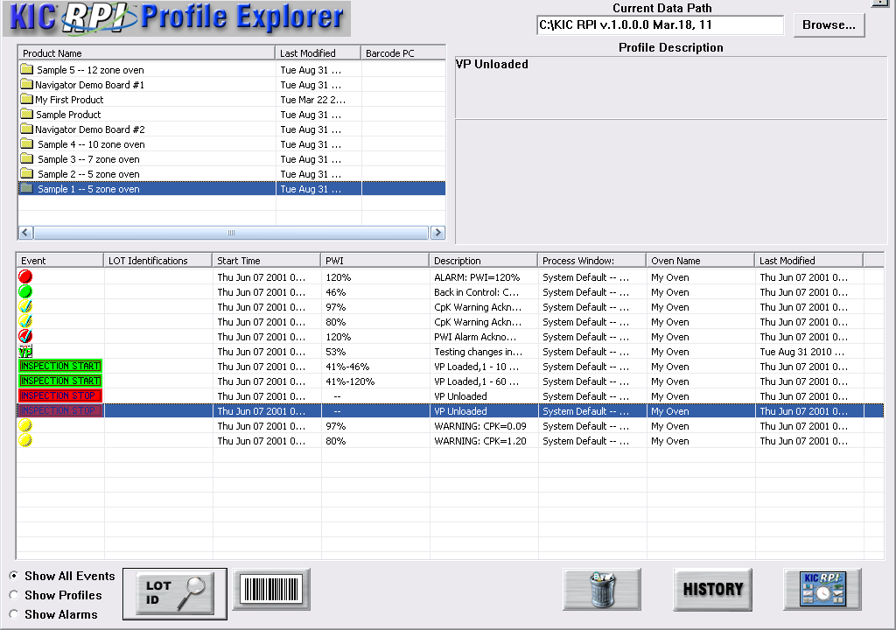

Figure 147

Your new network drive should be displayed in the upper right-hand corner of the screen as the *Current Data Path*. See Figure 147.

**Note**: The Network path will be grayed out and cannot be changed from inside of Profile Explorer.

All data collected in this RPI application will now be written to the network folder chosen.

**Note**: If you have multiple RPI systems, you will need to create a separate folder on the Network drive for each system – e.g. KIC Line 1, KIC Line 2, etc.

If the network is unavailable when accessing various areas of the software (Define/Edit Process Window, Run A Profile, Profile Explorer), a message will appear alerting you to the issue:



When this occurs, you are still able to use the software but only working with files (ovens, Process Windows, profiles) that are located in the local directory. It will temporarily reset back to the local install directory and any new files generated or updated will be saved in the local directory (*C:\RPI*). If the network connection is re-established, the RPI software must be restarted to begin writing directly to the network directory again.

Any data that was collected while the software was offline will be moved to the network directory after the connection has been re-established and the RPI software is restarted.

## View Historical Data

You can also view all collected data over the network from any computer that has the RPI software installed.

**Use the following steps to view historical data over the network:**

1. From your remote computer, start the RPI software and click on the “*I am not going to run profiles or live Virtual Profiling*” button. See Figure 148.

**Caution**: Do not choose this button when working at the PC where the RPI hardware is installed.

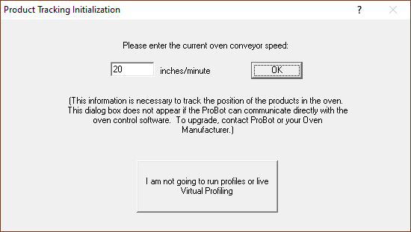

Figure 148

1. The software will open up normally. When the main screen appears, click the Profile Explorer button.

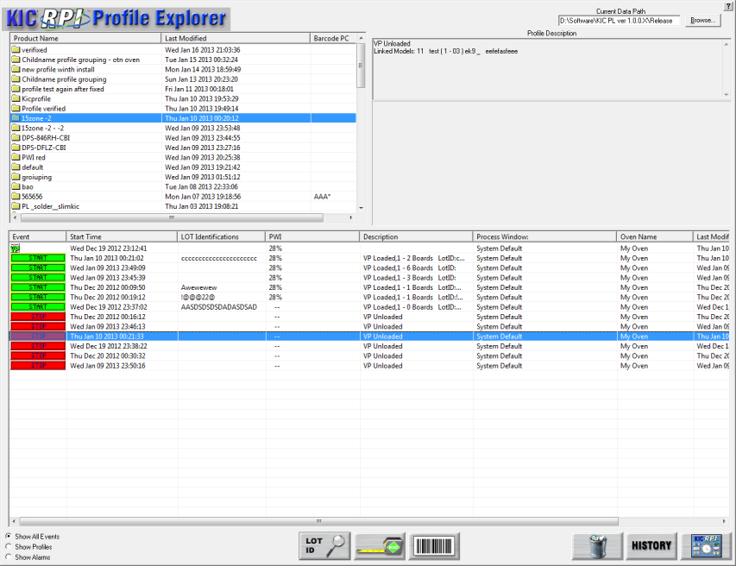

Figure 149

1. A **Browse** button is enabled in the upper right hand corner of the screen: See Figure 149.

You can now click the Browse button and point to the directory where your profiles are. Keep in mind that you want to direct it to the root directory of the main “Profiles” folder.

For example: If the profiles are in the folder F:\RPI\Profiles\Board A, you would direct it only to the folder F:\RPI\

# Communicate with Oven Controllers

Because RPI can interface directly with the oven controllers on many reflow oven models, several leading manufactures act as Value Added Resellers (VARs) for KIC software. RPI can automatically send setpoints and other recipe data to these oven controller systems, eliminating the need for separate data entry.

The table below lists the oven manufacturers that support communication:

|  |  |  |  |
| --- | --- | --- | --- |
| **Oven Manufacturer** | **Communication Capable** | **Baseline Oven Recipe Capable** | **Min. software version for comm.** |
| **BTU** | Yes | Yes | 2.2 |
| **Vitronics** | Yes | Yes | 7.03 |
| **Heller** | Yes | Yes | 1.0.6.3.2 |
| **Rehm** | Yes, on V6 and VXP models | No | N/A |
| **Seho** | Yes | Yes\* | N/A |
| **Senju** | Yes | No | v1.0.0.3 |
| **SMT** | Yes | Yes | v388389 |
| **Sonic** | Yes | Yes | v1005.3.101.22 |
| **Mailbox** | Yes | No | — |

Figure 150: RPI Supported Oven Controller Communications

## Confirm Oven Communications

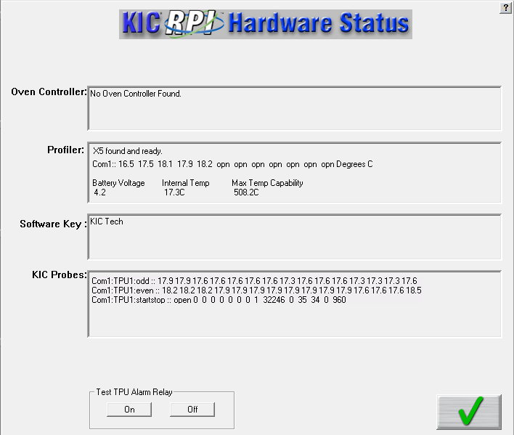

Figure 151: Hardware Status – Oven Controller Communication

Once you’ve installed the system on a communication-capable oven, your first task is to check the Hardware Status screen to see if the software recognizes the oven controller.

If the appropriate system isn’t identified in the *Oven Controller*, field check the following:

* Verify that the software is installed on the same PC and hard drive as the manufacturer’s oven controller software.
* Exit the software and run the *ConfigurationProgram.exe* found in the RPI root folder. The Hardware tab lists a selection of ovens and oven models.
* Contact KIC or the oven manufacturer to make sure the version of oven controller software and firmware is compatible for oven communications.
* Make sure that the latest versions of the correct drivers are properly installed. (Contact KIC or the oven manufacturer for details.)

## Configure Software For Oven Communication

|  |  |
| --- | --- |
| There are *two* items you have to set in the GlobalPreferences screen when configuring the software for use with oven communications. See Figure 152.   1. Enter an oven name and zone lengths and zone limit data. 2. Check **Use Oven Base Recipe**. (Optional.) | Graphical user interface, text, application  Description automatically generated  Figure 152 |

## Use a Base Oven Recipe With Oven Communication

The operating parameters of a reflow oven are specified by the manufacturer in the oven controller. These parameters may include zone setpoint temperatures, conveyor speed, fan speed, Nitrogen On/Off, conveyor width, etc. Taken together, these parameters form a *Base Oven Recipe*, which RPI uses as a set of default values.

RPI can set/load the zone setpoint temperatures and the conveyor speed parameters, adjusting them from the default values in the Base Oven Recipe.

In order for the engineer to specify the other parameters, a *Base Oven Recipe* must be created. This oven recipe has all the oven parameters except the zone set point temperatures and conveyor speed set correctly. When you load a Virtual Profile for a given product, this software will modify the set points and conveyor speed in the Base Oven Recipe, and then load the Base Oven Recipe into the oven controller. In this way, the oven will be setup exactly as it was during the Baseline Profile.

|  |  |
| --- | --- |
| When the *Use Oven Base Recipe* option is selected, nothing will happen until a Virtual Profile is loaded from the Profile Explorer. Then the software will present the Browse dialog in order to select the Base Oven recipe. | Baseline Recipe  Figure 153: Browse window for selecting the *Base Oven Recipe* |

## Run A Profile Using Oven Communication

When running profiles with oven communications, be aware of the following differences when compared to regular operations:

1. When running a profile and going through the sequence of screens leading up to the *Select Thermocouple* screen, you will not see a pull-down menu for the oven since there can be only one. You will also not see the screen for the oven settings since this was taken care of in Global Preferences.
2. When you are running the software with oven communication, the software sends data to the oven’s PC control software. This communication seems transparent at first, but once you gain more experience you will see certain signs that the KIC software and the oven controller are communicating. One of the first things you might notice is that the recipe name loaded on the oven controller software will be *KICPROFILE*. Loading the *KICPROFILE* recipe provides the benefit of giving the KIC software a vehicle to update oven settings without having to call a specific recipe file name and location of an oven controller recipe.
3. When running a profile, the software uses a Base Oven Recipe as a starting point for the oven recipe then changes the name to *KICPROFILE* and will/can only change the zone setpoints and conveyor speed settings thereafter. This gives the software the flexibility to change setpoints and conveyor speed on the fly without having you manually rename or save the recipe file.
4. For your first profile, load appropriate temperature and conveyor speed settings in the oven control software. Once you have run your first profile or have loaded an existing profile from the Profile Explorer zone setpoints, you can make conveyor speed adjustments manually while viewing the profile or let it happen automatically if you have the Navigator software option installed.

Once you choose to run a profile *using the predicted setpoints and conveyor speed,* the software automatically sends these new settings to the oven controller software to be loaded. When the new settings are loaded, watch for the following:

|  |  |
| --- | --- |
| * With some oven controllers there may be an audio warning, indicating that the oven is going to change settings. Some of the audio indicators are also accompanied by a timer that will not allow the oven to load the new setpoints until the programmed time has elapsed. These timers can be reduced or turned off at the customer’s discretion. | |
| * The software will display the message “Waiting for the oven controller to acknowledge recipe change”. There is a time delay displayed for an estimated period for the oven to acknowledge the changes and that all conditions are right to set the oven to these new setpoints. See Figure 154. | Figure 154: Waiting for Oven Controller to Acknowledge Recipe Change |
| * You may notice with some ovens that it takes longer than others, you’ll have to get a feel for this as you go but if you feel the change is taking too long then switch over to the oven software and try to ascertain if there is some kind of disturbance that would cause the oven controller not to load the new setpoints. | Figure 155: Recipe Copy Successful |

1. If you are starting a profile and the software tells you that the oven’s actual zone temperatures are not within 2 degrees of the of the setpoint value, and you know that you have waited long enough (possibly even answered that they are still changing), but now you know they are not, then you will have to answer *No* and follow the instructions. This information is outlined in the user manual, but what happens next may be a little confusing to a first time user. Here is a list of what takes place and why:

* You answer ***No*** the temperatures are not getting closer and the system then asks you to change the Setpoint values to that of the Actual. What the system is doing by this is finding out what the oven will actually control to in certain zones. It then takes the differences and uses them to update the oven.ini file so the next time the system optimizes for a profile it will take the zone delta limitations that it learned and apply it to the next profile. The software will use the new zone delta limits until the values change again by a set of oven setpoints that can’t be maintained by the oven are chosen. Remember that it is very important that you are sure that the oven can’t achieve the original setpoints before you answer ***No***. Once the new delta limits are established this will affect the capability of the Navigator to optimize your profiles.

|  |  |
| --- | --- |
| * Next the system will take you to the Verify Minimum and Maximum Setpoint Temperature screen. This is to verify that we have not allowed the KIC software to choose setpoint values that the oven is not capable of controlling to. See Figure 156. | Figure 156: Verify Setpoints |

* Next the software will prompt you that it will calculate new setpoints. When you click on OK, the screen will change to a profile graph that has calculated new oven setpoints for the oven to load in order to produce the optimized profile results. This works the same even if you don’t have the Navigator option. If you entered the new setpoints manually the software will automatically find new setpoints like the Navigator would when you get to this point. Be patient you may have to go through this cycle of the oven not controlling to setpoint values a few times before the proper combination of acceptable setpoints and profile optimization can be found. In worst case scenarios you may have to change the 2.0 degrees delta between setpoint and actual because the oven is just simply not capable of getting within 2 degrees C of the setpoint no matter what the temperature. Please contact KIC Tech support if this is the case.

**Note**: If you get into a situation where you are having to adjust too many times and are still not getting setpoints that the oven will control to, but you are or you will be in spec by manually changing predicted setpoints, then go into the Optimization Tab and turn off “Allow Zone Setpoints To Change”. The next time around the KIC software will not change any of the zone values but you can go in and change them manually to exactly what the actual values are and run the profile.

## Start a Virtual Profile With Oven Communication

Before running a Virtual Profile with oven communications, review the following:

1. You have *Use Base Oven Recipe* checked in Global Preferences but the software did not ask you to select it when you started the VP. If you have just run your baseline profile and start a VP immediately, without exiting that product, then the VP will start without asking you to choose a Base Oven Recipe. The system assumes since you just ran a successful baseline profile that all of the oven settings are correct, and in turn, the Base Oven Recipe settings are correct.
2. You setup your product and have a baseline profile now but you do not have an oven recipe to match it. What recipe will you load when you want to run production on this product? Remember that even though you originally loaded a specific oven recipe file, the software took over and loaded the KICPROFILE recipe on your oven and did not save any subsequent zone setpoints and conveyor speed changes to that original oven recipe.

You can save any changes made to the original recipe while profiling if you want to create a recipe that can be run on the oven controller without the software running. If you choose not to save the changes, when you load this product under the software it will load the proper recipe parameters for that product.

|  |  |
| --- | --- |
| 1. When starting a Virtual Profile from the Profile Explorer, the software prompts you to select your Base Oven Recipe. The *Select the Base Oven Recipe to be loaded* screen appears, letting you to browse your PC and point to the location and file name of the Base Oven Recipe you want to use for this product. See Figure 157.   Remember it should be the same one you choose when you originally ran your baseline profiles. If you choose the wrong Base Oven Recipe, you could have boards fall off the conveyor or never even make it in because the Base Oven Recipe you chose does not match the width of the original file you loaded. | Figure 157: Select the Base Oven Recipe to be Loaded |

1. When you have selected and opened the Base Oven Recipe the KIC software will load that recipe on the oven. All of the parameters in this recipe are correct for this product except the zone setpoints and conveyor speed. With some ovens, you may hear and audio warning, you may see the light tower change to an amber state, you may even see the conveyor stop momentarily and then start again indicating that the oven is loading the Base Oven Recipe. Seconds later you may hear or see one or all of these signs again as the software sends just the zone setpoints and conveyor speed settings to the oven controller.

|  |  |
| --- | --- |
| 1. If you have already loaded a VP and selected a Base Oven Recipe then you will not see the *Select the Base Oven Recipe to be loaded* screen, instead you will see the screen shown in Figure 158. Click **Yes** to verify that you are loading the correct Base Oven Recipe. If you choose **No** then the *Select the Base Oven Recipe to Be loaded* screen appears. | Figure 158 |

**Note**: If you feel that the system is taking too long to load the Base Oven Recipe or the setpoints, switch over to the oven control software and see if you can detect a reason why the oven is not accepting the changes.

## Base Oven Recipe Automatic Verification

For Base Oven Recipe compatible ovens, users can automatically verify the correct Base Oven Recipe before beginning a Virtual Profile. This feature is especially useful for users that have multiple production products using multiple Base Oven Recipes. The system lets you select the Base Oven Recipe and if the selected recipe does not match, the Virtual Profile cannot begin.

### Enable the Base Oven Recipe Automatic Verification

1. Close the software if open.
2. Find and open the file: C:\software root directory\Log\KIC2000UserSettings.kiccfg
3. In the [PROPHET] section find and edit the line:

AllowNotChangeRecipeAuto=1

1. Save and then exit the file.
2. Open the software.
3. On the Global Preferences screen Global tab, select the **Use Oven Baseline Recipe** check box.

|  |  |
| --- | --- |
| The next time a Virtual Profile is started a dialog box appears, prompting you to verify the correct Base Oven Recipe, or select a different one. See Figure 159. | Figure 159 |
| Select the “Yes” button to continue. Select the “No” button to choose a different Base Oven Recipe. See Figure 160. | Figure 160 |
| If the selected Base Oven Recipe does not match, a yellow dialog box appears.  To select a different recipe select the **Continue** button.  When the correct recipe is selected, the software goes directly to the Virtual Profile display: |  |

# Troubleshoot COM Ports

## Comport.Exe

The RPI installation includes a software utility that will help the KIC technician troubleshoot and identify easily if the COM port is functional or not. Check C:\RPI\ folder for the file COMport.exe. Double click to open. See Figure 161.



Figure 161: COMPort Test – Main Screen

Once the COMport.exe software is open, select the COM port that you wish to test and click the “Run Test on Selected Ports” button. A message appears in the main window. See Figure 162.



Figure 162: COMPort Test – Run Test successful

If the COM port is not active or is in use by different software, you will see a message in the main window: See Figure 163.



Figure 163: COM Port Test – Run Test failed

### Comport.Exe Buttons

 Run a full test for the selected COM port.

 Run a partial test of the selected COM port by opening the port.

 Run a partial test of the selected COM port by closing the port.

 Exit the COM Port Test utility

# Status Messages And Alarms

The software communicates system status through messages that it displays on the monitor. Some simply report an operating condition, some provide a warning that process parameters are changing, and still others, called *alarms,* announce out-of-spec conditions, operational failures, lost communications, and other process critical problems that might require immediate corrective actions.

|  |  |
| --- | --- |
| Alarm messages typically appear in red. An alarm status may accompany a signal from the eTPU to the optional alarm relay, which, in turn, may trigger hardware-related events such as sounding audible alarms, lighting signal towers, or stopping infeed conveyors. |  |

Some status messages and alarms are specific to different functions of the software. Some may appear when you are first running profiles to establish a baseline. Others appear only when you begin Virtual Profiling.

## Acknowledge Alarms

|  |  |
| --- | --- |
| Once displayed on the monitor, an operator needs to acknowledge the alarm, clicking on it to notify the software that the message has been received and make the displayed panel disappear. |  |
| You can use password protection to limit the ability to acknowledge alarms. To do so, you first need to specify the following value in the KIC2000UserSettings.kiccfg file:  [HOST]  UsingPasswordwithRedAlarm=1  Next, you need to specify a password on the Global Preferences screen *Engineer Password* option. Once password protection is in place, clicking a red alarm message displays a prompt that requires you to enter the password to acknowledge the alarm and remove the message. |  |



**Note**: Password protection only applies to alarms. A simple mouse click acknowledges and clears warning messages.

## Messages During Profiling and Baseline Profiling

During the profiling portion of getting your RPI ready to monitor and record real-time production and prior to starting a Virtual Profile, you may experience some conditions that cause the system to alert you to. Below is a table of some of the messages that you might see during this process: See Table 2.

|  |  |
| --- | --- |
| **Message Alarms** | **Message Description** |
| **Message, High PWI** | Recent profile of xxx%, PWI must be no greater than 90% |
| **Message Alarm H2** | eTPU Communication Failure - wait 5 seconds and try again |
| **Message Alarm H7** | Conveyor has stopped or encoder has been disconnected Virtual Profiling cannot be started. |

Table 2: Profiling System Alarms

## System Message and Alarms

### Message, High PWI

|  |  |
| --- | --- |
| If the verification profile PWI is >= 90%, you will receive this message when starting the VP.  If there was a problem with the most recent profile, it can be deleted and the system will try to use the next most recent profile as the baseline profile. Otherwise, you are advised to run another profile. See Figure 164. | Graphical user interface, text, application  Description automatically generated  Figure 164: Message High PWI |

### Alarm Message H2

|  |  |
| --- | --- |
| This message will appear if the eTPU is not detected when attempting to start Virtual Profiling. This can occur if there is an issue with the eTPU, or the connection configuration. Waiting 5 seconds sometimes allows a connection to the eTPU to be established. See Figure 165. | Graphical user interface, text, application  Description automatically generated  Figure 165: Alarm H2 |

### Alarm H7

|  |  |
| --- | --- |
| This alarm will appear when trying to start a Virtual Profile from the Profile Explorer. The oven conveyor must be running and set to the correct speed settings in order to start Virtual profiling. See Figure 166. | Graphical user interface, text, application, email  Description automatically generated  Figure 166: Alarm H7 |

## Alarms and Messages during Virtual Profiling

The software incorporates the use of warning and alarm dialog screens to let you know if there is a problem and the cause for that problem. Below is a partial list of the warning and alarm dialog screens with explanations. These Alarms are active only when Virtual profiling is running.

| **Process Alarms** | **Description** | **Activates Alarm Relay** |
| --- | --- | --- |
| **Alarm # 1** | PWI=x% - Process is out of spec | **Yes** |
| **Alarm # 5** | No Barcode read for this board. –or–  No Barcode read for xxx boards. | **No** |
| **Alarm # 5A** | Process Traceability barcode scan failed | **Yes** |
| **Alarm # 5C** | Process Control barcode scan failed | **Yes** |
| **Alarm # 8** | The length of the current product does not match the length of the product during the baseline profile. | **No** |
| **Alarm # 10** | This alarm only occurs when the KIC software and the oven control software are communicating and indicates that the oven is not set to the baseline profile recipe. | **Yes** |
| **Alarm # 11** | The KIC speed sensor has detected that the conveyor speed has changed significantly since the baseline. | **Yes** |
| **Alarm # 12** | Incorrect Process Control String (Barcode Option). | **Yes** |
| **Alarm # 16** | Maximum allowable back-to-back boards exceeded (When enabled) | **Yes** |

Table 3: Virtual Profiling – Process Alarms

|  |  |  |
| --- | --- | --- |
| **Hardware Alarms** | **Description** | **Activates Alarm Relay** |
| **Alarm H1** | eTPU Communication Failure (happened after Alarm H2) | **Yes** |
| **Alarm H2** | eTPU Lost Communication with PC.  Note: This alarm condition can activate the alarm relay that is controlled by the eTPU | **Yes or No** |
| **Alarm H7** | Conveyor Stopped or Speed Encoder broken or not connected properly. | **Yes** |

Table 4: Virtual Profiling – Hardware Alarms

|  |  |  |
| --- | --- | --- |
| **Warnings** | **Description** | **Activates Alarm Relay** |
| **Warning # 2** | This process is likely to go out of spec soon. | **No** |
| **Warning # 3** | The last profile was out of spec. | **No** |
| **Warning # 4** | Oven temps have changed significantly since baseline. | **No** |

Table 5: Virtual Profiling – Warnings

### 

### Detailed Alarm Information

Most alarm conditions will activate an external KIC Alarm Relay, which can be used for stopping the infeed conveyor and preventing further boards from entering the oven during an alarm. The default operation is if the alarm condition is corrected, even if the alarm notification message on the screen has not been acknowledged, the Alarm Relay will automatically turn off allowing boards to resume entering the oven.

However, some users may only want to resume product flow only AFTER the alarm notification has been acknowledged. For Alarm numbers 1, 10, and 11 (see above table for each alarm description) you can modify this functionality so that the Alarm Relay will stay activated until the screen message is acknowledged.

To change to this operation:

1. Exit the RPI software
2. Using Windows Explorer, browse to the C:\RPI\Log directory and open the *KIC2000ReadOnly.kiccfg*
3. Modify the line *AROnUntilAcknowledge=0* to *=1*
4. Save and Close the file, then restart the software

### Activate Alarm #5a

The **Global Preferences** screen **Barcode Option** tab gives the user the ability to choose to activate an alarm if a product barcode label is not read.

#### Barcode Option Tab

|  |  |
| --- | --- |
| 1. On the **Global Preferences** screen **Barcode Option** tab, click the checkbox next to **Traceability** to select it. | The **Traceability (Entrance)** barcode function that activates Alarm #5A if a products barcode label is not read. |
| 1. Ensure that the radio button next to **Traceability (Entrance)** is selected. |  |
| 1. Click the green check button Description: \\RND\RND_Service\For DaveK\RPI\RPI Graphics\RPI Art File\bt-NAVint_Check.bmp to save the settings. |  |

### When Alarm #5a Occurs

When the Barcode Product Sensor (BPS) detects a product whose barcode label has not been read, or the BPS is tripped accidentally, the alarm #5A is activated and the process is stopped via the alarm relay.

Alarm #5A displays four alarm buttons: **Manual Entry Keyboard/Handheld Scanner, Rescan using Fixed Mount Scanner, Proceed without a Barcode, and Remove this board from Line.**

#### Manual Entry Keyboard/Handheld scanner

Click this button when you want to enter the barcode again by using either the keyboard or a handheld scanner connected to a USB Port.

|  |  |
| --- | --- |
| 1. Click the **Manual Entry Keyboard/Handheld Scanner**  button.   The software displays the Barcode input field and hides all other unselected buttons. |  |
| 1. Type in the new barcode and press the **Enter** key.   The software will clear the alarm message and deactivate the Alarm relay to allow the board into the oven. |  |
| The barcode will be added to the board. | |

#### Rescan Using Fixed Mount Scanner

Click this button when you want to scan the barcode again by using the fixed mount Barcode scanner.

|  |  |
| --- | --- |
| 1. Click the **Rescan using Fixed Mount Scanner**  button.   The software displays the Barcode input field and hides all other unselected buttons. |  |
| 1. Scan the barcode with the fixed mounted Barcode scanner. |  |

|  |
| --- |
| Once the barcode is scanned, the software will clear the alarm message and deactivate the Alarm Relay to allow the board into the oven.  This barcode will added to the board. |

#### Proceed Without a Barcode

Click this button when you want to process the board without any barcode.

|  |  |
| --- | --- |
| 1. Click the **Proceed without a Barcode**  button.   The software will clear the alarm message and deactivate the Alarm relay to allow the board into the oven without a barcode. |  |
|  | |

#### Remove this board from Line

The software will display an alarm message “P*lease remove this board from the line now & click on the “OK” button*.”

|  |  |
| --- | --- |
| 1. Click the **Remove this board from Line**  button. |  |
| 1. Remove the board from the link conveyor. |
| 1. Click the green OK check button Description: \\RND\RND_Service\For DaveK\RPI\RPI Graphics\RPI Art File\bt-NAVint_Check.bmp.   The software clears the alarm message and deactivates the Alarm relay to get ready for the next board.  If user clicks the “Cancel” button, the software returns to alarm #5A. |  |

### Activate Alarm #5c

The **Global Preferences** screen **Barcode Option** tab gives the user the ability to choose to activate an alarm if a product barcode label is not read.

#### Barcode Option Tab

|  |  |
| --- | --- |
| 1. On the **Global Preferences** screen **Barcode Option** tab, click the checkbox next to **Process Control** to select it. |  |
| 1. Click the green check button Description: \\RND\RND_Service\For DaveK\RPI\RPI Graphics\RPI Art File\bt-NAVint_Check.bmp to save the settings. |

### When Alarm #5c Occurs

When the Barcode Product Sensor (BPS) detects a product whose barcode label has not been read, or the BPS is tripped accidentally, the alarm #5C is activated and the process is stopped via the alarm relay.

Alarm #5C displays four alarm buttons: **Manual Entry Keyboard/Handheld Scanner, Rescan using Fixed Mount Scanner, Proceed without a Barcode**, and **Remove this board from Line**.

#### Manual Entry Keyboard/Handheld Scanner

Click this button when you want to enter the barcode again by using either the keyboard or a handheld scanner connected to a USB Port.

|  |  |
| --- | --- |
| 1. Click the **Manual Entry Keyboard/Handheld Scanner**  button.   The software displays the Barcode input field and hides all other unselected buttons. |  |
| 1. Type in the new barcode and press the **Enter** key.   The software will clear the alarm message and deactivate the Alarm relay to allow the board into the oven. |  |
| This barcode will be added to the board if the software also is using the Traceability barcode option. | |

#### Rescan Using Fixed Mount Scanner

Click this button when you want to scan the barcode again by using the fixed mounted Barcode scanner.

|  |  |
| --- | --- |
| 1. Click the **Rescan using Fixed Mount Scanner**  button.   The software displays the Barcode input field and hides all other unselected buttons. |  |
| 1. Scan the barcode with the fixed mounted Barcode scanner. |  |

|  |
| --- |
| Once the barcode is scanned, the software will clear the alarm message and deactivate the Alarm relay to allow the board into the oven.  This barcode will be added to the board if the software also is using the Traceability barcode option. |

#### Process without a Barcode

Click this button when you want to process the board without any barcode.

|  |  |
| --- | --- |
| 1. Click the **Proceed without a Barcode**  button.   The software will clear the alarm message and deactivate the Alarm relay to allow the board into the oven without a barcode. |  |
|  | |

#### Remove this board from Line.

The software will display an alarm message “*Please remove this board from the line now & click on the “OK” button*.”

|  |  |
| --- | --- |
| 1. Click the **Remove this board from Line**  button. |  |
| 1. Remove the board from the link conveyor. |
| 1. Click the green OK check button Description: \\RND\RND_Service\For DaveK\RPI\RPI Graphics\RPI Art File\bt-NAVint_Check.bmp.   The software clears the alarm message and deactivates the Alarm relay to get ready for the next board.  If user clicks the “Cancel” button, the software returns to alarm #5C. |  |

### Activate Alarm #12

The **Global Preferences** screen **Barcode Option** tab gives the user the ability to activate an alarm if a product barcode label is in the wrong format, Alarm #12 Incorrect Process Control String.

#### Barcode Option Tab

|  |  |
| --- | --- |
| 1. On the **Global Preferences** screen **Barcode Option** tab, click the checkbox next to **Process Control** to select it. | The **Process Control** feature allows control of the process by comparing the barcode string of a product to the corresponding process currently running. It ensures that the product matches the process. |
| 1. Select one of the two radio buttons for **Process Control**.   These radio buttons let you specify using one or two scanners, together with fields for entering identifying prefixes for the scanners. | This feature enables the choice of applying traceability at the oven entrance or exit. |
| 1. Click the checkbox next to **Traceability** to select it.   The Process Traceability feature links each product’s profile data with its barcode. |  |
| 1. Click the green check button Description: \\RND\RND_Service\For DaveK\RPI\RPI Graphics\RPI Art File\bt-NAVint_Check.bmp to save the settings. |  |

#### Barcode Process Control Dialog Box

When Virtual Profiling is started, the system produces the Barcode Process Control dialog box. As long as the Process Control function is enabled (Global Preferences), this dialog box will appear every time Virtual Profiling is enabled.

|  |  |
| --- | --- |
| 1. Enter the barcode string that is specific to the product that is running.   The software reads the incoming String and compares the barcode string to that of the Process Control String, for every product.  If the string values differ, A**larm #12** is activated, and the process is stopped via the alarm relay device. |  |
| 1. Click **OK**. |

### When Alarm#12 Occurs

When a barcode string is received that differs in format from the current product, the software will display a red alarm message - Alarm#12 – with three buttons: Stop Virtual Profiling, Process with current Barcode, Remove the board from Line.

#### Stop Virtual Profiling

|  |  |
| --- | --- |
| 1. Click the **Stop Virtual Profiling**  button. |  |
| 1. Click the green check button Description: \\RND\RND_Service\For DaveK\RPI\RPI Graphics\RPI Art File\bt-NAVint_Check.bmp to stop virtual profiling. |  |
| Note: Users must wait for all boards to be removed from the oven. |  |

#### Process with Current Barcode

Users may deactivate the alarm relay to allow a board into the oven even if the barcode is in incorrect. Use this button to stop the alarm when you want to use the barcode that is on the label.

|  |  |
| --- | --- |
| 1. Click the **Process with Current Barcode** button . |  |
| This barcode will be added to the board if the option for **Traceability** was selected on the **Barcode Option** tab. |  |

#### Remove This Board From Line

You use this feature when you want to remove a PCB out of Line before it is passed into the oven, but are going to keep the current Virtual Profile running.

|  |  |
| --- | --- |
| 1. Click the Remove this board from Line button . |  |
| 1. Remove the board from the line and then click the green check button Description: \\RND\RND_Service\For DaveK\RPI\RPI Graphics\RPI Art File\bt-NAVint_Check.bmp. |  |

### Alarm#16 – Maximum allowable back-to-back boards has been exceeded

This is alarm in disabled by default. You may want to enable this optional alarm if you want to be alerted when too many products are being loaded back-to-back into the oven, which can sometimes lead to other process related issues. It will allow you to specify how many consecutive back-to-back boards are allowed. If that number is exceeded, an alarm will be generated.

#### To enable:

|  |  |
| --- | --- |
| 1. Exit the software, browse to the *C:\RPI* directory and run the *ConfigurationProgram.exe*. Select the *Hardware* tab. |  |
| 1. Under the *Product Board Sensor* section, select the *Alarm on Continuous Boards* checkbox. Enter the *Maximum* number of back-to-back boards that you want to allow before the alarm is generated. |  |
| During *Virtual Profiling*, if more than the specified number of back-to-back boards are detected entering the oven, an alarm will be generated indicating the problem.  **NOTE:** This alarm setting can also be useful for identifying other hardware issues such as: products stuck in transition onto oven conveyor (when underneath the board sensor), misadjusted, dirty, or faulty board sensors, etc. |  |
|  |  |

# Light Tower

There are two available light towers – one is connected directly to the optional Alarm Relay and uses a single Red light; the other connects to the USB port of the PC, and uses 3 colored lights – Red, Yellow, and Green.

Both lights are a means of providing an audio or visual cue when the automatic system software has determined that the oven process has reached an out-of-control condition.

## Standard Light Tower

This light tower plugs directly into the *Alarm Relay* box. It uses a single Red light with an audible buzzer, which are both activated anytime an alarm condition occurs. Because it is controlled directly by the *Alarm Relay*, the light and audible buzzer will stay on for as long as the *Alarm Relay* is energized.

## 3 Color USB Light Tower

As this light tower connects to a USB port on the PC running the RPI, it can be used with or without the *Alarm Relay*. With the use of the USB Light Tower, you get additional visual information on the state of your process through a variety of LED indicators – Red, Yellow, and Green. You also have the ability to mute the audible buzzer when an alarm condition occurs. When an alarm occurs, a small button will appear in the upper left corner of the Crystal Ball. Clicking on this button will mute the audible buzzer. Clicking the button a second time will un-mute the buzzer. If left muted, and the process returns to an in-spec condition, the buzzer will be automatically active again when the next alarm occurs.



### LED Light Status

When VP is not running – All LEDs and buzzer are turned off

When VP is running and the process is in-spec but the oven is empty – GREEN LED flashing

When VP is running and the process is in-spec with product in the oven – GREEN LED on solid

When VP is running and the process is in a Warning condition – YELLOW LED on solid

When VP is running and the process is in an Alarm condition – RED LED on solid

When VP is running and the process is in an Alarm condition w/Buzzer muted – RED LED flashing

To customize the operation of either the USB Light Tower or the Alarm Relay, see the [Alarm Tab](#_Alarm_Tab) section.

**Note**: For more information about the Light Tower and Alarm Relay, see the *Automatic System Hardware Installation Manual* (TFS-330210-000).

# **Appendix A:** **The Process Window Index**

**A Method for Quantifying Thermal Profile Performance**

## The Problem

While there are currently statistically valid methods for quantifying pick and place and screen printer performance, there is no widely accepted method for comparing performance of thermal profiles, and thus, no quantifiable system of ranking thermal process performance. Once a thermal profile has been run, it is judged as being either in or out of spec, and perhaps subjectively judged as being OK, good, or really good. Efforts to track process performance for SPC or QC generally focus on a single, or a small group, of profile statistics; for example, peak temperature of one or two thermocouples on a golden board. The Process Window Index is a statistical method for ranking thermal profile and thermal process performance.

## Define the Process Window Index

|  |  |
| --- | --- |
| The Process Window Index is a measure of how well a profile fits within user defined process limits. See .  This is done by ranking process profiles on the basis of how well a given profile “fits” the critical process statistics. A profile that will process product without exceeding any of the critical process statistics is said to be inside the Process Window. The center of the Process window is defined as zero, and the extreme edge of the process window as 99%. | Process-Window-Index  Figure 167: Process Window and PWI |
| A “Process Window Index” of 100% or more indicates that the profile will not process product in spec. A “Process Window Index” of 99% indicates that the profile will process product within spec, but it is running at the very edge of the Process Window. A “Process Window Index” of less than 99% indicates that the profile is in spec and tells users what percentage of the process window they are using: for example, a PWI of 70% indicates a profile that is using 70 percent of the process spec. | PWI-Theory  Figure 168: The Process Window Index (Single Statistic—Peak Temperature of one Thermocouple) |

The PWI tells users exactly how much of their process window a given profile uses, and thus how robust that profile is. The lower the PWI, the better the profile. A PWI of 99% is risky because it indicates that the process could easily drift out of control. Most users seek a PWI of below 80%, and profiles with a Process Window Index between 50% and 60% are commonly achieved (if the oven is sufficiently flexible and efficient).

Figure 168 shows the Process Window Index for the Peak Temperature of a single thermocouple. The Process Window Index for a complete set of profile statistics is calculated as the worst case (highest number) in the set of statistics.

For example: if a profile is run with six thermocouples, and four profile statistics are logged for each thermocouple, then there will be a set of twenty-four statistics for that profile, and the PWI will be the worst case (highest number expressed as a percentage) in that set of profile statistics. Note that Figure 169 shows the user-designated critical statistics for a single thermocouple.

PWI How Determined - Leaded R0511A -- NoTitle NoBorder

Figure 169: The Process Window Index  
(Multiple Statistics for a Single Thermocouple and Final PWI Calculation)

## Calculate the PWI

To calculate the Process Window Index: i=1 to N (number of thermocouples); j=1 to M (number of statistics per thermocouple); **measured\_value[i,j]** is the [i,j]th statistic’s value; **average\_limits[i,j]** is the average of the [i,j]th statistic’s high and low limits; and **range[i,j]** is the [i,j]th statistic’s high limit minus the low limit.

PWI Calculation Formula R0811A No Border

Figure 170: Formula for calculating the PWI

Thus, the PWI calculation includes all thermocouple statistics for all thermocouples. The profile PWI is the worst case profile statistic (maximum, or highest percentage of the process window used), and all other values are less.

**Note:** When using non-centered Target values, a modified formula is used.

## Benefits of Ranking Thermal Profile Performance

The analysis of thermal profiles with the Process Window Index offers four significant benefits. The first is that profiles can be easily compared, and users can be confident that they are using the best profile their process can achieve. Before the PWI was available for profile analysis, comparing profiles was subjective, and users could never be certain they had the best profile for their product. The PWI provides an excellent opportunity for process improvement and its use is a significant step towards Zero-defect Production.

The second benefit is that the PWI greatly simplifies the profiling process. When used in advanced profiling tools, all profile statistics are reduced to a single number (the PWI) that even the most inexperienced operator can understand. This means significant savings in terms of training costs and a reduction in defects caused by operator error. It further means that in a few minutes, an inexperienced operator can setup an oven with the optimal profile, a job that formerly could take an experienced engineer hours.

The third benefit is that because the PWI reflects the performance of the whole profile, it provides much better indicator of process capability than tracking a single statistic. The PWI thus provides excellent data for SPC and other QC monitoring programs while simplifying data gathering and reducing process monitoring costs.

Finally, the PWI gives users a simple method for comparing thermal process performance. Comparisons may be made between individual lines on the shop floor, between processes at multiple plants, and between processes using dissimilar equipment. The ability to quantify thermal process performance will give electronics assemblers a means for comparing the performance of their soldering equipment. This is of value in selecting equipment, for buy off, and for process troubleshooting.

Table 6 is the result of a series of tests comparing oven performance using several sizes of PCBs. Each board was profiled in the given oven, and then an automated profile prediction tool was used to find the optimal profile for that board in the given oven. After the oven setpoints were changed and the oven stabilized, a second profile was run to confirm that the predicted PWI had been achieved. Table 6 shows that there is significant variation in oven performance between various makes and models. In this test, Oven C had more zones than Ovens A and B, and performed better, as would be expected.

|  |  |  |  |  |  |
| --- | --- | --- | --- | --- | --- |
| **Oven** | | **Board Type** | | | |
| **Manufacturer** | **Model** | **Motherboard** | **Cell Phone** | **Display Adapter** | **Mainframe** |
| A | X | PWI = 87% | PWI = 62% | PWI = 79% | PWI = 126% |
| B | Y | PWI = 71% | PWI = 58% | PWI = 61% | PWI = 93% |
| C | Z | PWI = 33% | PWI = 29% | PWI = 34% | PWI = 58% |

Table 6: Comparison of Oven Performance – Best Achievable PWI

## Conclusion

The simplicity of the Process Window Index makes its validity as a statistical tool readily apparent and its adoption as an industry standard clearly offers a significant opportunity for the improvement of the soldering process. The advantages detailed above point to its value in demystifying the soldering process and open the door to precision control of a process that has been ignored for too long. Issues like the coming of Lead-free electronic assembly mean that electronics assemblers can no longer be complacent about their soldering process. Sophisticated tools utilizing the PWI as a standard for accurately measuring the thermal process will mean more efficient production, improved and simplified process control, and higher quality final product.

# **Appendix B: Recalculating Zone Delta Limits From Navigator/Auto-Focus Predictions**

Occasionally, when using the *Navigator* or *Auto-Focus* options to generate new recipes, it may give suggested setpoints that your specific oven may not be able to achieve. For example, it may suggest setting Zone 1 to 100 and Zone 2 to 150, but after loading the settings, you find that your oven is only able to hold Zone 1 to 109. When this situation occurs, there is procedure in the software you can follow that will force it to “learn” the capabilities of your oven, which means it will be able to provide suggested setpoints that your oven is more likely to be able to maintain. The steps below will show how to perform this recalculation both on a stand-alone PC, and also when the software is communication with the oven control software.

## For Stand-alone Software Installations (Not Communicating with Oven)

|  |  |
| --- | --- |
| 1. When you go to start the predicted profile, click on the traffic light and the software will first ask if the oven is stabilized. Choose No. |  |
| 1. Next, it will ask you if the oven is still in the process of stabilizing. Choose No. |  |
| 1. The software will then display this message, letting you know that it will now start the “recalculation” process. (Note: on a stand-alone oven, you do not need to change the actual oven setpoints at this point). Click OK. |  |
| 1. On this screen, change the zone setpoints to the actual temperature that the oven is able to maintain. After entering new setpoints, click the arrow forward button. |  |
| 1. Next, it will bring you to the Zone Setpoint and Zone Min/Max Temperatures screen. This is just to allow you to confirm that the Min/Max values that are entered are correct. Click the arrow forward button. |  |
| 1. Click OK on this screen to start the “recalculation” of the zone delta limits. | Description: prediction without key 7 |
| The software will now automatically change some of the default settings of the software, to settings that are more applicable to your specific oven, in regards to how it calculates the suggested recipe setpoints. When the calculation is completed, it will return you to your original profile plot, and it will display a new “Predicted” recipe suggestion that your oven should be able to maintain. | |

## For Oven Controller Software Installations

|  |  |
| --- | --- |
| The following section outlines the steps used when your profiling software is installed on the oven PC, and is communicating with the oven control software. | |
| 1. When you go to start the predicted profile, click on the traffic light and the software will prompt you if the oven temperatures are not within 2 degrees of the zone setpoint. If the temperatures are not getting closer, click “No”. |  |
| 1. *IMPORTANT:* you will now need to switch over to your oven control software, and change the setpoints to the temperature that the zones are actually controlling to. Only click “OK” after you have modified the oven recipe. |  |
| 1. Next, it will bring you to the Zone Setpoint and Zone Min/Max Temperatures screen. This is just to allow you to confirm that the Min/Max values that are entered are correct. Click the arrow forward button. |  |
| 1. Click OK on this screen to start the “recalculation” of the zone delta limits. |  |

The software will now automatically change some of the default settings of the software, to settings that are more applicable to your specific oven, in regards to how it calculates the suggested recipe setpoints. When the calculation is completed, it will return you to your original profile plot, and it will display a new “Predicted” recipe suggestion that your oven should be able to maintain.

# Appendix C: Configuration Program

The system has many individual software settings that can be changed to suit the users process and or hardware set up. The configuration program tool facilitates quick and easy system setting changes, saving the user from the complications of manually editing the configuration files.

**Note:**  Only persons with advanced training in the automatic system software should modify these settings. Changes using this tool will directly affect the data collected by the system. Configuration software tool location:

*C:\RPI\ConfigurationProgram.exe*

## User Settings Tab

**Allowable Change** – Defines how much deviation is allowed in any one of the 30 probe TC’s before a Warning condition is generated.



**Exclusion** – Allows user to disable any of the 30 probe TC’s from the VP calculations.

**VP Idle Mode** – Optional feature that can be used along with energy savings features of some ovens.

**Display Host Screen** – Enables/disables the display of the Host diagnostic screen.

**Display Units Per Hour** – Enables live display on top of VP general tab that tracks how many products have been processed in the past hour (value resets at the top of each hour).

**Vantage Live Oven Support –** Enables interface of data with the Vantage System.

**Use Baseline Profile Expiration** – Automatically require new baseline profiles after specified number of days.

**Temperature Triggers and Sample Rates**

The temperature triggers dictate when the profile begins and ends allowing for more consistent data collection. This area of the tool allows you to change the temperature trigger values as well as sample rate for each application type.

There are three temperature triggers:

**Start -**The profile Start temperature trigger is always 2C above the “Maximum Product Temperature at start of profile” setting in the Global tab of the Global Preferences screen. This value can be changed as needed from as low as 15C to as high as 40C.

**Mid Point –** The midpoint temperature trigger must be higher than the start trigger, and the End trigger. Be sure the temperature in your heated process will achieve this setting or the profile will fail.

**End –** The profile will end when all of the thermocouples attached to the profiler have cooled to below the End-Temperature trigger setting.

Note: The separation between the Midpoint and Stop Trigger temperatures must be at least 10ºC/18ºF.

**Sample rate –** Set the sample rate for each application type.

### Use Baseline Profile Expiration

Enabling this function allows the system to require a new baseline profile is run after a specified number of days have elapsed. When enabled, additional functions will appear on various screens in the software.

****

**Global Preferences/Control Limits Tab** – When it is enabled in the *Configuration Program*, it adds an additional selection at the bottom of this tab. Selecting the checkbox allows you to define the number of days after a baseline profile is run that it will automatically expire. This feature can be used to ensure that the system is always using an up to date profile as the baseline.

Note: When expired, the profile will still be viewable. However, it will not be able to be used as the baseline for monitoring production.



**Profile Explorer – Search Button** - When the expiration feature is enabled, you will see a new button appear in Profile Explorer:

1. Click this button to access a search window which will allow you to easily identify when each of your baseline profiles will expire.
2. Enter the number of days (window of time remaining until profiles will expire), and then click Search.
3. All products with a baseline profile set to expire within the specified time-frame will be displayed.
4. Selecting a particular product and clicking on the *Run New Baseline Profile* will automatically take you to the *RUN A PROFILE* screen and will select that product name.

## Shifting Tab

In the event that the software does not properly shift (align) the profile it may be necessary to manually enter measurements to correct any profile display/shifting issues.

Select the check box and then enter the required measurements. Contact supplier of system for assistance.

## Decimal Tab

This area controls the number of decimal places for the Conveyor Speed and Zone Setpoints displays in the software.

## Hardware Tab

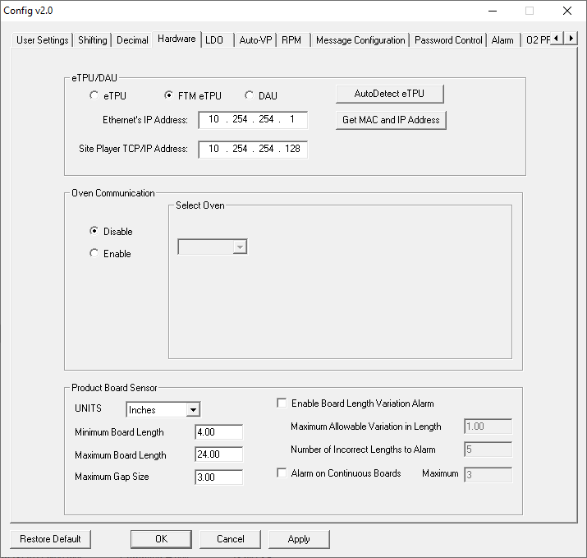This area controls the configuration of the eTPU network addresses, allows for enabling or disabling of the oven communication when applicable, and for adjusting parameters for the board sensor operations.

## Auto-VP Tab

*Auto-VP* is a specialized feature for product changeovers that is dependent on a wide variety of variables. There are multiple configurations of the Auto-VP feature depending on the capabilities and processes in place in the factory. Contact your systems supplier to identify if this functionality can be implemented with your system

## RPM Tab

See [RPM Configuration](#_Remote_Process_Monitoring) section

## Message Config Tab

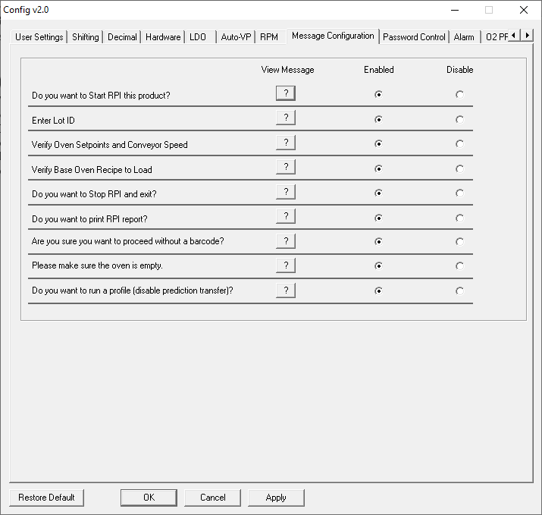

When certain messages are displayed in the software, the user can select a checkbox for “*Do not show this again*”. If checked, that message box becomes “disabled”. This area allows the user to enable or disable those messages.

NOTE: The ‘*Do you want to run a profile?*’ message box does NOT contain the disable checkbox. Disabling this message will also disable the transfer of predicted settings when communicating with an oven controller software. That message can only be disabled in this window.

## Password Control – Multi User

The software offers a Multi User Control capability to configure certain functions as password protected and, thus, requiring the use of specific user levels.

The user types are:

* Administrator
* Engineer
* Tech
* Operator (default)

### Access to the Password Control Tab

By default, the Multi User Control is disabled. When this password function is enabled, it will require the entering the default Administrator password before the Configuration Utility can be accessed. The Password Control tab can only be used by the Administrator, or the Engineer/Tech user types if specified.

If the Multi User Control is enabled and a user starts the utility, the utility will not launch until they enter the correct password (Default Administrator password is Admin). If the user does not have the password they can Cancel and close the utility.

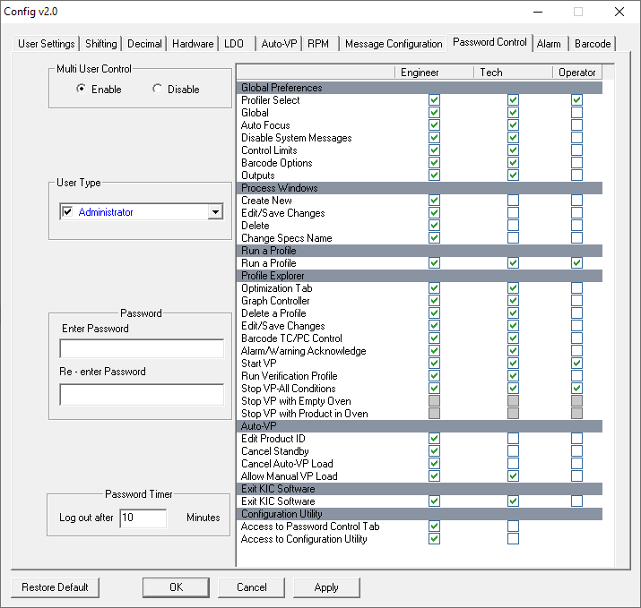

### Multi User Control

To apply Multi User Control, Administrators will click the **Enable** radio button and then click **OK**.

The confirmation dialog is answered, and then the utility must be restarted.



When the administrator logs back in, a password is required.

### Password Control Tab

The **Password Control** tab allows administrators to manage passwords and permissions for each user type. The image below represents the Password Control tab when Multi User Control is enabled. This tab displays a **Password Control Chart**, highlighted, which contains a list of every area in the software. At the bottom of the list, you can give access to the rest of the Configuration Utility tabs, and the Password Control tab individually.



**Stop VP Selections**

There are three different available options for controlling when a VP can be stopped:

* Stop VP – All Conditions: This is the default setting. An authorized user can stop the VP at any time.
* Stop VP with Oven Empty: User can stop the VP only when there is no product in the oven.
* Stop VP with Product in Oven: When user clicks Stop button, they have a choice to wait for products to exit the oven, or they can force a stop even if there is still product in the oven.

NOTE: To enable use of either of the second two options, the *Stop VP – All Conditions* selection must be unchecked.

**Examples of Stop VP Selections**



**Stop VP with Oven Empty:**

OK – Clicking OK will acknowledge this message window and the VP will stop automatically once the last board exits the oven.

Cancel – The *Stop* request will be cancelled, and the VP will continue to run.

**Stop VP with Product in Oven:**

OK – Clicking OK will acknowledge this message window and the VP will stop automatically once the last board exits the oven.

Cancel – The *Stop* request will be cancelled, and the VP will continue to run.

Force Stop – The VP will stop immediately and return to the Profile Explorer screen.



If the *Force Stop* selection is used, additional notes will be automatically added into the *Description* column in Profile Explorer. It will note which user level stopped the VP, and how many products were still in the oven when the stop occurred.

### User Type Area

The **User Type** pick list allows the Administrator to select and enable the password function by user type.

By default, each user in the menu will be unchecked/disabled. By selecting a user type, you not only enable or disable the password entry field and the Password Timer, but also select the type of user to enable and configure.

The columns in the **Password Control Chart** will be enabled depending on the user type selected:

**Administrator** = All columns enabled

**Engineer** = All columns enabled

**Tech** = Only Tech and Operator columns enabled



### Password Area

The Password entry fields are disabled until a user type is selected.

When a user type is selected, the **Enter Password** fields will display as ‘XXXXX” if a password had previously been entered. When a user enters a password ‘X’s will show to indicate an entry, but not show the actual password. After entering a password in the two fields, click the ***Apply*** button before changing to another User Type.



### Password Timer Area

The **Password Timer** is configurable and represents the amount of time before the user is automatically logged out due to being idle.

### Main Screen With Password Control

With Password Control enabled, the software Main Screen with display a Log In button with a letter on it.

O = Operator (default)

A = Administrator

E = Engineer

T = Tech

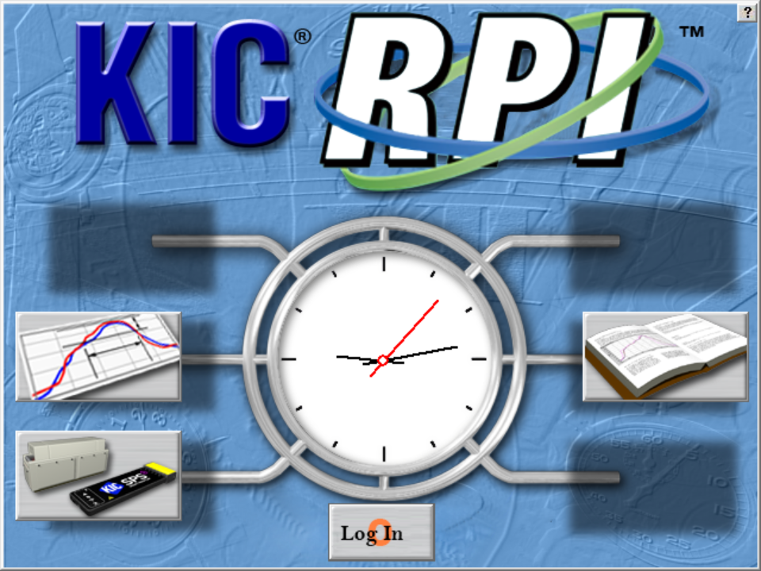

Note that the Operator user type is the default, and typically has the least access privileges.

### Main Screen Log In

When the Log in button is clicked, the software displays a drop down menu, as shown here.

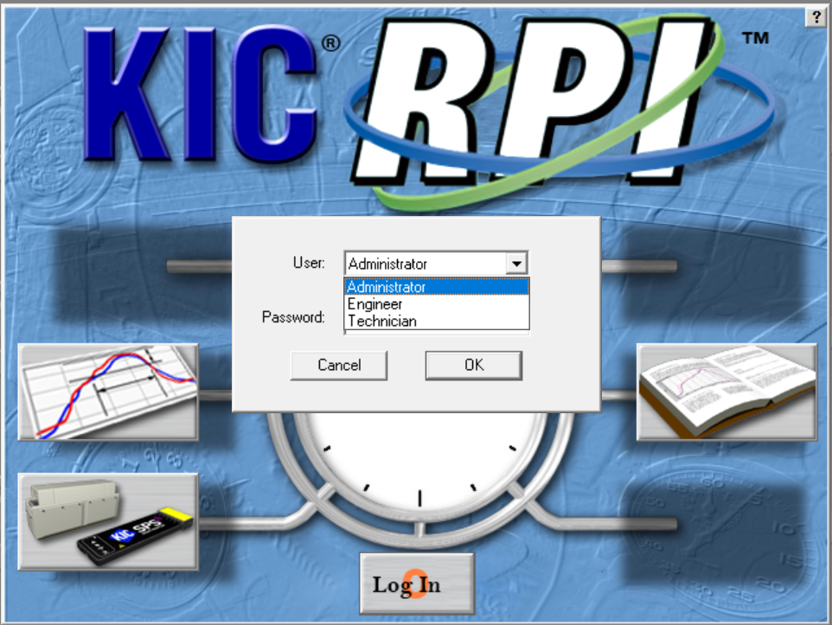

Note that you can log in from most screens, such as from the Log in button in the lower left of the Graph screen.



#### Example of Limited Access to Functions

This screenshot shows the limited access that an Operator, for example, may have. Notice that there are no privileges to create, edit, delete, or save changes.



### Responding to an Alarm



## Alarm Tab

The Alarm tab allows for enabling of the USB Light Tower, and for customizing the operation of the *Alarm Relay* functions.

### Alarm Relay Matrix configuration

When the *Alarm Relay* is in use, you can match the alarm output behavior to your specific production needs through the Alarm Relay (AR) Matrix. By default, the system only outputs a signal to the relay when it is running Virtual Profiling and an alarm (red crystal ball) condition. The alarm condition prompts the eTPU to send a signal that energizes the *Alarm Relay*, letting it power an audible or light indicator or stop an infeed conveyor

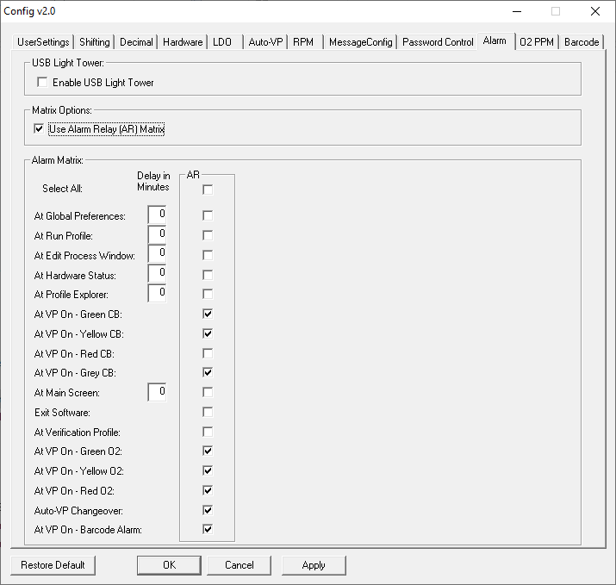

When enabled, a list of operational conditions appears. If an item is checked, the Alarm Relay will be energized during that condition. If an item is unchecked, the relay will be de-energized at that condition. For example, you might want to keep boards from entering the oven except when the Virtual Profile is in a green or yellow crystal ball state. Selections you make on the matrix will “invert” the signal that energizes the alarm relay, stopping the infeed conveyor from allowing boards to enter.

**Delay In Minutes**: This allows a user to specify a delay before an alarm (audible/visual/mechanical) is generated at the selected condition. A ‘0’ (default) means the alarm will be generated as soon as the condition occurs.

Even if someone tried to bypass the entire system by shutting down the KIC software, it can be configured so that it still would not allow product to enter. The matrix gives you more control over your process, ensuring that system is in use whenever product is run.

**NOTE:** When the *USB Light Bar* is used, changing the settings in this Matrix will not alter the *USB Light Bar* operation. It will only affect the operation of the *Alarm Relay.*

|  |
| --- |
|  |

### USB Light Tower configuration

#### Enable/Disable USB Light Tower



To enable the use of the USB Light Tower, enable the checkbox on the Alarm tab. This will enable the default operation of the USB Light Tower as previously described.



When enabled, you will also have the ability to customize the operation of the USB Light Tower. Select the *Use USB Light Tower Matrix* checkbox to activate the matrix functions.

#### USB Light Tower Matrix

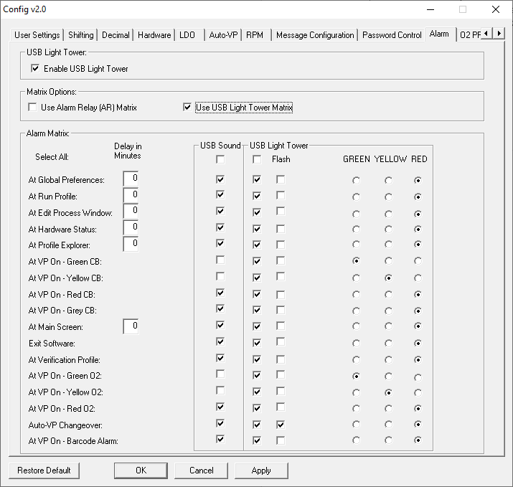

When enabled, a list of operational conditions appears. The matrix allows for enabling individually, the sound and light operation for each condition. If an item is checked, the sound or light turns on during that condition. If an item is unchecked, the sound or light will be off at that condition.

When the light function is enabled for a condition, one of three colors can be chosen to appear.

For most conditions, the light will appear solid. If you wish for the light to flash in that condition, select the *Flash* checkbox.

## Barcode Tab

The **Barcode** tab is used for configuring some of the barcode interface functions and some barcode operations.

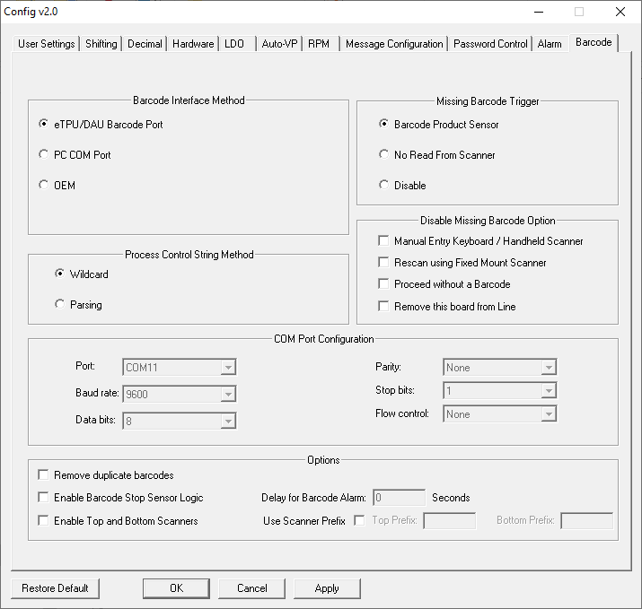

### Barcode Interface Method Area

The **Barcode Interface Method** area specifies where a barcode string will be coming in:



**eTPU Barcode Port** – via 9 pin serial connection on eTPU

**PC Com Port** – via 9 pin serial port or USB Port on PC. **NOTE:** To use a USB barcode scanner, it must be programmable for a USB Serial Port interface.

**OEM** – only available with specific oven manufacturers

If PC Com Port is selected, the **COM Port Configuration** area also becomes active. This area specifies which Com Port the scanner is connected to, and the Com settings. This area must be configured when using either a DB9 (Com Port) or USB connected scanner:



### Missing Barcode Trigger Area

The **Missing Barcode Trigger** area specifies what method is used to trigger the Missing Barcode Alarm function.

**Barcode Product Sensor** – requires the installation of the BPS sensor adjacent to the barcode scanner. If this sensor is triggered, and a barcode is not received, the Missing Barcode Alarm is generated.

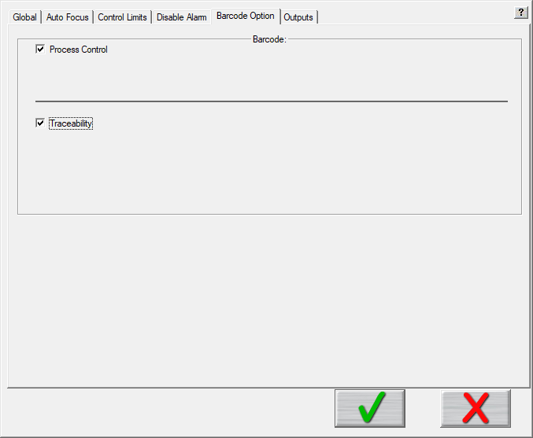

**No Read From Scanne**r – some scanners can be programmed with a “No Read” output. If “No Read” is the string received, the Missing Barcode Alarm is generated.

**Disable** - the software will never generate a Missing Barcode alarm. Typically used when some other process verification is in use and the alarm from KIC is not required/desired.

NOTE: When either **“No Read From Scanner”** or **“Disable”** is selected, some of the configurations previously referenced in the [*Barcode Section*](#_Barcode_Tab) will automatically be disabled, as shown here:

### Process Control String Area

This area allows you to select which method of Process Control string identification will be used in the software:



**Wildcard**: Default setting; This method requires that the *Control String* being defined is always an uninterrupted, consecutive grouping characters – either at the beginning, middle, or end – of a barcode string.

**Parsing:** This method allows you to select any specific characters from within a barcode string to be used as the *Control String.* The Parsing method is helpful when the locations of the Control Strings vary from product to product.

### Disable Missing Barcode Option Area

This area allows you to disable some of the available choices that are given when a Barcode alarm is displayed:



The four selections listed represent buttons that a user can click on when a Barcode alarm appears on the screen. By selecting a particular checkbox, the software will no longer display that button on the alarm message dialog window.

For example, when the barcode option is in use, and you never want a product to be allowed to enter the oven without the associated barcode string attached to the data, you can select the ‘Proceed without a Barcode’ checkbox. This will prevent that button from being accessible. Below is an example of a Missing Barcode Alarm condition, when that function is disabled. The open spot is where the ‘Proceed without a Barcode’ choice would have been displayed:



### Options

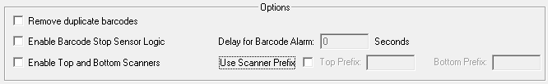

**Remove duplicate barcodes**: For situations where a barcode scanner always sends out multiple scans for each barcode read, enabling this function forces the software to ignore duplicate barcode strings. Once a given string is received, it will ignore any duplicate receipts of that same string. When a different string is received, the filter function resets.

**Enable Barcode Stop Sensor Logic**: Enabling this function causes the external Alarm Relay to energize every time the Barcode Stop Sensor (BSS) is triggered, stopping the product on the in-feed conveyor. This ensures confirmation that each product has been checked for, or assigned, a valid barcode ID before allowing it to enter the oven. This functionality may be needed when a short in-feed conveyor is in use, there are time delays in receiving barcode ID strings, or an extra layer of barcode validation is desired for control before the product enters the oven.

**Note:** The Barcode Stop Sensor (BSS) and Barcode Product Sensor (BPS) functions cannot be used at the same time. Only one of the two configurations can be used. If the *Enable Barcode Stop Sensor Logic* is selected, the *Missing Barcode Trigger* section and associated functions will be overridden by this function.

Note: The BPS and BSS physical sensors are identical. The software configuration determines what operation the sensor input will trigger.

**Enable Top and Bottom Scanners:** This logic may be needed when barcode labels are attached to different sides of the boards, and two scanners are installed.

**Use Scanner Predix:** Allows you to specify the Prefix that you will be programming into each scanner. When applicable, this allows for identification of which scanner a barcode string was read from.

When the Enable Top and Bottom Scanners is in use, and the scanners are connecting through a PC Com Port, an additional menu becomes active, allow you to specify which scanner is connected to which Com Port:

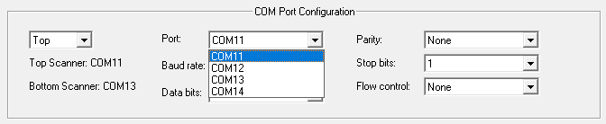

# Contact KIC

|  |  |
| --- | --- |
| **On the Web**  You can find the latest KIC product news along with a library of useful information at our website:  [www.kicthermal.com](http://www.kicthermal.com) or [www.kic.cn](http://www.kic.cn) | map |

**KIC Technical Support**

KIC Tech Support (phone) is available by email:

USA: [tech@kicmail.com](mailto:tech@kicmail.com)

Europe: [europe.tech@kicmail.com](mailto:europe.tech@kicmail.com)

Asia: [asia.tech@kicmail.com](mailto:asia.tech@kicmail.com)

**KIC Product Training**

Contact KIC Customer Support by email, [training@kicmail.com](mailto:training@kicmail.com)

**KIC Sales**

Contact KIC sales:

USA: [sales@kicmail.com](mailto:sales@kicmail.com)

Europe: [europe.sales@kicmail.com](mailto:europe.sales@kicmail.com)

Asia: [asia.sales@kicmail.com](mailto:asia.sales@kicmail.com)

China: [asia.sales@kicmail.com](mailto:asia.sales@kicmail.com)

**Find the KIC Representative in Your Area**

Send an email or visit our web page to find a local representative.